Commercial Property Network, Inc.
29 Emmons Drive, Suite F-40, Princeton, NJ 08540
Ph: (609) 921-8844 Fax: (609) 924-9739
www.cpnrealestate.com

OFFICE-MEDICAL: Sale or Lease/Low rates-reno available
83 Princeton Avenue, Hopewell Township-Immediate Occupancy

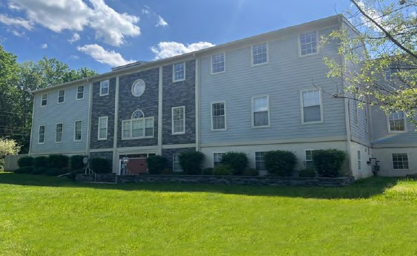
13,500/SF Full building for sale, with income/expansion potential.
Suites from 548sf, 1029sf, 1271sf, 1556sf, 2226sf, 2609sf & 4835sf full top floor.

In town location, offering great access, ample parking and close to services.
Recent lobby, bathroom and exterior renovations, newly paved parking lot.

Total: 13,500/SF, 3 floors, elevator served
Suites: Varied sizes with several offering sole exterior access
Plumbed Dental Suite Available

Zoning: Office Professional Service uses allowed/Commercial-1 zone

Parking: Over 50 spaces

Signage: Signage potential for large tenant

RATES: For Lease: Asking $18.50/SF, most competitive in region
Immediate occupancy, flexible terms
For Sale: Asking $137/SF ($1,850,000)

83 Princeton Avenue is ideal for professional or services firm seeking to own with income and expansion potential.

LOCAL MAP
In town location, can walk to restaurants and other services
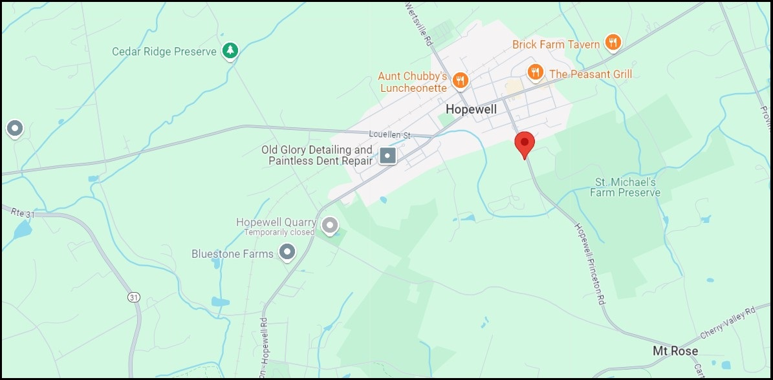

REGIONAL MAP
Convenient to Route 31 and Bucks County. Ten minutes from Princeton.

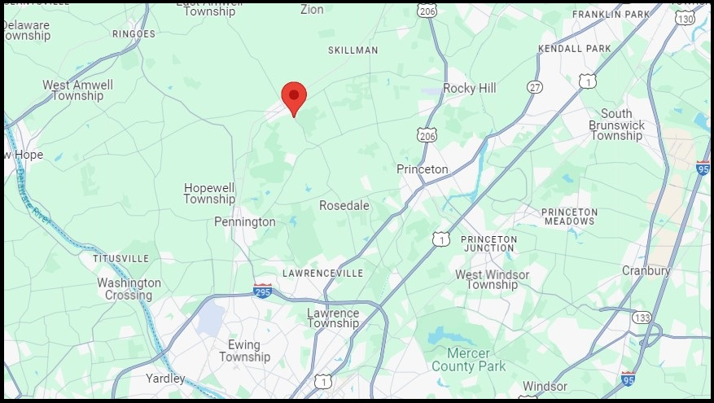

FLOOR PLANS: 1st Floor, 548, 1261 and 2567sf

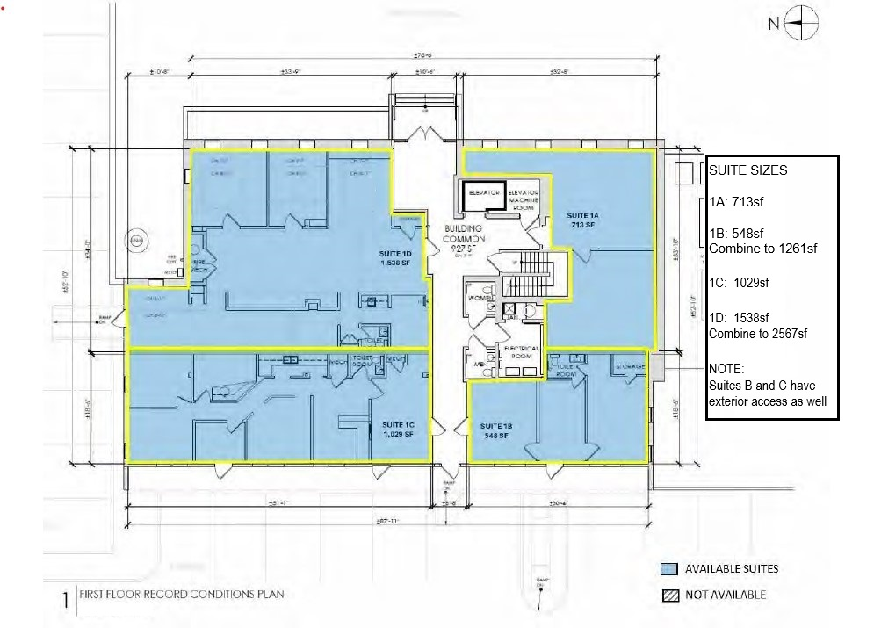

SECOND FLOOR: 1327/SF to 2870sf

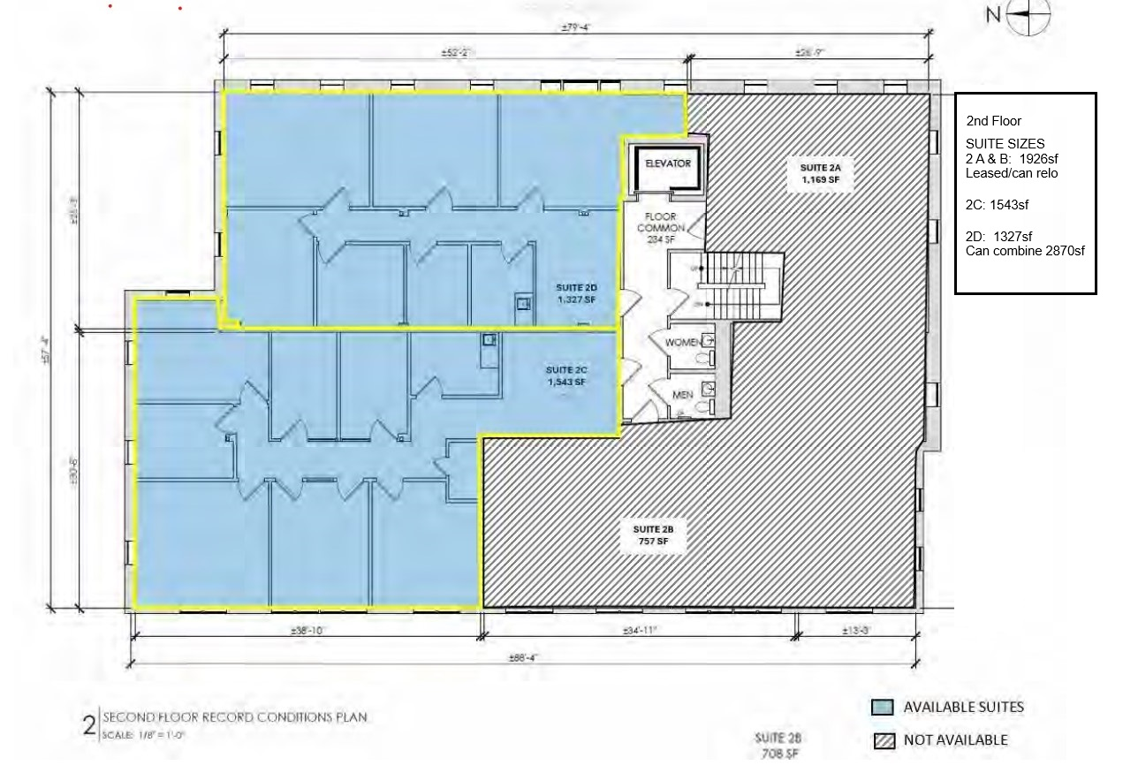

THIRD FLOOR: Total Floor of 4835SF, divisions available
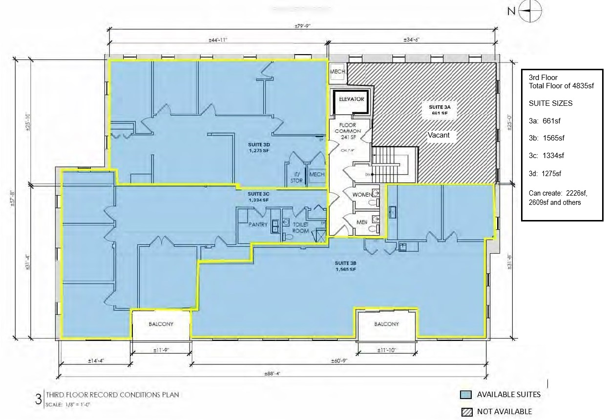

SITE PLAN

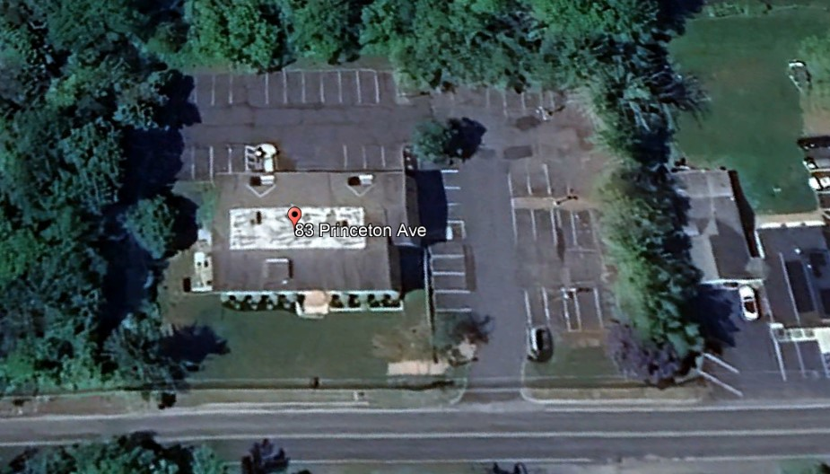

For Further Information, please contact:
Al Toto, Senior VP totocpn@aol.com 609-658-3828

William Barish, Founder/Broker bbarish@cpnrealestate.com 609-731-6076

