FOR LEASE: PRIME RETAIL SPACE
Discover Your New Retail Location in Corona, Queens!
Property Highlights: 38-05 Junction Blvd.
Description: The Property is situated on Junction Blvd, directly next to the elevator entrance to the Junction Blvd stop on the 7 train and other mass transit with 6.8M annual ridership. Corona is one of the fastest growing and most diverse neighborhoods in New York City with a bustling small business community.
Building: The space benefits from high ceilings, two dedicated egresses (Junction Blvd and 38th Avenue), and heavy pedestrian traffic. This vacant space is adjacent to other popular tenants such as Taco Bell, Teppanyaki One Japanese Grill, and a popular sneaker / sportswear store which all serve as draws to the street.
Square Footage: Approximately 2,800 sq. ft.
Monthly Rent: $22,000
Available: Immediately
Restrictions: All may apply - No Mexican cuisine, Asian cuisine, or Smoke/weed shops
Contact: Ralph Kahn 718-490-5614
View from Platform of 7 Train
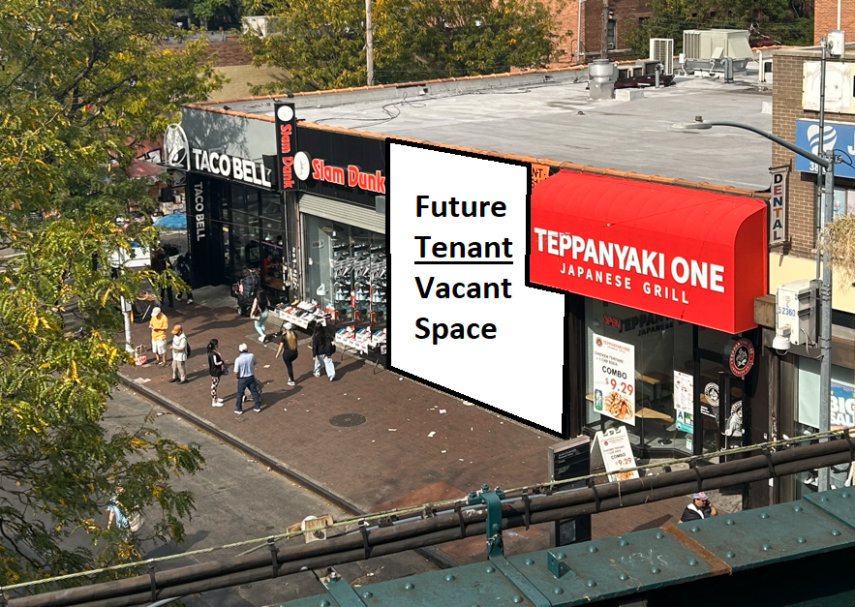
View From Junction BLVD
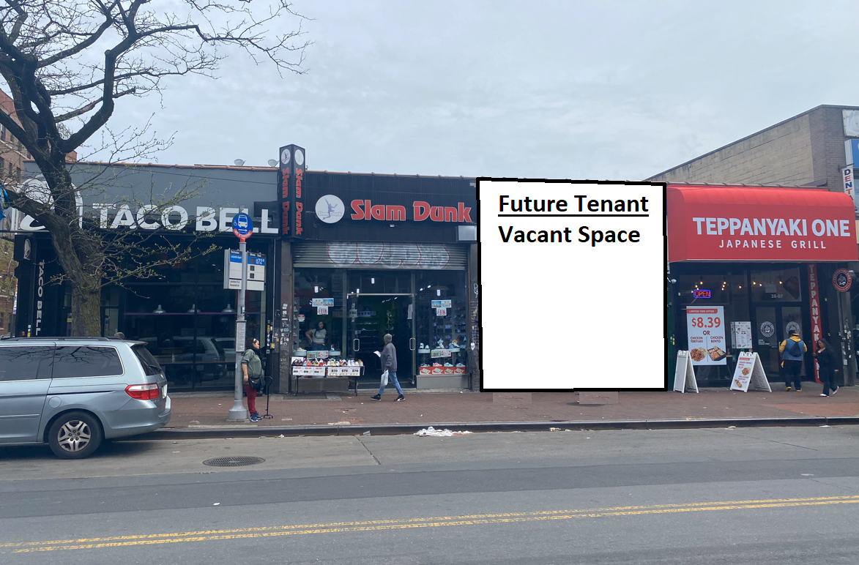
Layout of Vacant Space
