ESSO GAS STATION - BUSINESS WITH PROPERTY FOR SALE
2001, 16TH Avenue, Campbell River, BC
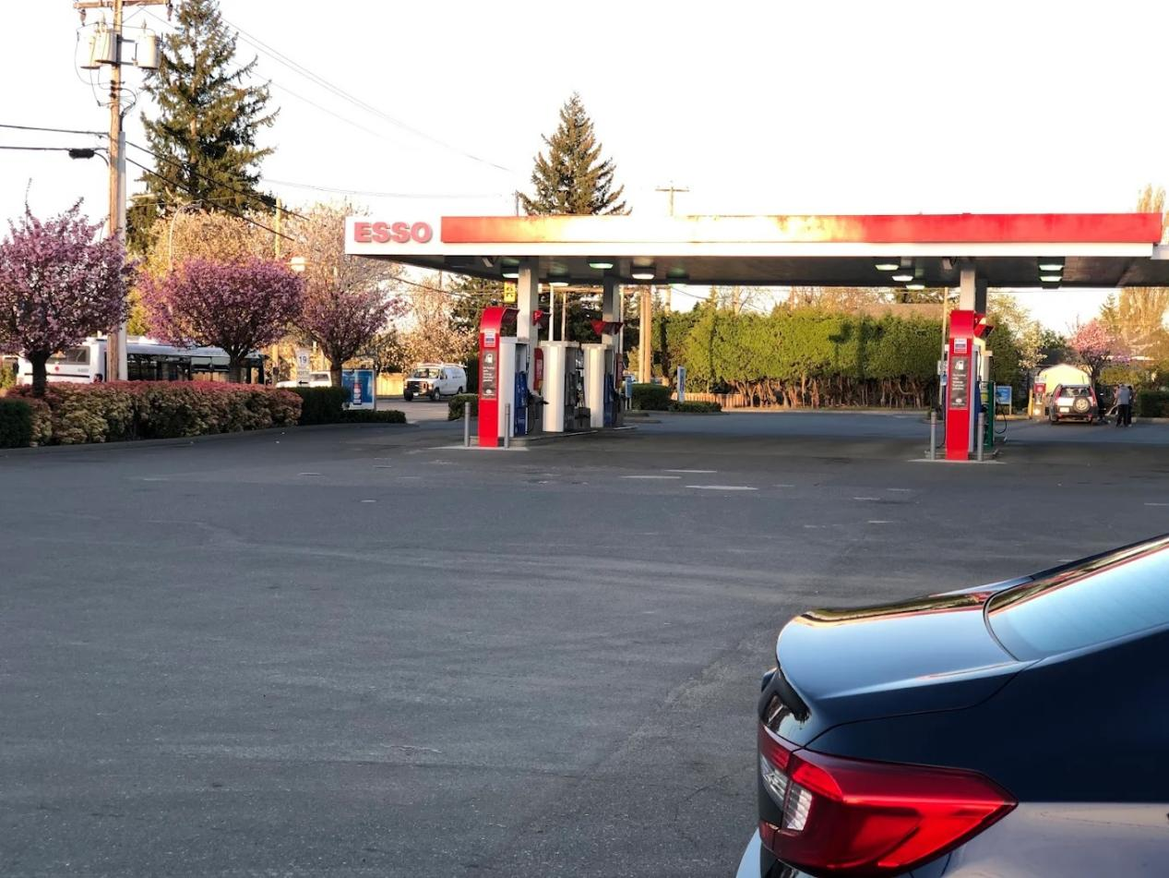

This Esso station property offers an excellent investment opportunity in a strategic Vancouver Island location, featuring a drive-thru McDonald’s restaurant with approximately 20 seats, convenience store, and car wash facility, benefiting from both local traffic and strong tourism activity throughout the year.
British Columbia, widely known as the “Salmon Capital of the World.” The city is a major tourism and outdoor recreation destination, attracting visitors year-round for salmon fishing, whale watching, kayaking, hiking, mountain biking, and eco-tourism. Campbell River also serves as the gateway to Northern Vancouver Island and nearby coastal communities.

