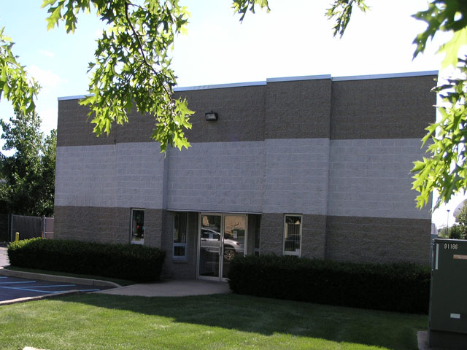

Building Size: 10,000 sf
Available Size: 6,000 sf - Front Unit
Lot Size: .75 acres ±
Offices: 1,500 sf ±
Ceiling Height: 16’±
Drive-Ins: 2 (10’ x 14’)
Heat: Gas
Power: 600 amps

Asking Lease Price: $16.00 Per SF Gross - Firm
Taxes: Base Year Included
- Occupancy Arranged
- Front Unit
- Ample Parking

