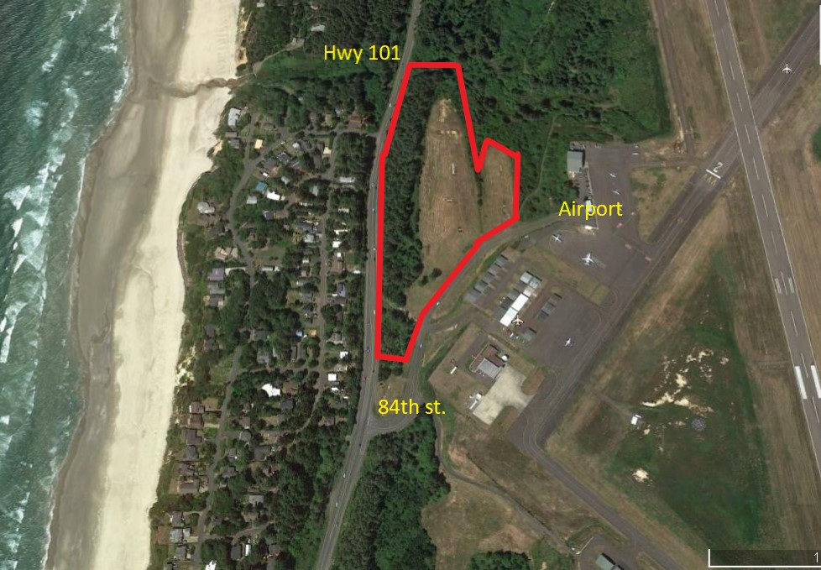

Vacant Parcels for Lease
Newport, Oregon Airport
Description:
Up to 10 acres of vacant land is available for lease on a long-term basis (40-60 years). The overall property shown above is approximately 10 acres in size, however, the property can be subdivided into smaller parcels depending on the end user’s needs. The City of Newport owns the property which has been master leased to a developer who is offering individual parcels to tenants for sub-lease. Terms of the master lease include a 40-year initial term with (2) 10 year extension options. Those terms can also be made available to tenants sub-leasing individual parcels. This property lies within an Enterprise Zone. Please refer to agent for additional information.

A long-term lease can provide an end user the financial flexibility of not tying up significant funds in the purchase of the land. The funds that would otherwise be used to purchase the land can, therefore, be used to build out the improvements. A long-term lease may also meet the criteria of a replacement property for an IRC 1031 tax deferred exchange. Please contact agent for additional information.

The location is excellent with visibility and frontage on Coast Hwy. 101. Access to the property is off of SE 84th st. the main access to the Newport Airport.

Lease Rates:
. Lease rates vary depending on the size and configuration of an individual parcel. The pricing below is
estimated.

For 8-10 acres: Lease rate of $.36/sf/year
For 4-7 acres: Lease rate of $.39/sf/year
For 1-3 acres: Lease rate of $.41/sf/year

Zoning & Land Use:
The property is part of the Newport Airport Development Zone Overlay (Chapter 14.22 of the City of Newport
Municipal Code). Uses of the property should “encourage and support the continued operation and
vitality of Newport Municipal Airport by allowing certain airport-related commercial and recreational uses
in accordance with state law”. Discussions with the City of Newport have indicated a broad range of uses
that would be allowed and encouraged. It is recommended that interested parties discuss their proposed
use with the Newport City Planning Department. The City of Newport is very supportive of development
of the Airport property.

Site Configuration:
Overall site design and configuration has not been determined. The site layout shown below is simply to
illustrate how the site may be sub-divided. Note the inclusion of a central access drive. This access drive,
if necessary, will be constructed by the developer.

The City of Newport has seen significant growth in both their residential and business sectors yet very
little land is available for commercial development. This property represents a unique opportunity to
build in a highly desirable area at a very attractive price and terms.

Agent: Alan Wells, CCIM
Commercial Associates

202 NW 6th Street
Corvallis, OR 97330
(541) 754-6320
Cell: (541) 990-9613
E-mail:alan@commercialassociates.org
www.commercialassociates.org

The information contained herein was secured from sources deemed reliable but is not guaranteed by broker and is subject to price change, prior sale, error or omission, correction or withdrawal without notice.

Survey

Possible Site Layout

