
FOR SALE
or LEASE
2,510 sq. ft.
MEDICAL OFFICE CONDO

111 W. High Street
Medical Office Building
Next to Christiana/Union Hospital
Elkton, Maryland
- Suite 303 – 2,510 sq. ft.
- Prime Medical Office Space
- Sale Price $219.00/ sq. ft.
- Lease $20/sf NNN

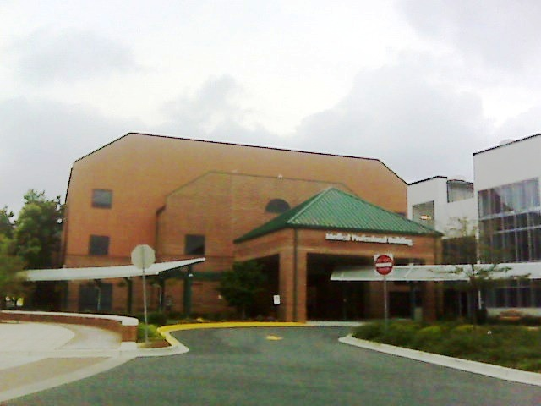

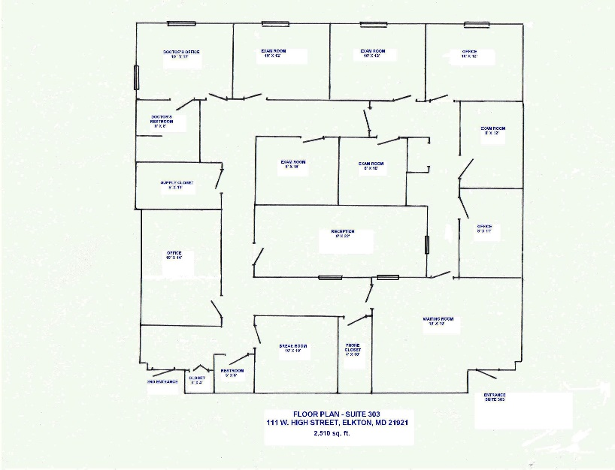

Milestone Commercial Realty
P.O. Box 1218
Elkton, MD 21922-1218
# 410.620.5115
www.MilestoneCR.com
CALL:

RICK LEIPOLD, CCIM - # 410.441.4419

.

