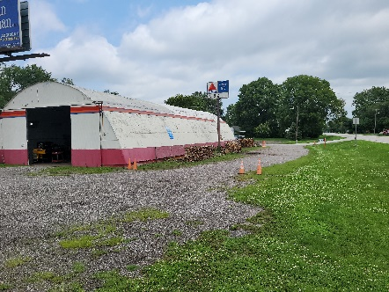
For Sale:
2350 State Road 25 W
Lafayette In 47909
$ 450,000

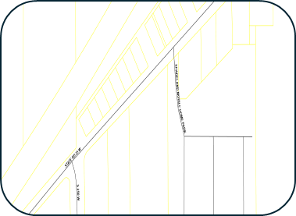
Several Lots
Lots 8 thought 17 all in one offering (seller will not subdivide)
Lots of State Road frontage approx. 500 ft. 2 entrances from road
Lot is approx. 2 acres+-
Great location for a convenience store, storage units or continue as a truck repair shop.

Located in a small town West of Lafayette. Just off State Road 231. Within 10 Minutes of Purdue University, Lafayette and West Lafayette. Shadeland is growing in households. One gas station with a small liquor store, small convenience store, auto repair shop, glass blowing shop.


824 Columbia St
Lafayette, IN 47901
765-250-4644
www.lenwilson.com

