Active transportation is defined as walking and bicycling and sometimes includes transit since the rider is usually a pedestrian on at least one end of their trip. Public health professionals have touted the benefits of active transportation and the physical activity associated with it. In 1996, the United States Surgeon General issued a report on the link between physical activity and health and the prevention of chronic disease. Exercise and physical activity are important for people of all ages, but they are even more critical for older adults to maintain their quality of life. However, research has shown that physical activity levels typically decrease with age (Schutzer and Graves, 2004).
Transit
The map below shows where older adults live in the region and frequent-service transit stops with ¼ mile service areas. TriMet defines frequent service as transit arriving about every 15 minutes. Clearly the downtown location is fairly well served by frequent transit service. Older adults who live close to a frequent service transit route are typically able to take advantage of the service. There are many tracts that have a high percentage of older adults that are not close to a frequent service transit line. Older adults with the resources to own and operate an automobile may not need to rely on transit. Lower income older adults or those that choose not to use their car in these areas have fewer transportation options. As the Baby Boomer generation ages, these areas of reduced access may increase.

Figure 10: Population 65 and Over and Frequent Transit Service in the Region
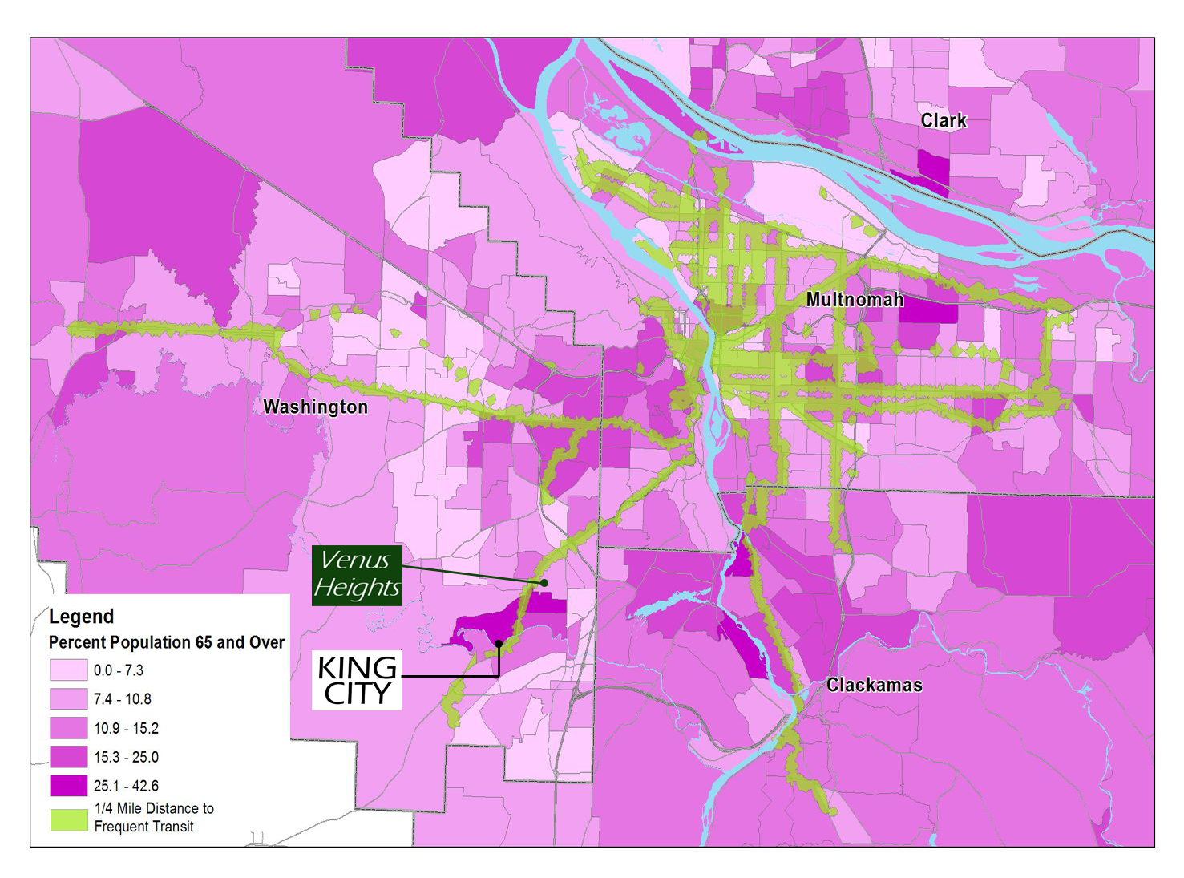
Source: US Census Bureau and Metro

