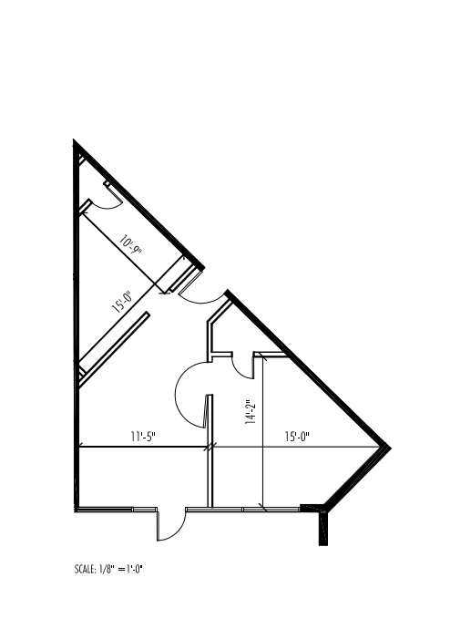
103’-8’
108’-2”
29’-1”
78’-0”
27’-9”
Center Point • Suite 109 • 503 SF
Base Rent: $731.87 ($17.46/ sf)
NNN: $106.46 ($2.54/ sf)
Total $838.33 ($20.00/ sf)
JB Dallas LLC • (214)854-0338

