Eastgate Center

2255 East Greg St., Suite 101
Sparks, Nevada 89431
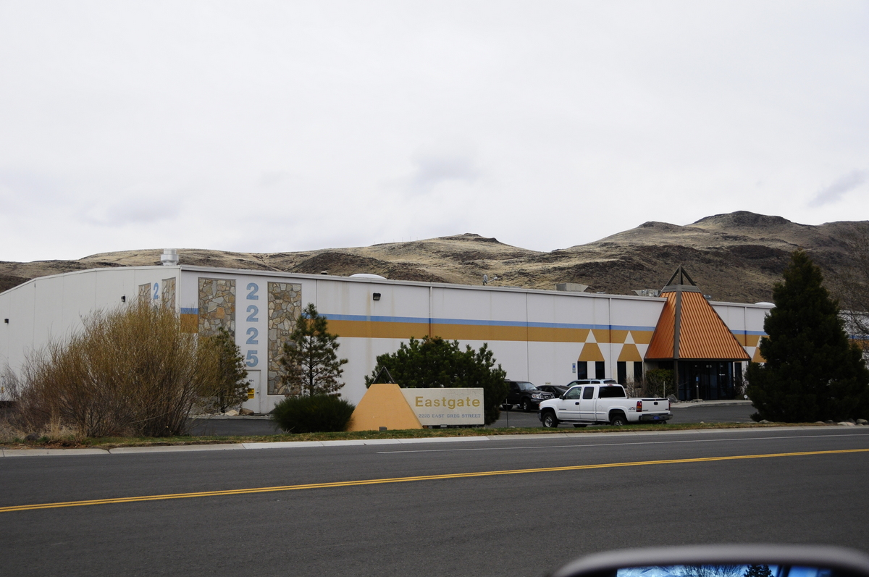

25,000 SF Flex Space

> 1,585 S.F Office with 23,415 S.F. Warehouse

> 50’ x 40’ Column Spacing, 24’ Clear Height

> Four 9’x 9’ Dock Doors and one 12’x 14’ Drive-in Door.
> 400 Amps, 480/277 Volts Three Phase Power

> Fenced Shipping/Receiving Yard
> 0.6 GPM/2,000 S.F. Fire Sprinkler System

Located ¼ mile south of I-80 Exit 22

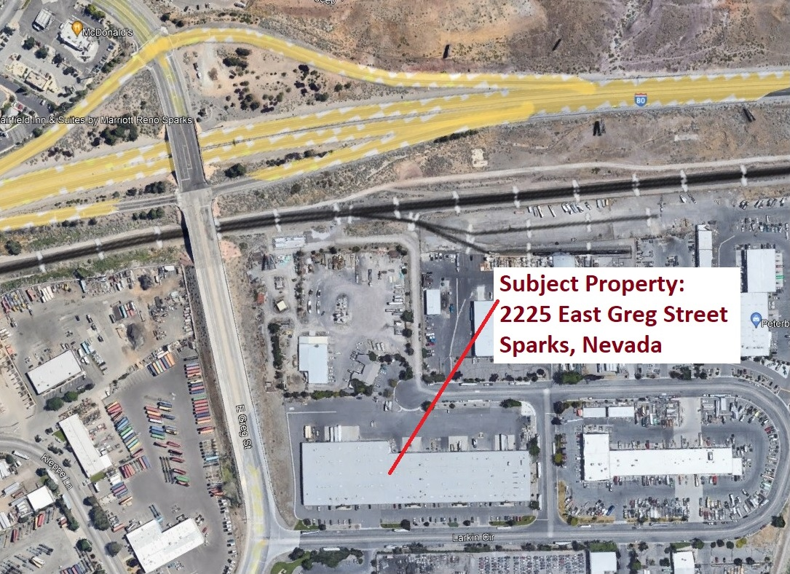
Site Plan

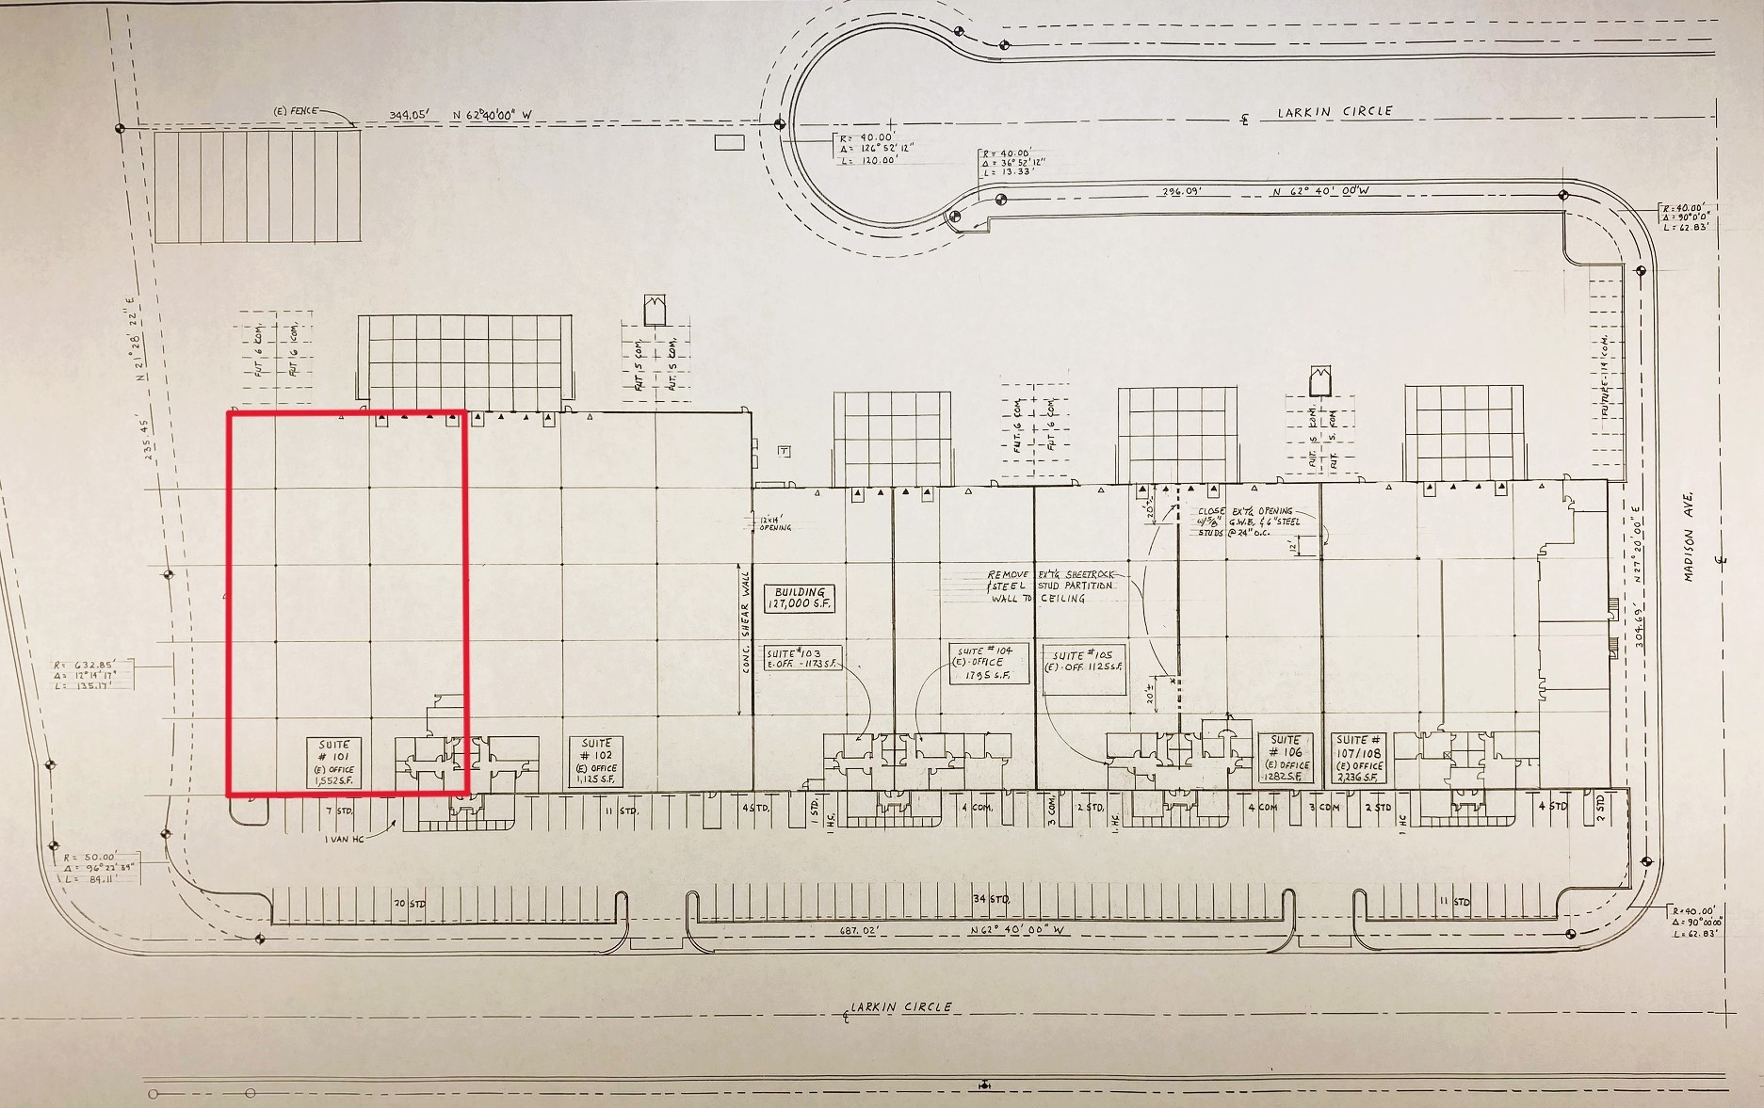

Office Floor Plan

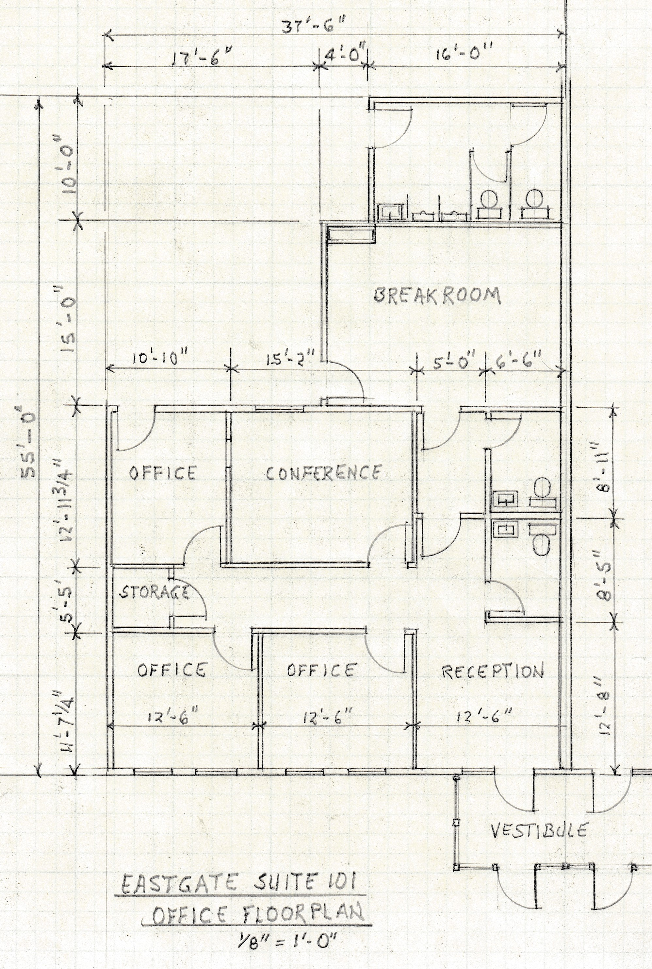

EASTGATE CENTER

Contact: MMK Properties Nevada Realty and Property Management
Mark Meiser Bill Bowden License #S.12100
(775) 359-0303 (O) (775) 829-9550 (O)
(775)-750-4081 (C)

EGCPROMO 101 02122024

