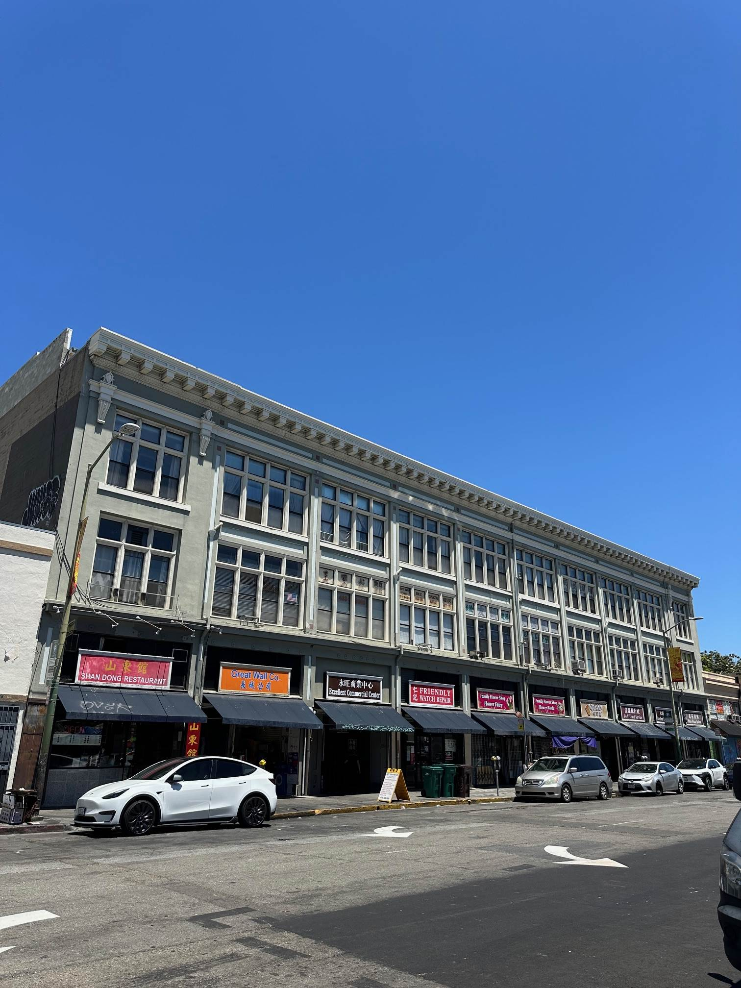
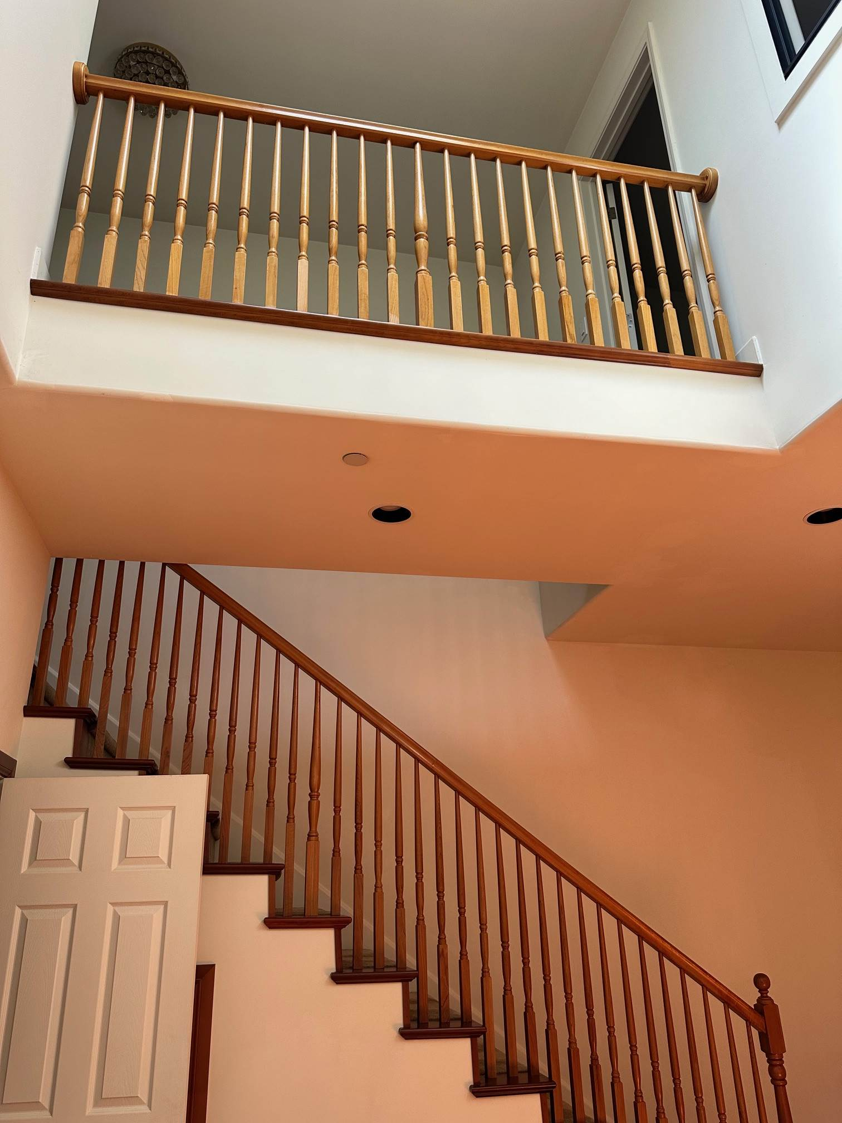
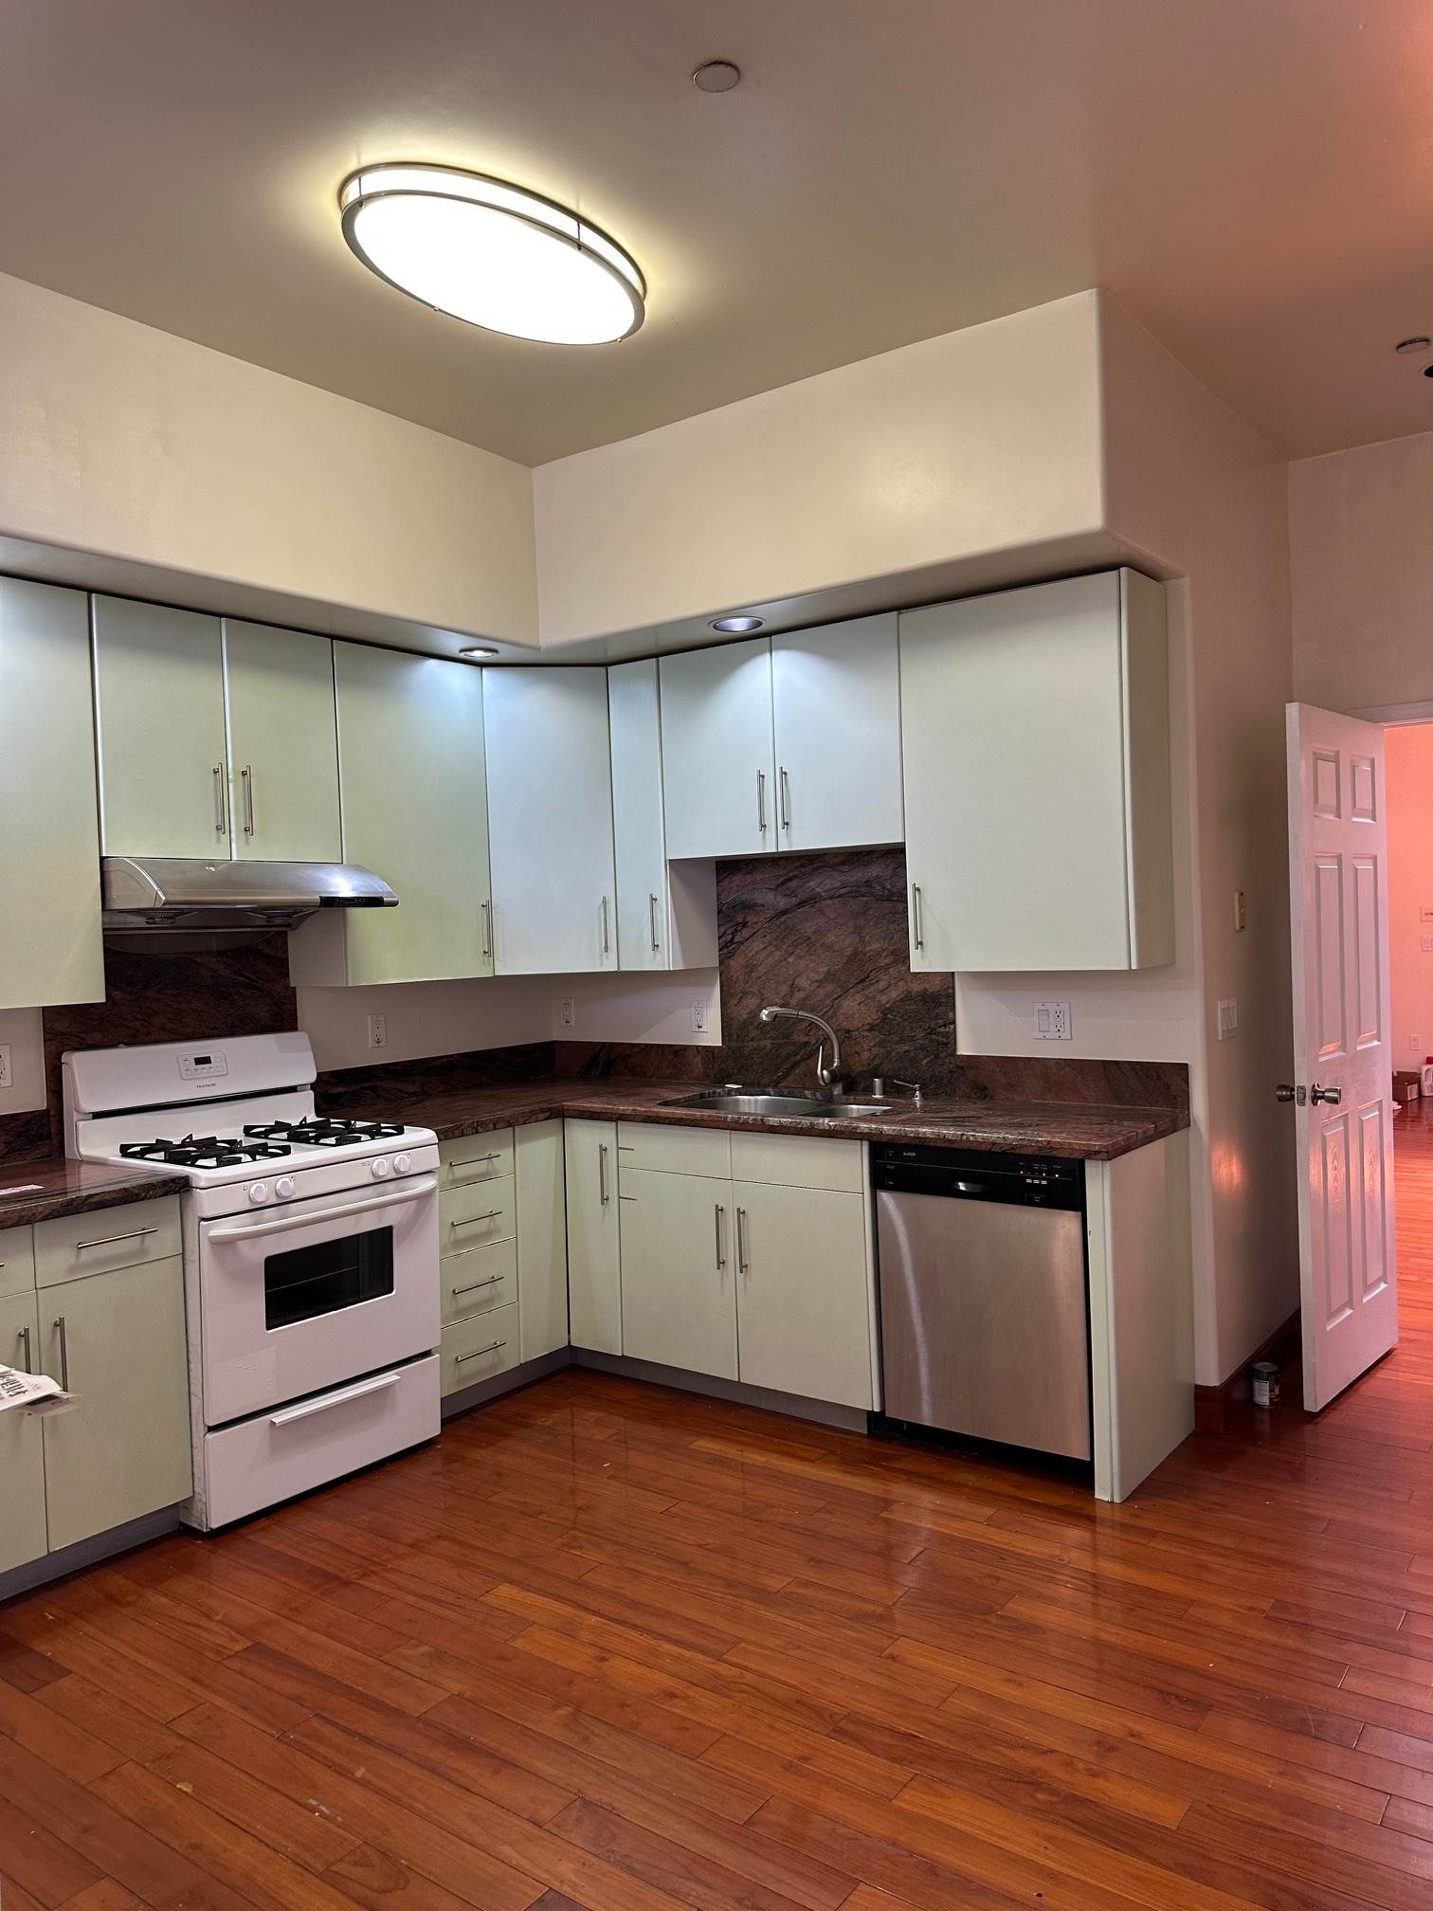

FOR SALE (HUGE PRICE REDUCTION)
20 Residential Condominium
324 10th Street Oakland, CA 94607

B.C. Realty is pleased to offer the valuation of 324 10th Street, (20) two-story loft style units that are individually parceled in the heart of Chinatown in Oakland. With excellent access to Downtown / Uptown Oakland, Lake Merritt, major employers, public transit, retail and shopping options - there is no better location within the City of Oakland.

PROPERTY
324 10th Street is a 4-story building that feature (20) live/work units in the top two floors, all 2-Bedroom / 1.5-Bathroom units at 1,169 sf with an open floor plan, private patio, washer & dryer, stainless steel appliances, dishwasher, and granite countertops. While the 1st two floors of the building are made up of multiple retail spaces and are separately owned from the live/work units. Each floor is accessible by stairs or elevator. Utilities are individually metered, so expenses are light. Due to each unit having a separate APN, there is short term profit potential by selling off each individual unit.

HIGHLIGHTS
▪ Potential Rental Upside of 16% ▪ 14% Loss to Lease ▪ Individually Metered ▪ HOA Managed
▪ Live/Work Loft Units Range from 880 to 1,429 Square Feet; Averaging 1,169 Square Feet.

INCOME AND EXPENSE
Average rent $2200 x 20 condos = $44,000. GSI $528,000.
Business Tax $7000, Property Tax $60,000., Insurance $4921, Management Fee $24,000.,
HOA $85,680, Total Expenses $181,601. NOI $243,338.

Asking at 8.25% CAP Rate: $2,950,000. Million Dollars $147k per condo

Contact: B.C. Realty, Website: BCRealtyLeader.com
Bonnie Chui, DRE #00894884 Phone: (510) 835-8888
Email: bcleader2015@gmail.com

