THE SHENIAN COMPANY
COMMERCIAL REAL ESTATE BROKERAGE

12 FOOT HIGH CREATIVE SPACE! 9 FOOT HIGH WINDOW LINE!
1500 Walnut Street
Philadelphia, PA 19102

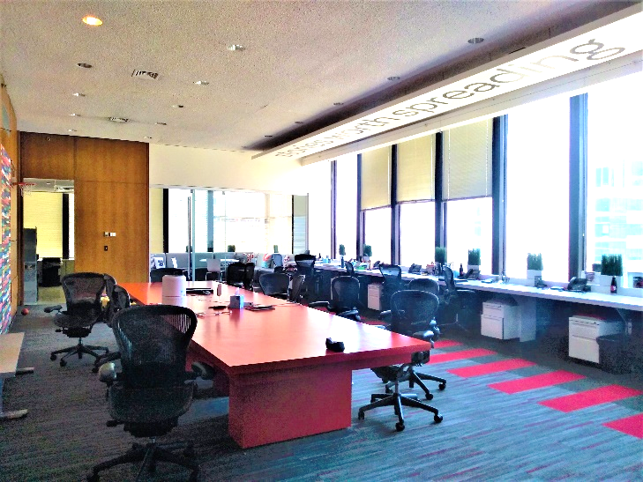
- Space features
- True one-of-a-kind space
- 6,940 sf. Can be demised.
- 12-foot-high ceilings
- 9-foot-high window lines
- Panoramic views
- Glass conference rooms!
- Open layout
- 18th floor; 3 sides glass line
- Fresh air vents
Building features
- Asking $23.00 + E
- Paying 6% commissions
- $3.5 million garage renovation
- Renovated Lobby
- State of the art hvac
- New shared conference room

For further information contact:
P. Chris Shenian
The Shenian Company
Philadelphia, PA 19102
Mobile: 610-331-2797
Email: pcshenian@shenian.com

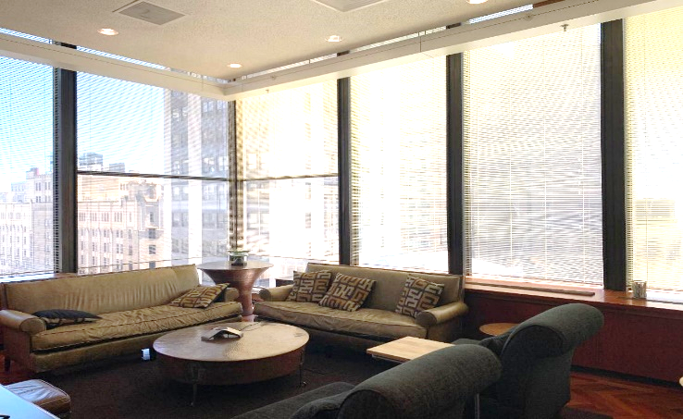
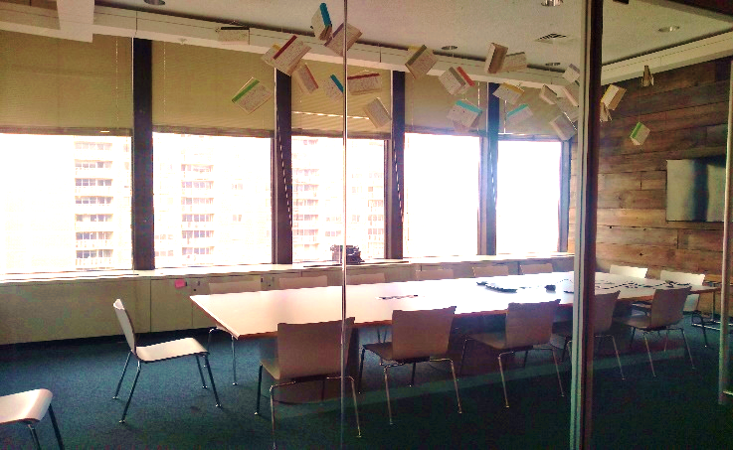
Disclaimer: This information has been obtained from sources believed reliable. We have not verified it and make no guarantee, warranty, or representation about it. Any projections, opinions, assumptions, r estimates used are for example only and do not represent the current or future performance of the property. You and your advisors should conduct an independent investigation of the property to determine to your satisfaction the suitability of the property for your needs+

