

SPRING PINES OFFICE PARK
Webster, NY 14580

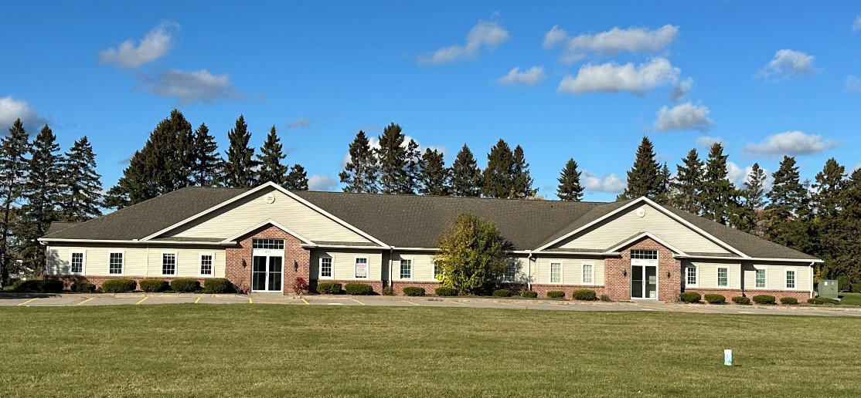
FOR SALE - BUILDING 1680
7,530 Total Square Feet

Professional - Medical Office Space

- Address: Spring Pines Office Park, Webster, NY 14580
- Town/County: Town of Penfield/County of Monroe
- Location: Off Empire Blvd and Plank Road
Minutes from the 104 Expressway and I-590 at Empire Blvd.
- Zoning: BN-R (Business Non-Retail)
- Land: .70 Acres
- Total Square Feet: 7,530 (approximately)
- Rentable Units: Suite 100 Occupied
Suite 200: 2,323 SF Available
Suite 300: Occupied
Suite 400: Occupied
- Rental Rate: $14.00 PSF + NNN & Utilities (AS-IS)
- Sale Price: $1,150,000
- Taxes: $24,535 or $3.26 PSF (approximately)
- CAM: $33,132 or $4.40 PSF (Approximately)
- Utilities: Tenant Responsibility
- Parking: Common, paved lot parking
- Storage: Basement available (unfinished)
- Signage: Signage available
- Available: Immediate
- Description: Modern, move-in ready office space ready for multiple uses. Standard professional office space, service, medical space currently has multiple exam rooms, private offices, reception area, and restrooms. Ample parking for customers and staff.

ALL INFORMATION IS DEEMED ACCURATE BUT SUBJECT TO CHANGE AT ANYTIME

1892 S. Winton Road, Suite 100
Rochester, NY 14618
phone: 585.546.4170
fax: 585.546.3587
www. moorecre.com

