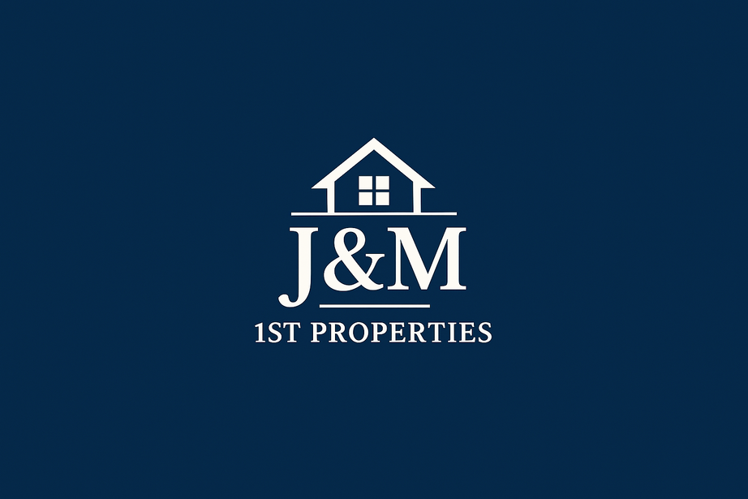
Office Spaces Available! Call: 904-735-9996 or 904-882-8528 2301 Park Ave., Orange Park, FL 32073 (Suites 208-210)
Our full-service SHARED office leases include furniture for your entire team or for solo professionals launching a private practice. We also offer SEPARATE suites with two (2) rooms and a powder rom.
Each office offers peaceful views of the surrounding green space and wetlands, creating a refreshing and inspiring work environment. The property is fully accessible, features a spacious parking area, and offers affordable lease options designed to fit your needs.
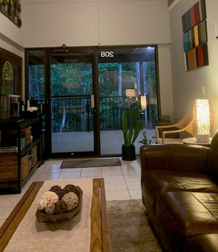 | 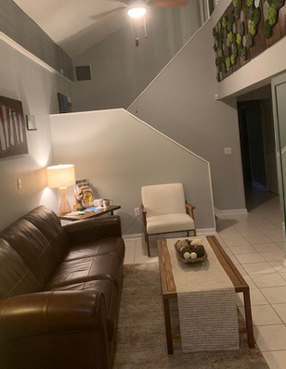 | 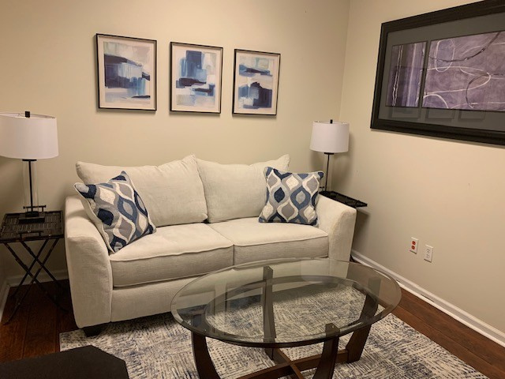  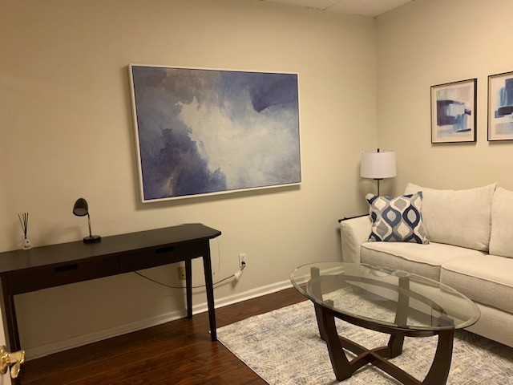
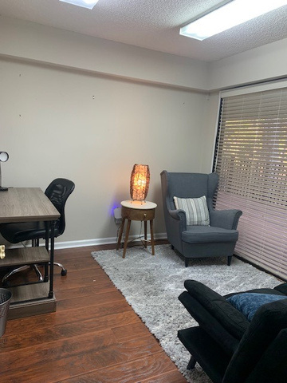  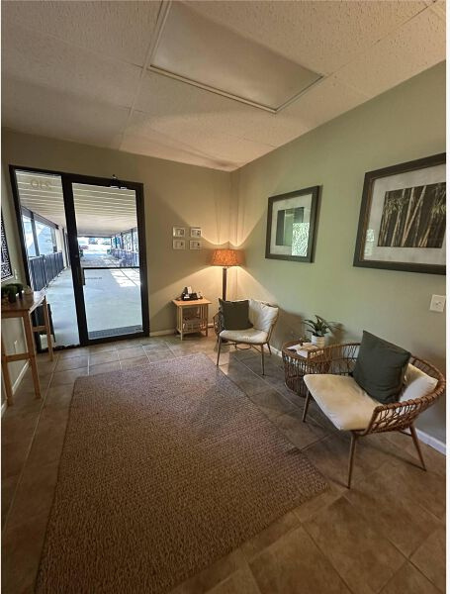 | 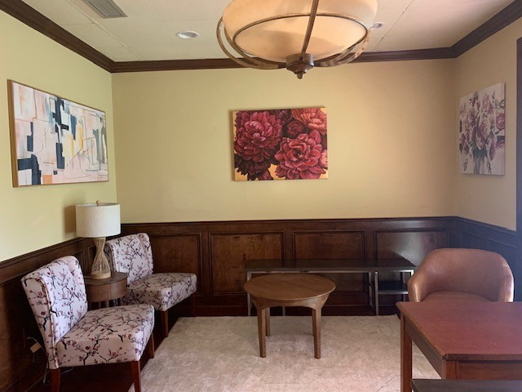  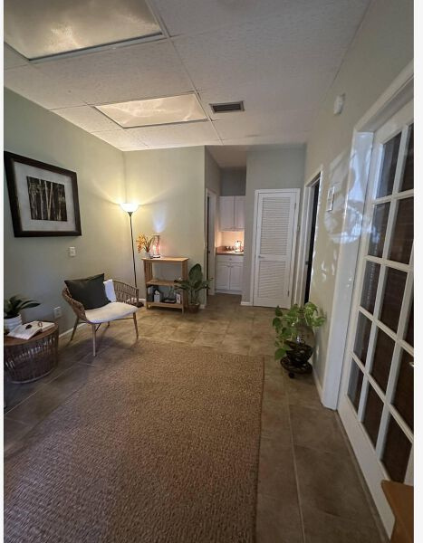 | 

