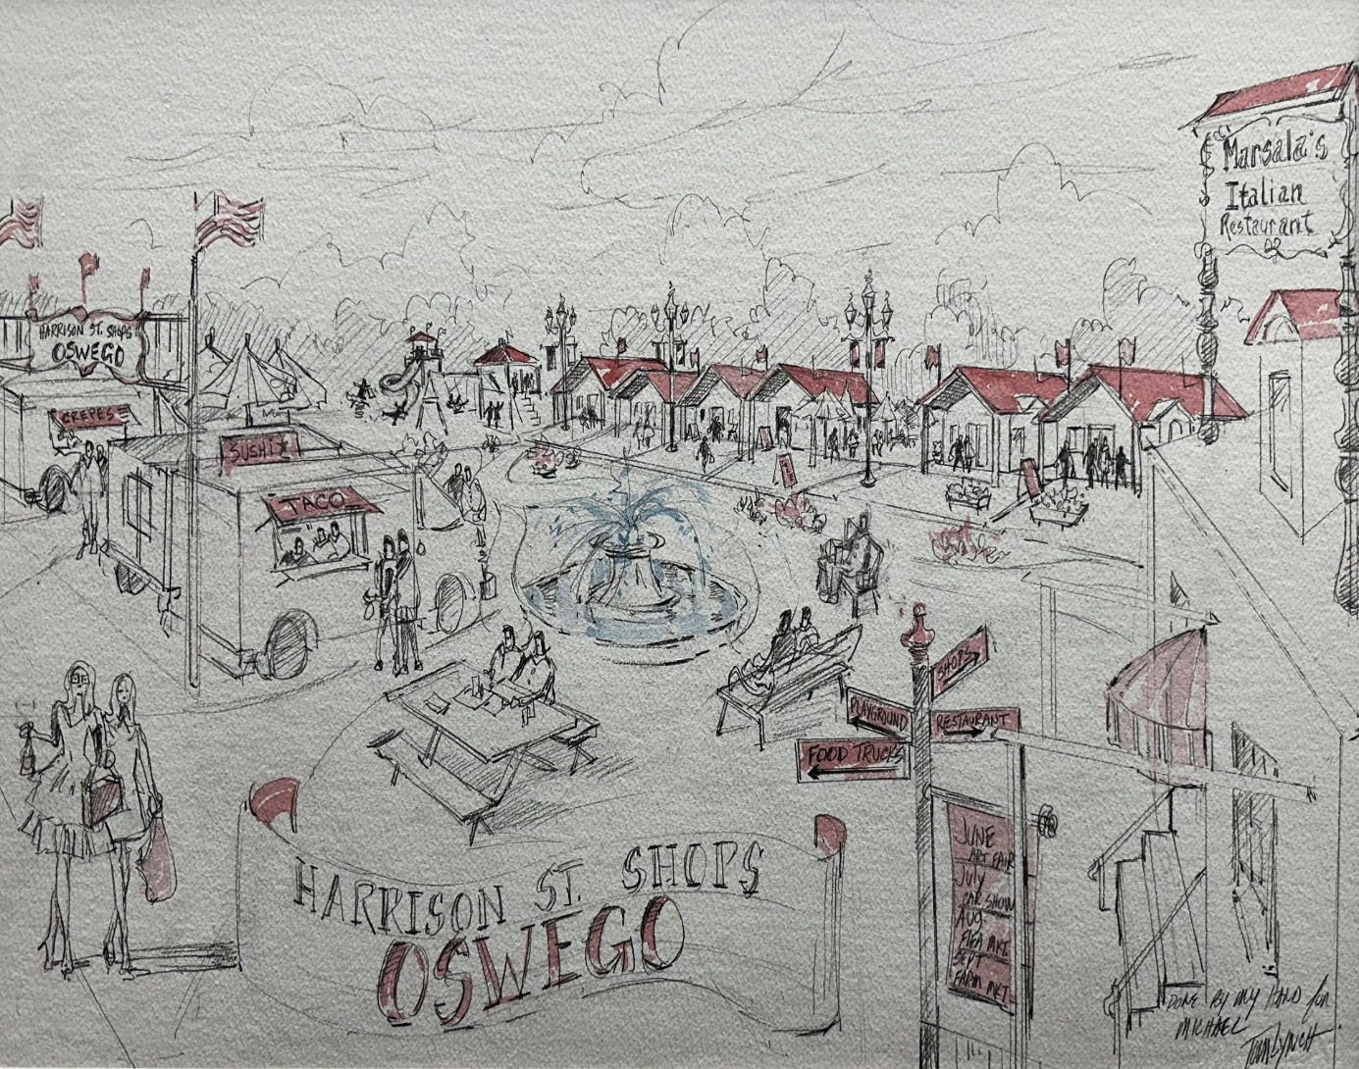
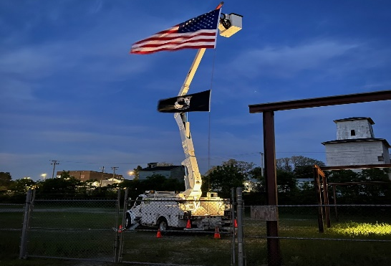

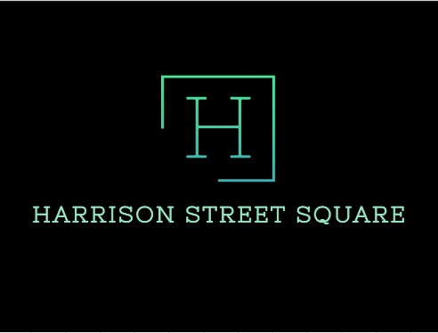
2025
Season
Harrison Street Station Shops

174 S Harrison Street Oswego IL 60543 833 USCS NOW www.harrisonstreetsquare.com
Applications for the 2025 season will be accepted no later than Dec 15, 2024

RENTAL INFO & STATION HOURS:
Each 12 x 14 Station Shop will be leased from May 1 through December 31. Supplied with heating and cooling, lighting and power.
Rent for each shop is $3600 plus a $500 security deposit for the 2025 season.
Hours: May 1– December 31 (Tentatively)
Friday: 9 am to 5 pm
Saturday: 9 am to 5 pm
Sunday: Noon to 4 pm

***Please note the dates and times below are the operators’ minimum requirements. Vendors are encouraged to stay open longer than the times listed. Monday through Thursday hours are optional.

Harrison Street Station shops offer business start-ups an advantage to start selling products and services of interest to guests of Harrison Street Square (HSQ). Merchants operating shops will be additionally connected to consumers from yearly Oswego Farmers’ Markets, Wine on the Fox, Holiday Walks, and all other events held downtown. HSQ also presents a unique opportunity and advantage to sellers by its spacious surrounding outdoor retail center with food court and close parking. Only (8) 12×14 shops will be available, and we expect a considerable number of applicants for the 2025 season.
All Harrison Street Station Merchants are required throughout the Leasing Season to Carry a Business EIN, Pay Local Oswego & State of Illinois Tax and Carry Current Business Liability Insurance on Space and Products (contents). If your business type requires licensing, proof of that will be needed also.
www.harrisonstreetstations.com

