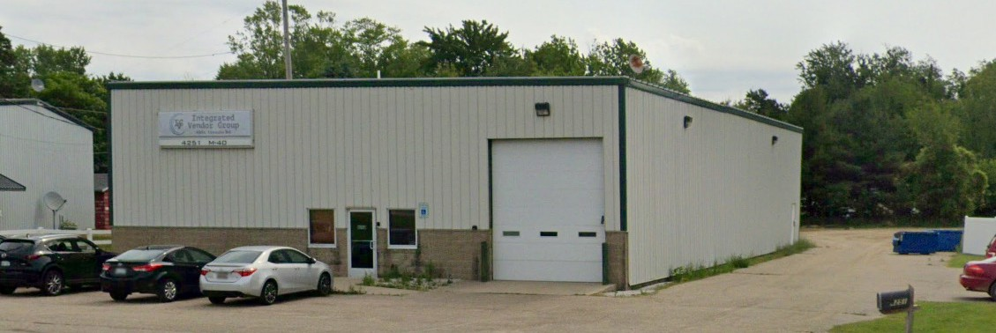

Summary
6,000 SF free standing industrial building directly off M-40. Fillmore Township Taxes.

Contact Info
Matt Lepard
43 E 8th Street
Holland, MI 49423
matt@lepcoholdings.com

Property Information

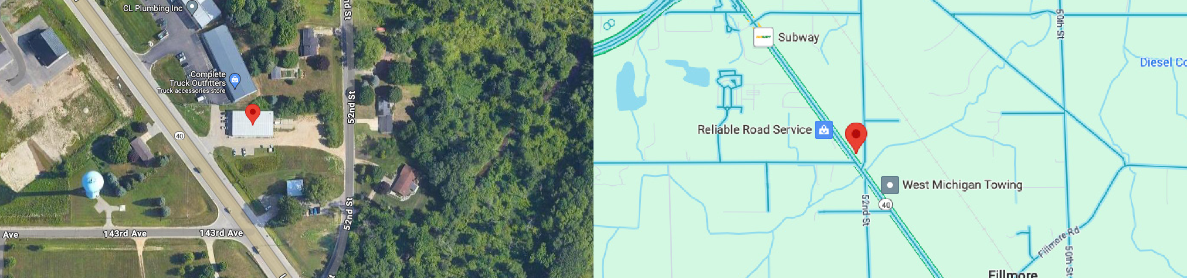
Rent Per SF
Property Type
Property Subtype Building Class Zoning
Ceiling Height Lot Size Parking
No. Stories Year Built Tenancy Loading Docks HVAC System Facilities
Connectivity Power
$7.5/SQ
Mixed Industrial Commercial
Warehouse
C
MIC
Avg. 20 feet
1.54 Acres
11 - Paved Surface
1; Structural Mezzanine Over Office (~1200sq ft)
2002
1
One loading dock with two 12x16 ft drive through garage doors Office: Forced Air; Warehouse: Heat Only
Kitchen/dining area, two enclosed conference rooms/offices and open area office Fiber Optic
240v 3 Phase; 200 AMP Service

