
747 Broadway, Brooklyn
Prime Retail Location
Exposure on 3 Corners- Adjacent to Train
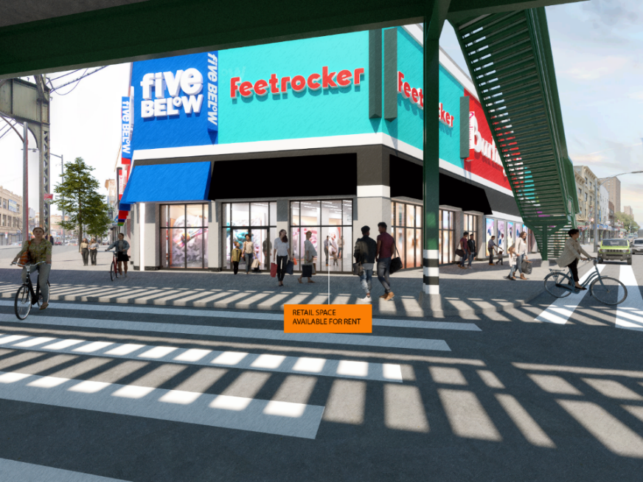
3,300 SF Available at the Corner Intersection of Broadway- Flushing- Graham
Adjacent to Both Burlington and Five Below
CAN DIVIDE
Rent: Please Inquire
Corner Intersection of Broadway- Flushing- Graham
Tremendous Opportunity for National Tenant
Contact Person:
Joseph Betesh
718-265-1200
Joey@abecomanagement.com

