F o r S a l e
2.27 Acres
Corner Hwy 59 & Starfish Lane

Price: $750,000 $7.58 / SF

Site: 2.27 Acres 98,881.2 SF

Dimensions: 267’ front Hwy 59 x 399’ Starfish Lane

Assessment #: 50658

Zoning: GC-2 Public, Cultural, Recreational District

Utilities: Electricity to site. No Sewer or Water on site

Comments: Excellent visibility and access.

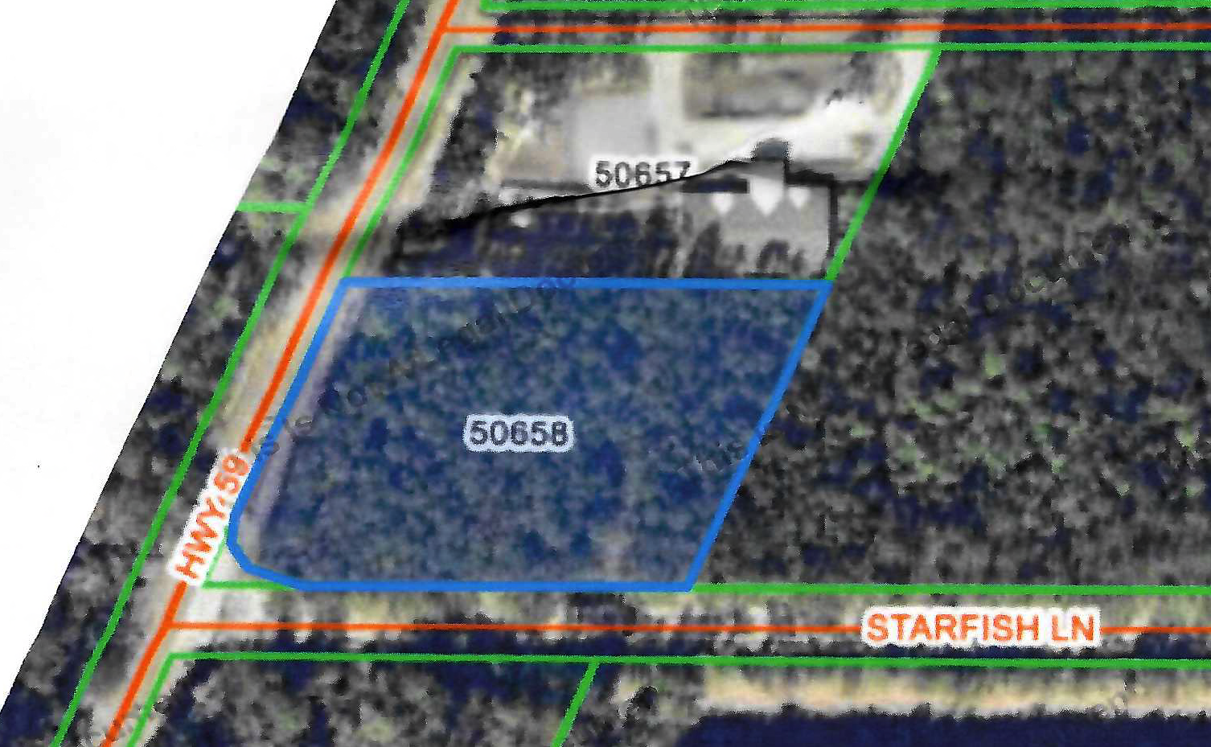



228 Old Landing Road
Covington, LA 70433
dsderbes@gmail.com
Off: 985-892-8980
Fax: 985-892-7332
Cell: 985-264-2990

The information provided is deemed reliable, but not verified or Guaranteed 5-18-26 MLS 2548938
File: flyer 2.27 Hwy 59 Golden

