Development Opportunity

1011-1061 W Summit Parkway, Spokane, WA
Two lots for sale at Kendall Yards comprised of a total of 2.05 acres.
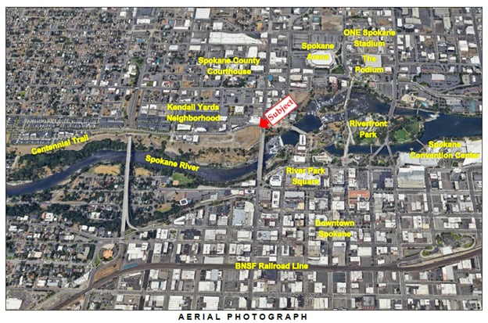

Property Description
This unique development opportunity is located along the north ridge of the Spokane River gorge in the highly sought-after Kendall Yards neighborhood, just steps from the scenic Spokane River and Centennial Trail. With Riverfront Park situated directly to the east, the site offers immediate access to some of Spokane’s most cherished recreational spaces boasting spectacular views of the Spokane River, downtown Spokane and sweeping territorial views.
Comprising two parcels with a Community Business (CB) zoning designation, this property is ideally suited for a range of uses, including commercial, hotel, and multi-family residential developments.
Kendall Yards is a vibrant community featuring a mix of single- and multi-family residences, medical office buildings and a dynamic commercial district. The property’s proximity to downtown Spokane places employment opportunities, recreational amenities, and shopping within easy walking distance, enhancing its appeal for future residents and businesses alike.
The neighborhood is well-served by multiple arterial roads, including a robust transportation network that ensures convenient access to and from the property for residents, employees, and visit
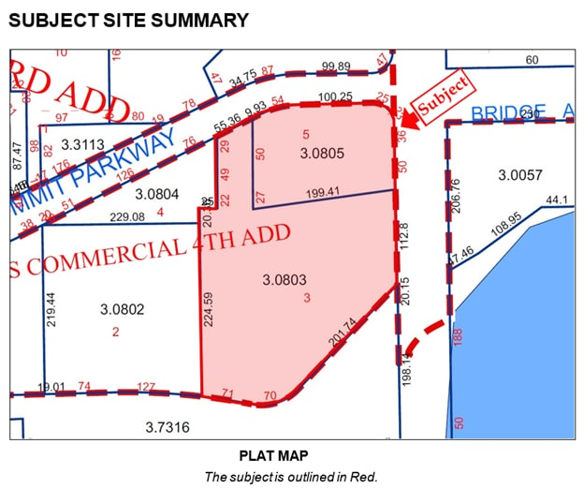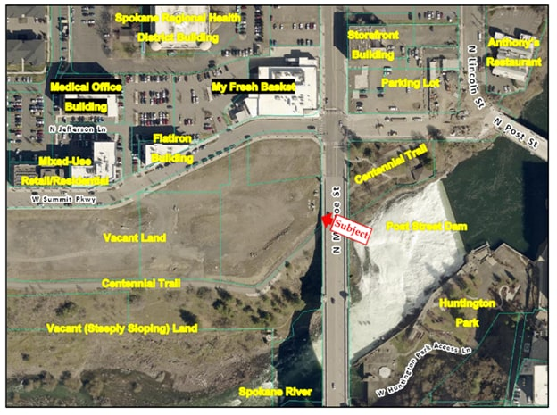
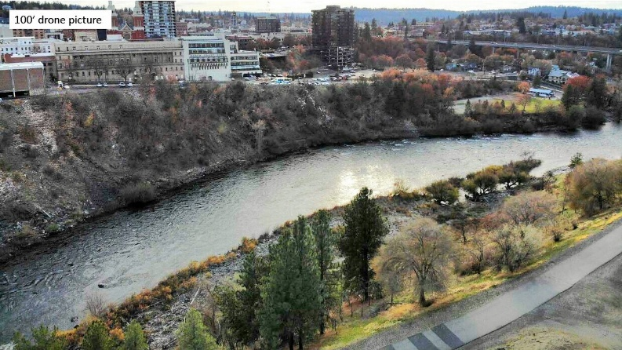

Due Diligence:
Premera can provide the prospective buyer with a complete package of site due diligence and development materials, including the following:
- Geotechnical report
- Cosky tank restrictions and approach
- Foundation approach
- Rapid impact compaction test results
- Topographic survey (TOPO)
- Existing site conditions documentation
- Commercial stormwater area report
- Details on Monroe Bridge foundations
- Construction approach for the 72-inch main sewer
- Fire access approach
- Sewer elevations for tie-in
- Department of Ecology No Further Action (DOE NFA) determination
- Utility access and availability
- Kendall Yards Covenants, Conditions, and Restrictions (CC&R’s)
For additional information on this property, please contact:

Jon Parkin

Premera Blue Cross

jon.parkin@premera.com

(425) 918-3467 (o) | (425) 361-6750 (m)

