FOR SALE
$100,000

THE FARLOW HOUSE, LOCATED AT 412 N. WILMINGTON STREET, IS BEING OFFERED "FOR SALE" BY THE

STATE OF NORTH CAROLINA
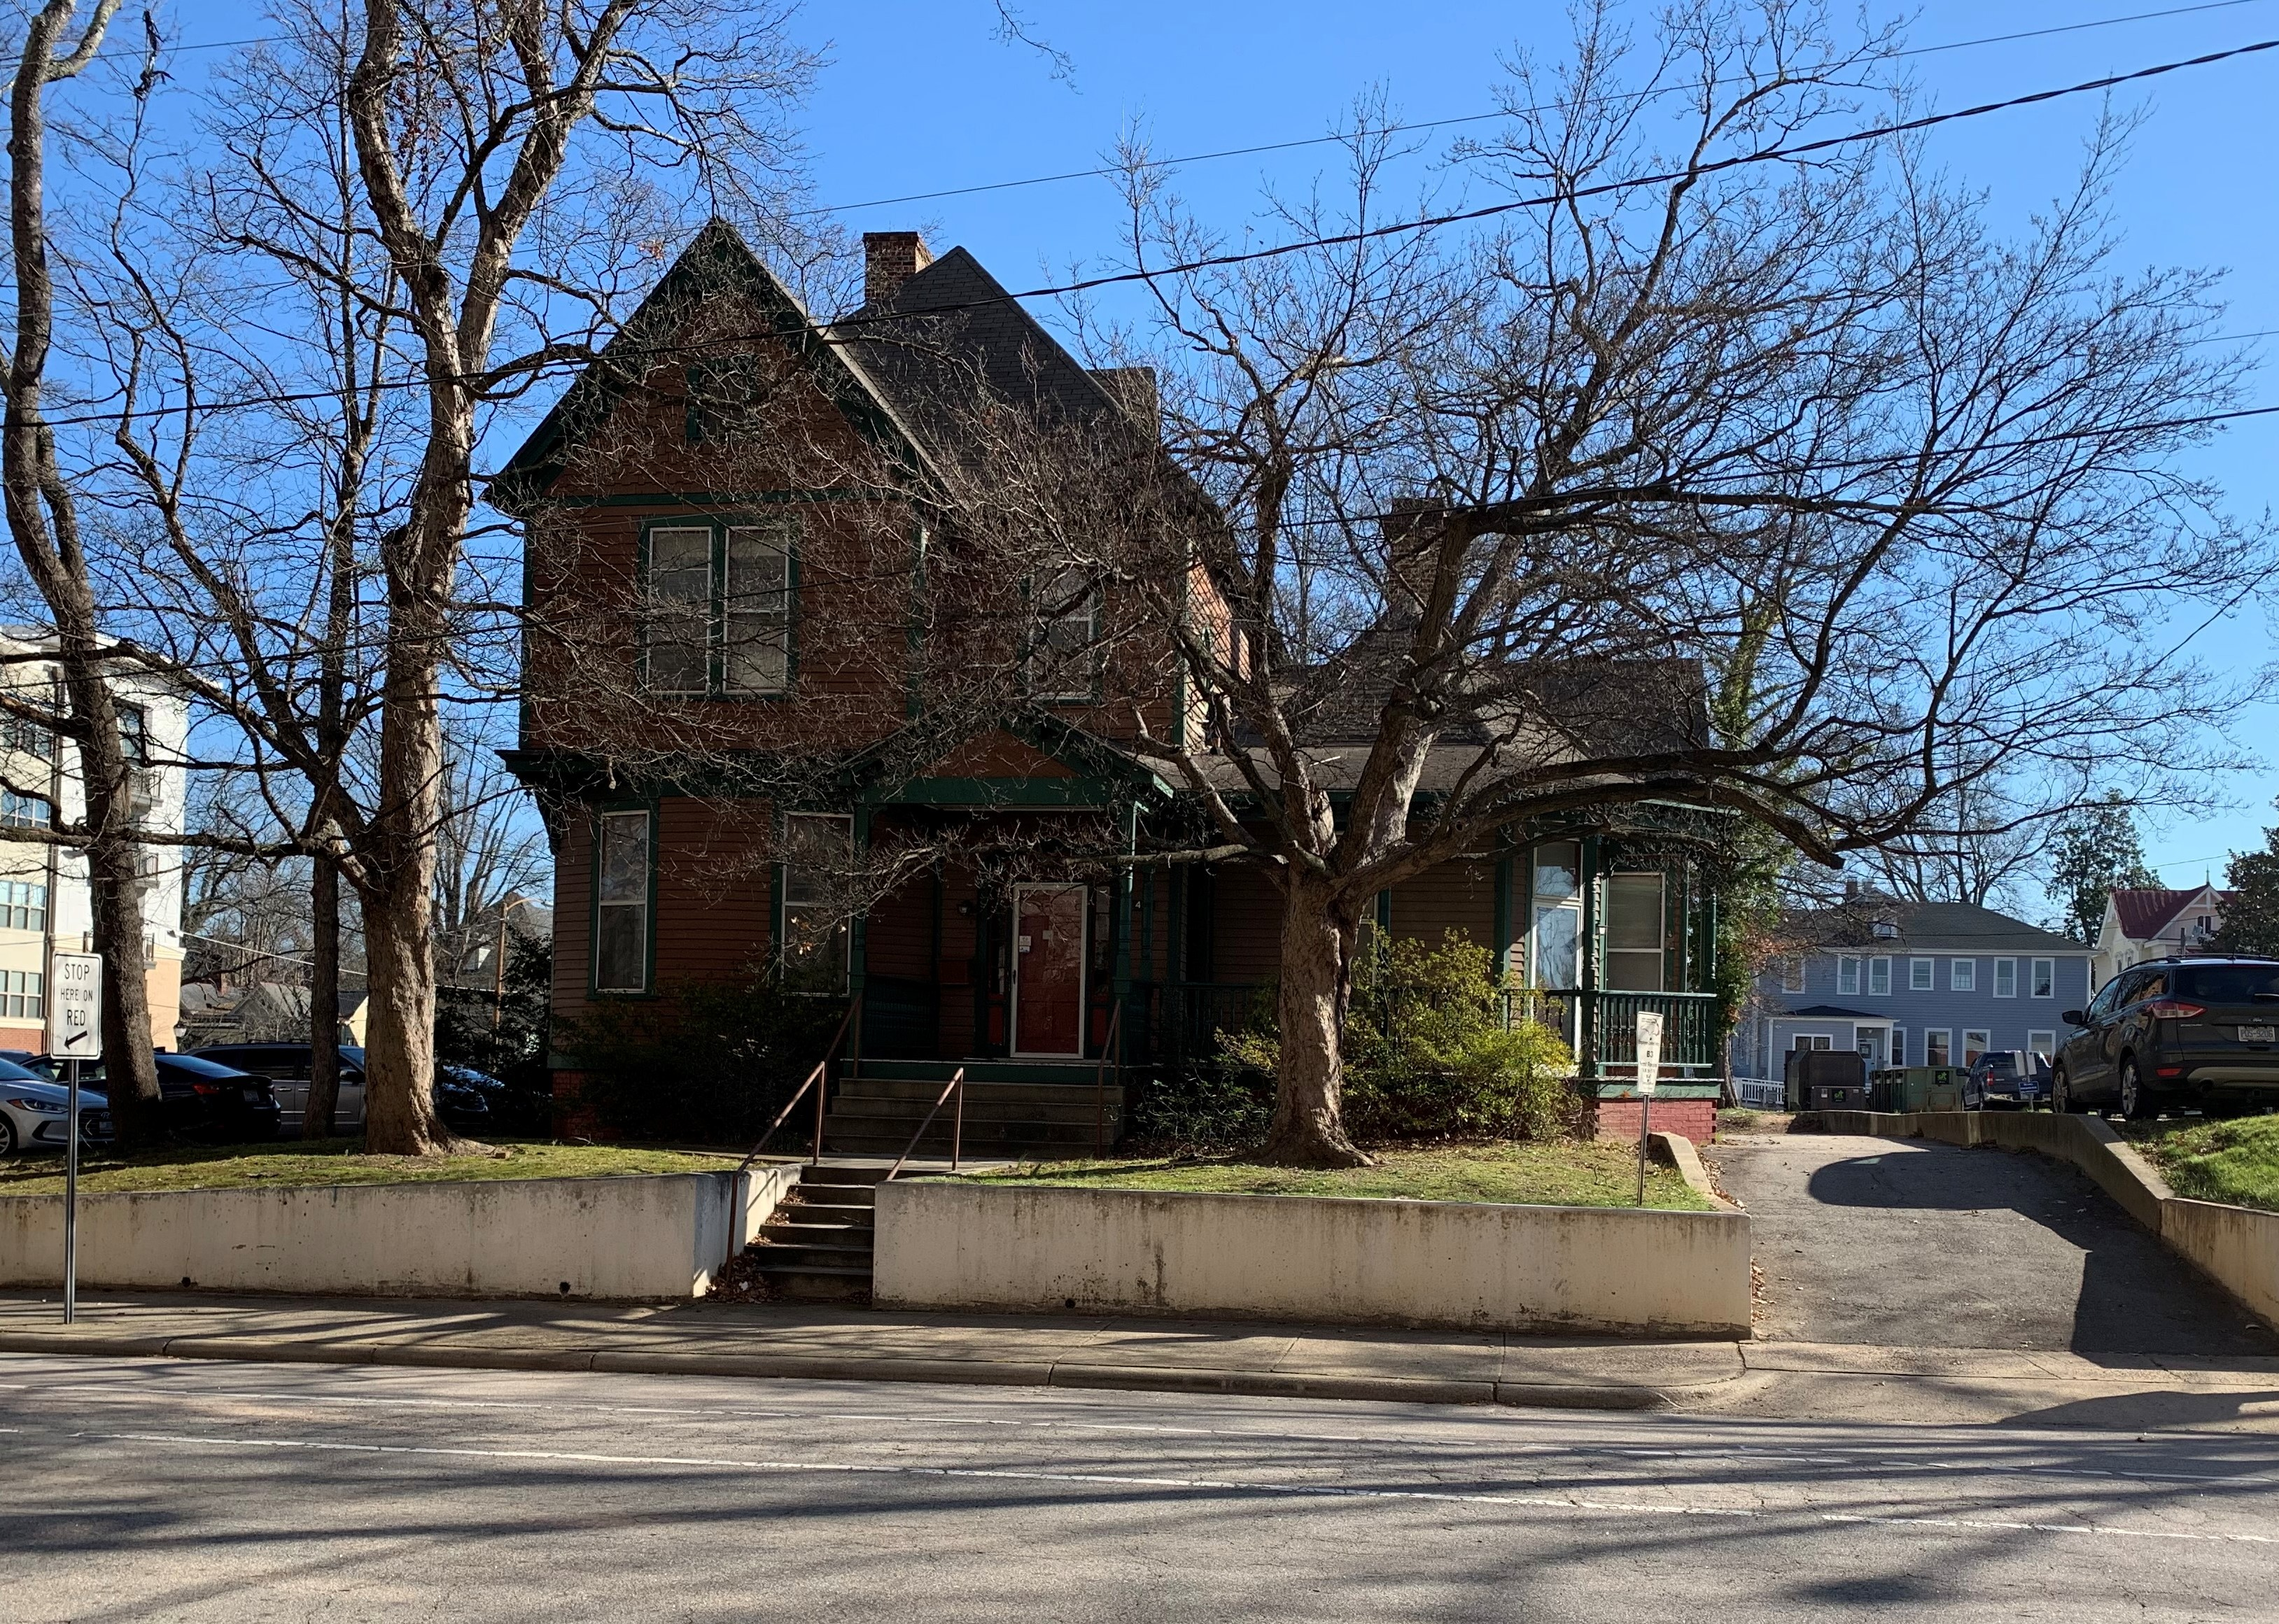

The Farlow House (House only ) will need to be moved from its present site. Buyer will be responsible for all expenses related to relocation of the house. For more information contact: Dannielle Sampson, State Property Office, at Dannielle.Sampson@doa.nc.gov or visit our website at https://ncadmin.nc.gov/about-doa/divisions/state-property-office . Please see Sale Procedure and Offer to Purchase Form below.

SALE PROCEDURE

- The house will be advertised for sale immediately and continue until such time a suitable offer to purchase has been accepted by the State Property Office. Offers may be emailed to Dannielle Sampson at Dannielle.Sampson@doa.nc.gov or delivered to the State Property Office, 325 N. Salisbury Street, 6th Floor, Raleigh, North Carolina, 27603. A deposit in certified funds for no less than one percent (1%) of the offer amount made payable to the State of North Carolina shall accompany all offers.

- The State Property Office reserves the right to reject or negotiate any and all offers and, in its sole discretion, will determine the successful offeror.

- Title to the house will be conveyed by Deed of Structure (Bill of Sale). Prospective purchasers are encouraged and shall be responsible for making all independent inquiries and confirming the accuracy of the information contained herein. Any and all prospective purchasers are advised to make an independent investigation of these matters, and any responsibilities or liabilities arising out of or relating to such matters are expressly disclaimed by the State of North Carolina. The State of North Carolina is not responsible for any cost incurred by prospective purchaser. The house will be sold “as is, where is, with all faults”.

- The property will be sold for cash upon delivery of the deed. Once the successful offeror has been determined and accepted, the one percent (1%) certified funds deposit will be applied to the purchase price. If the purchaser subsequently fails, refuses, or is unable to close the transaction for any reason, the State of North Carolina will retain the deposit.

- The State Property Office shall be entitled to retain and use without compensation to any party, individual or entity any information submitted, including but not limited to any concept, element or idea (including financial or ownership structures or schemes) disclosed in or evident from an offer. All information submitted in response to this offer shall become the property of the State of North Carolina.

- The State Property Office reserves the right at its sole and absolute discretion and without liability to modify, amend or otherwise change, or to extend, suspend, postpone, cancel, any part of this offering.

- The State of North Carolina and their respective officers, employees, consultants and agents, shall not under any circumstances, including pursuant to contract, tort, statutory duty, law, equity or otherwise, or any actual or implied duty of fairness, be responsible or liable for any costs, expenses, loss of opportunities, claims, losses, damages or any other liabilities to anyone arising out of or related to this offering. By submitting an offer to purchase, prospective purchaser(s) has accepted and agreed to the foregoing.

- All offers must be submitted on the attached “Offer to Purchase Form”. Once an acceptable offer has been agreed to and accepted by the State Property Office, a Purchase Agreement will be executed by the State Property Office and offeror.

OFFER TO PUCHASE FORM

Farlow House at 412 N. Wilmington Street

I, , hereby submit an offer to offer to purchase in the amount of $_________________(U.S. Dollars) on the Farlow House located in Raleigh, Wake County, North Carolina and further identified as: Farlow House- 412 North Wilmington Street, Raleigh, Wake County, North Carolina. I fully understand in the making of this offer to purchase, that in order to be considered, offer shall be received in the State Property Office by email address to: Dannielle.Sampson@doa.nc.gov
or
Hand Delivery Address:
State Property Office
325 N. Salisbury, 6th Floor
Raleigh, North Carolina 27603

Attached are my Certified Funds in the amount of $ ,made payable to “State of North Carolina”, which represents a deposit of not less than one percent (1%) of this offer.

If my offer is accepted and I fail, refuse, or are unable to close the transaction at the time of delivery of the deed, my deposit will be retained. It is further understood that the balance of the amount offered will be due upon delivery of the duly executed deed. All offers are subject to acceptance or rejection for any reason at the discretion of the Director, State Property Office. Title to the house will be conveyed by Deed of Structure (Bill of Sale). The property will be conveyed "as is, where is, with all faults".

Signature: (SEAL)
Printed Name:
Title:
Address:
________________________

Phone Number:

