

Gas station, car wash & retail building

210 Keller ave s, Amery, WI

217 HARRIMAN AVE S, AMERY WI

Being Offered at $1,300,000.00

Degraw commercial group Tammy DeGraw 715-939-2306

tammy@degrawcommercial.com

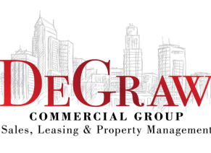



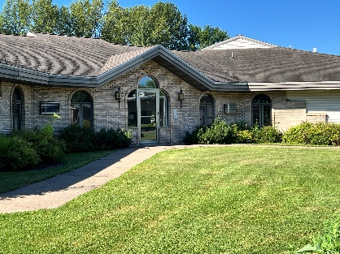

Prime Investment Opportunity – Gas Station, Car Wash & Retail Building | Amery, WI

Outstanding opportunity to acquire a profitable, multi-use commercial property in a prime, high-visibility location along one of Amery’s busiest traffic corridors. This offering presents an excellent investment with established income and future upside.

The sale includes a profitable gas station and car wash, with all associated business assets included, providing a turnkey opportunity for the next owner.

Also included is the retail building, currently occupied by Save A Lot. The Save A Lot business is not included in the sale—only the real estate. The retail building is also available for lease, offering flexibility for investors or owner-users.

Property Features

• Prime location on a high-traffic commercial corridor

• Established, profitable gas station

• Profitable car wash

• Business assets for the gas station and car wash included

• Retail building included in the sale

• Save A Lot business not included

• Retail space available for lease or purchase

• Excellent visibility, easy access, and ample parking

• Multiple income streams with value-add potential

• Strong regional trade area serving Amery and surrounding communities

This is a rare opportunity to purchase a well-established commercial investment with proven profitability and exceptional visibility in a growing Western Wisconsin market.

Contact the listing broker for financial information, sale and/or lease details, and a property tour.

