Prime Middleton Route 114 Commercial Opportunity | ±25,000 Vehicles Per Day | Drive-Thru | Affluent North Shore Demographics

>>>>>>Offered in its entirety 4,000 sq ft or 2,386 sq ft or 1725 sq <<<<<<

***************Real Estate Also Offered For Sale****************

Property Overview
- Address: 323 North Main Street, Middleton, MA 01949
- Location: Route 114 with excellent visibility and strong daily traffic counts.
- Building Size: Approximately 1,754–4,140 SF available.
- Former Use: Fast-food restaurant with drive through.
- Parking: Surface parking ratio of approximately 3.1 spaces per 1,000 SF.

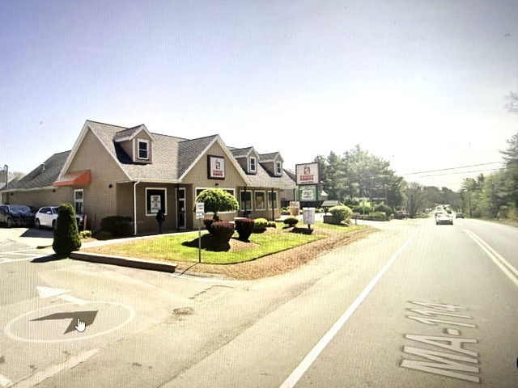

Five-Mile Radius Demographics
A 5-mile radius around the site includes portions of:
- Middleton
- Danvers
- Peabody
- Topsfield
- Boxford
- North Reading
Population
74,632 people
Households
27,462 households
Median Household Income
$148,279
High-Income Households
33.5% earn over $200,000 annually
Seniors
16,844 residents age 65+

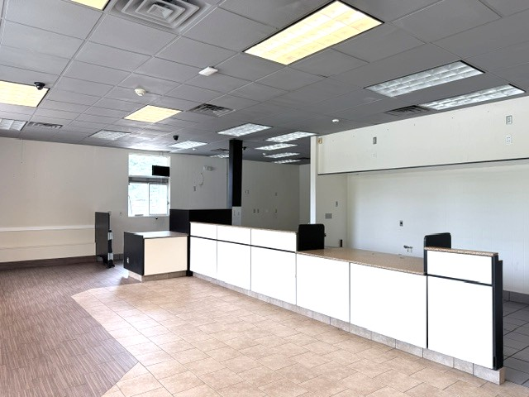

PROPERTY HIGHLIGHTS
📍 323 North Main Street, Middleton, MA

Prime Route 114 Location
- With the significant number of surrounding rooftops, apartments, and condominium developments, the opportunities for takeout and prepared food sales are exceptional. This strong residential density should provide a substantial and growing customer base, allowing the business to experience significant growth and increased revenue.
- Excellent visibility
- Strong traffic exposure
- Existing restaurant infrastructure
- Drive-thru capability
- Ample on-site parking
- Convenient access to I-95 and Route 1
- Affluent North Shore trade area
- Limited competing inventory
The property benefits from high daily traffic counts and excellent visibility along Route 114.

TRAFFIC EXPOSURE
Route 114 is one of the busiest east-west corridors in Essex County and is a major connector between I-95, Route 1, North Andover, Middleton, Danvers and Peabody. Traffic congestion along the corridor is consistently one of the town's biggest concerns, demonstrating the significant traffic volume and visibility enjoyed by businesses located here.
This property has been a retail fast food location for the past 40+ years. Dunkin Donuts had the opportunity to purchase land about a half a mile away and did so about 3 years ago. Since then, it was a combination of breakfast lunch, and a convenient store.
You could lease the entire property at an asking price of $6,000 modified NNN. Or best acceptable offer. Or you could lease the drive thru side of about 2,386 sq ft only, at a scaled price.
Installed within the past 2 years are the HV/AC units. Drive through is operational and permitted, there is a walk-in combo refrigeration / freezer, hoods, and additional equipment in the unit if a new tenant wants make use of them.
A grease trap is also in place.
There are literally thousands of new condos and apartments that have been built in the past year.
Exclusive Listing Agent
Frank A. Pasciuto
Pasciuto & Associates Commercial Realtors
781-883-0707 email frank@pasciutoandassociates.com
"Old-School Grit. North Shore Know-How. Deals Done Right."



