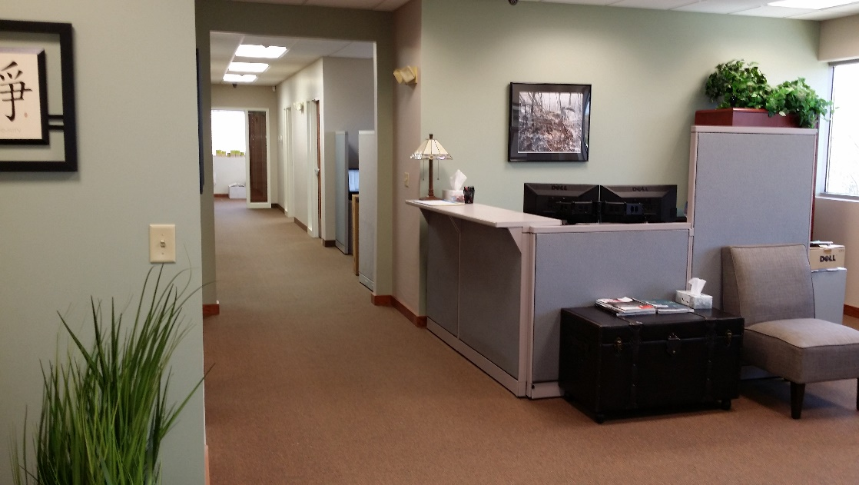

Class A Office Suite / Shared Space for Lease
Beautifully Decorated - Great for a Small Business
Located in Highland Corporate Park (in Corporate Park with CVS Corporate)
Easy Access to Route 146, Interstate 295 & Interstate 95
1300 Highland Corporate Drive
Cumberland, RI 02864
4 Private Offices plus Reception area available.
Includes Kitchen/Breakroom and Conference Room.
Common Area Restrooms (no additional cost or maintenance)
Also included in Rent: Security, Utilities, Janitorial Service, Trash Pickup, High Speed Internet Service, Color Copier/Printer/Scan/Fax, 24/7 Access, Elevator Access and Central Air.
Available Now

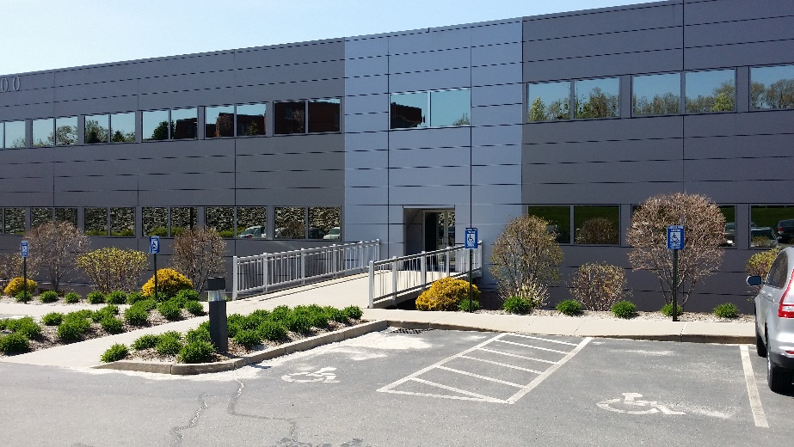
Contact: shenley@ectne.com for more information or appointment.

