1 WALKER AVE
Downtown Clarendon Hills Restaurant Opportunity
A rare opportunity to lease a fully built-out, updated restaurant space in the heart of Downtown Clarendon Hills. Positioned within one of Chicagoland’s most affluent suburban downtowns, this offering combines an existing restaurant buildout, walkable location, aggressive Village TIF support, and a strong surrounding dining demographic.
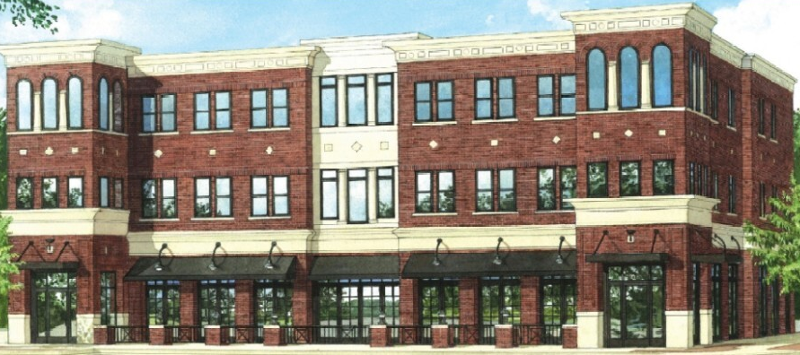
Property Highlights
Space Approx. 5,381 SF + Basement for events or 2nd concept + Expanded Outdoor Dining
Lease Rate $33/SF NNN | Property Taxes $3.07/SF | CAM $2.51/SF
Infrastructure Fully equipped restaurant w/ 2 kitchens, walk-in coolers, hoods, bar, electrical, sprinklers, elevator service, office
Aggressive Village TIF Support
The property is located within the Village’s Downtown TIF District, where Clarendon Hills has demonstrated an aggressive proactive approach toward attracting high-quality restaurants. Recent projects have included Village incentive packages exceeding $600K, structured as true public-private partnerships focused on tax-generating hospitality uses.
Market & Demographics
Clarendon Hills/Hinsdale represent one of the strongest dining demographics in the suburbs, featuring affluent households, strong discretionary spending, and a customer base that actively supports upscale dining concepts and experience-driven hospitality.


