

501 Glenwood, Pontiac, MI
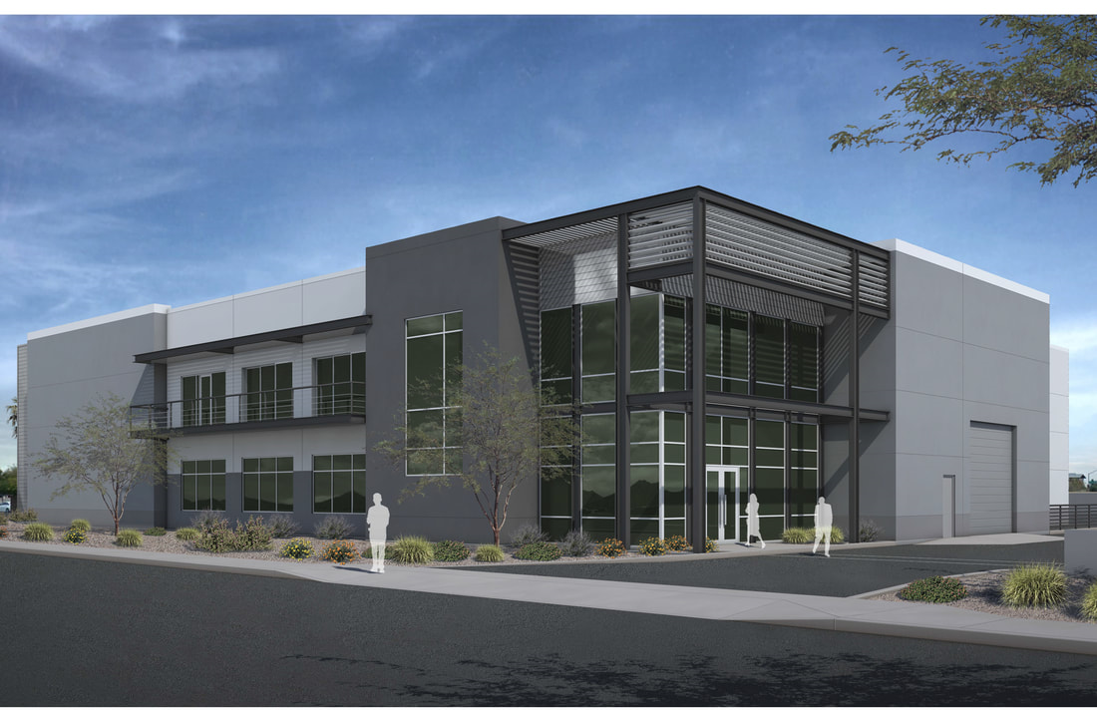
Property Information
- Build-to-Suit

- From 55,000 – 70,000 +/- Square Feet of Total Space
- For Sale or Lease
- 8-12 Dock Doors
- Ample Power available
- M4 zoning, Multiple uses
- Additional land possible
- Bordered by USPS Distribution Facility and GM Engineering

For Further Information, Please contact:

Paul Reschke
Spartan Real Estate Group
preschke@spartanreg.com
248-515-8225

