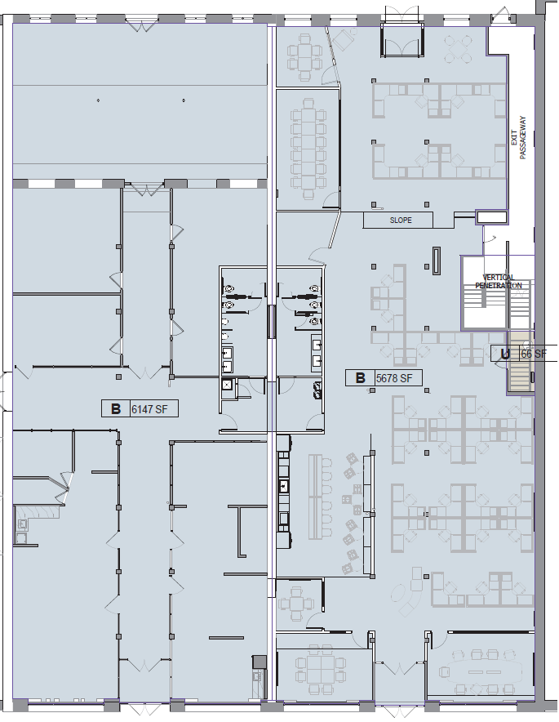
706 N. 1st Street
702 N. 1st Street
OCCUPIED
Leased
But Could Be
Made Available
1,470 USF
Total Available
6,147 SF
3,000 USF
1,050 USF

900 USF

