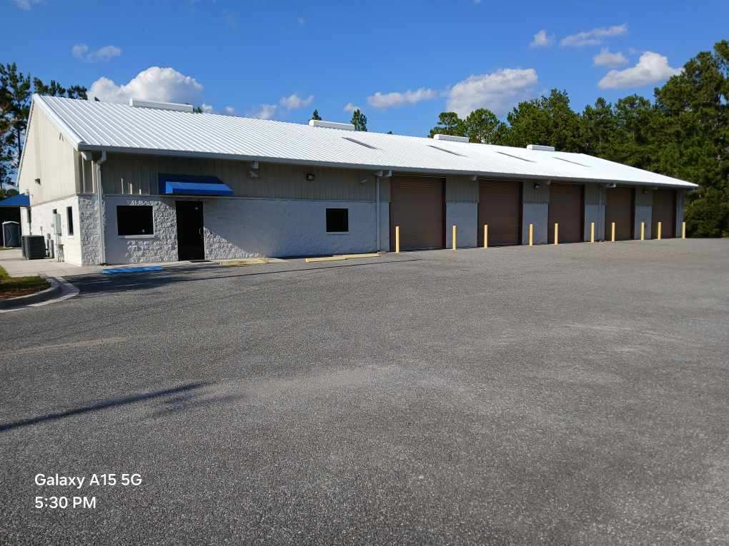

1509 SW CENTURY GLEN

Industrial Warehouse for Lease
LAKE CITY, FLORIDA

A Premier Industrial Opportunity in Columbia County
- For Lease 8400sqft or Divisible
- Industrial Warehouse (IW) Zoning
- Clear-Span Flexibility
- Prominent Location with High Visibility
This exceptional industrial facility is perfectly positioned for manufacturing, distribution, or storage in the thriving Lake City market. Works well for a service center, RV or Boat Repair, outdoor/indoor storage, and building supplies Its robust construction and functional design provide an ideal environment for business growth.
- Zoning: Industrial Warehouse (IW) - 8400sqft Ideal for a wide range of uses.
- Construction: Durable concrete block and steel construction.
- Clear Span Layout: Unobstructed interior allows for maximum flexibility in equipment placement and workflow optimization.
- High Ceiling Heights: Accommodates vertical storage (22ft) and large equipment with ease.
- Significant Office Space: A substantial, finished office area provides ample room for administrative and management staff.
- Prominent Location: Excellent access to I-75 and US-90 for superior regional connectivity.

Warehouse & Manufacturing Area
- Clear-Span Design: No interior columns to disrupt layout or workflow.
- High Ceilings: Provides ample vertical space for racking systems and large-scale operations.
- Durable Flooring: Industrial-grade concrete slab suitable for heavy loads.
- Ample Loading: Easy access for shipping and receiving.
- Remote Contral Bay Doors
- 10 Tandem Bay Doors

Office & Administrative Space
- Spacious Layout: A large, dedicated office area separate from the warehouse.
- Finished Interior: Professional environment for your team and clients.
- Flexible Configuration: Can be adapted for multiple private offices, an open-plan workspace, or a combination.

Lease Terms & Financials
This is a Triple Net (NNN) Lease opportunity.
Item | Rate
Base Lease Rate | $11.85 / Sq Ft / Year
Estimated NNN | $2.65 / Sq Ft / Year
Total Estimated Rate | $14.50 / Sq Ft / Year
Lease Term: 3-5 Years (Negotiable)
What is a Triple Net (NNN) Lease?
The tenant is responsible for their pro-rata share of the property's three "nets":
- Property Taxes
- Building Insurance
- Common Area Maintenance (CAM)
Strategically located with immediate access to major transportation corridors, placing your business within reach of North Florida and Southern Georgia markets.
- Minutes from I-75 Interchange
- Easy Access to US Highways 90 & 41
- Within a major commercial and industrial corridor
Curtis Carter
REMAX Commercial/REMAX Specialists
Commercial Real Estate Agent
[904-386-4651] corelabpro@yahoo.com
cuhttps://www.crexi.com/profile/curtis-carter-curtiscarrtiscarter@remax.net

Brochure Disclaimer: All information deemed reliable but not guaranteed. Dimensions, square footage, and financials are approximate and subject to verification by all parties.

