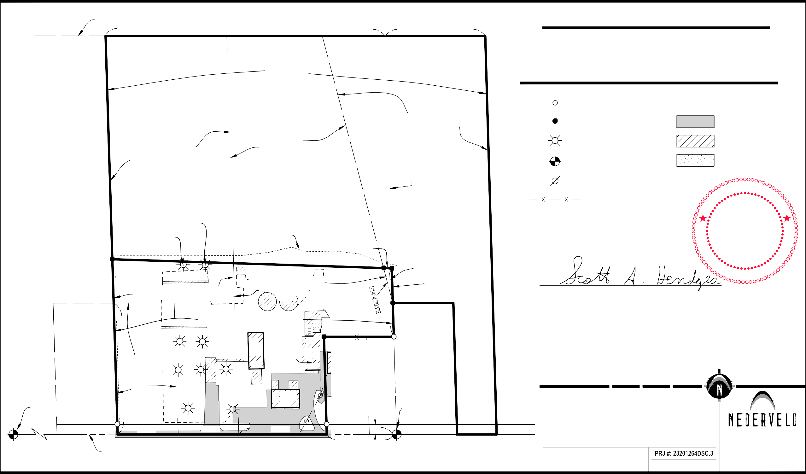
N LINE, SE 1/4, SW 1/4, SEC 29

400.00'

N89°59'43"E

923.35'
315.35'

NEW

208.00'

N89°59'28"E 330.41'

PARTIAL DESCRIPTION
Part of the Southwest 1/4 and part of the Southeast 1/4 of Section 29, Town 4 North, Range 15 West, Fillmore Township, Allegan County, Michigan

LEGEND

REMAINDER
738.87'
N01°43'27"W
6.84 ACRES

03-06-029-003-40

LIGHT POLE 8.2' SOUTH OF PROPERTY LINE
LIGHT POLE 10.6' SOUTH OF PROPERTY LINE
400.60'

OVERALL 1

TO BE DEEDED 3
751.92'
N01°43'27"W
7.05 ACRES

03-06-029-003-60

S. EDGE OF CORN FIELD
495.60'

REMAINDER
923.50'

REMAINDER 2.1
10.08 ACRES
793.99'
S14°47'03"E
N.-S. 1/4 LINE, SEC. 29

03-06-029-003-70

TO BE DEEDED 2.1
27.30'
S
E
O
I
N01°37'56"W
S

By:
O
S01°37'56"E
A
114.97'

Iron-Found Iron-Set Light Pole
Section Corner Utility Pole Fence
1318.89'

OH Overhead Utility Asphalt
Existing Building Concrete
M
I
C
E
O
F

Scott A
H
I
G
A
N
S
T
A
T
Hendges
C
I
L
R
O
License No. 4001047953
N88°08'20"W
F
R
P
D
E
S
N
E
Y
E
V
R
U
S
L
N

TO BE DEEDED
119.77
145.00'
226.55'
S01°37'56"E 111.58'
3.27 ACRES
N90°00'00"W
580.00'
1.1
4.94 ACRES

S89°59'30"W 200.00'
Scott A. Hendges Licensed Professional Surveyor No. 4001047953

This survey was made from the legal description shown above. The description should be compared with

200.00'
N01°43'27"W
435.00'

TO BE
NEW OVERALL 2
10.24 ACRES
N01°43'27"W
435.00'
N01°43'27"W 566.98'
BARN
120.5'
GRAVEL
BARN

GRAVEL
50.5'

27.5'

50.1'

N90°00'00"W 230.50'
-003-20
112.4'
112.4'
S01°37'56"E 323.42'

NED

-003-80
323.42'
the Abstract of Title or Title Policy for accuracy, easements and exceptions.

SURVEYOR'S CERTIFICATE:
435.00'
I certify that the requirements for 1970 PA 132, MCL 54.213 have been met. The relative positional precision of the corners identified for this survey and shown on the map are within the limits accepted by the practice of professional surveying.
N01°37'56"W

SW COR,
SECTION 29 T4N, R15W

NED
OH

DEEDED
4
2.00 ACRES
-003-50

200.00'

GRAVEL

N90°00'00"W
200.00'

BARN
92.2'
60.1'

290.73'

690.73'

NED
521.23'
230.50'
-003-10

S 1/4 COR, SECTION 29 T4N, R15W
OH
OH

200.00'
33'

S89°59'30"W

SCALE: 1" = 200' 0' 100' 200'

Ortman Commercial Real Estate, LLC Robert Ortman
682 State Street
Holland, MI 49423
138th Avenue

NORTH

www.nederveld.com • 800.222.1868
Holland
347 Hoover Blvd.

S LINE, SEC. 29
138th AVE.

130.41'
DRAWN BY: MJL DATE: 08.16.23
REV. BY: MJL REV. DATE: 10.30.23 REV.: REVISED PARCEL LABELS/ DESCS

1 OF 3
Holland, MI 49423
Ann Arbor, Chicago, Columbus, Grand Rapids, Indianapolis

23201264DSC.dwg
ML 11/2/2023 14:58
© 2023 Nederveld, Inc.

