Solares Hill Re-Development Opportunity
The Highest Address in Key West… The Rarest Opportunity in Old Town!
Perched atop Solares Hill - the highest point in Key West at 18 feet - and in the very heart of historic Old Town, is a rare 6-residential unit re-development opportunity. In most real estate markets, elevation is an amenity. In Key West, it is a strategic asset, a fundamental financial differentiator that separates this property from virtually everything else on the island.
The Key West market is supply-constrained, where land is scarce and entitlements are crucial, and this irreplaceable infill opportunity is already ahead of the curve. Critical groundwork has been laid, sophisticated architectural design work completed, and much of the renovation already accomplished, all by an experienced owner/developer - giving the next steward of the property a significant head start in completing the project.
The current owner has invested significant time and capital securing initial approvals and design work as well as initial renovations to 4 of the units, presenting a new buyer with a more streamlined path to final execution. In a market where entitlements are hard won and land is essentially unavailable, this head start represents measurable, tangible value.
The progress made to date, added to the value of the property’s high elevation, also a hard financial advantage given how low-lying properties are facing increasing carrying costs and potential long-term questions about insurability, represents a unique opportunity. Elevated properties represent a scarce and increasingly valued subset of the commercial market as the elevation gap between this property, and the rest of the island becomes more consequential, with meaningful lower flood insurance premiums, reduced lender scrutiny on flood exposure, stronger long-term financing terms, and lower borrowing costs for owners and for future residents.
In an island city that sits, on average, roughly two feet above the sea, 17-18 feet is everything and this unique investment opportunity awaits the buyer who will see the complete redevelopment to fruition.

Solares Hill History
At 18 feet above sea level, Solares Hill is the highest point in Key West. While several 17-feet measurements are located in the contiguous area, the actual 18-feet summit of the hill at 719 Whitmarsh Lane is only 2 doors away from the subject property. The hill is significant since the average elevation across the island of Key West is approximately two feet and coastal areas of the Gulf and Atlantic are subject to significant storm surge during hurricanes.
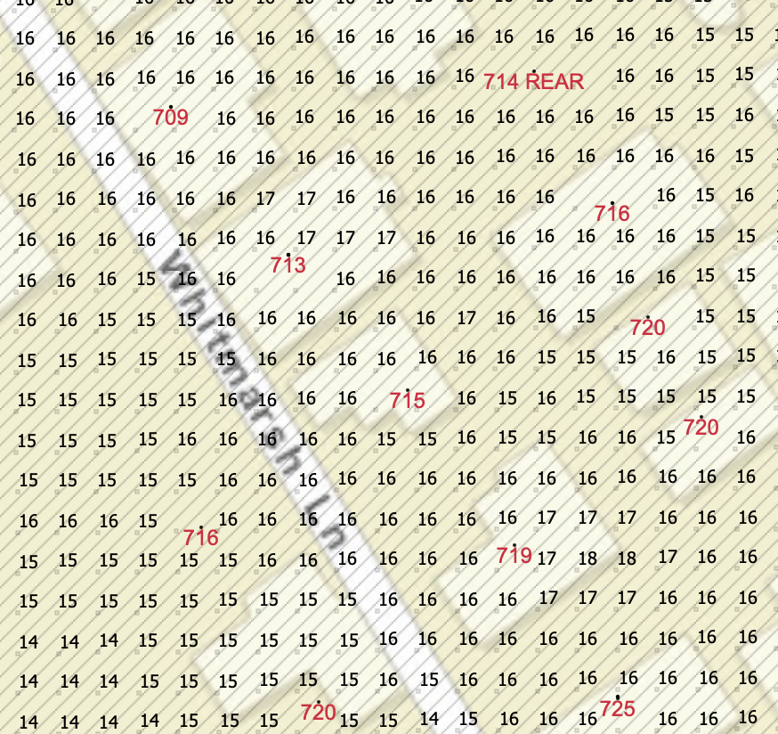
In the early 1800’s, Solares Hill was known simply as “The Woods” - a small timber forest standing at the outskirts of town. During the catastrophic Category 4 Havana Hurricane of 1846, with 7 foot waves crashing through the Historic District from the Gulf of Mexico to the Atlantic Ocean, many survivors crawled to Solares Hill and clung to trees to ride out the storm. It was literally Key West’s lifesaver for many.
After the storm, only 8 buildings in the city were habitable; the lighthouse had been washed out to sea drowning 14 people, the City Cemetery at Higgs Beach was unearth, and a salt pond running through the center of town was cut off from the harbor. In response, the city made a concerted effort to relocate damaged areas closer to Solares Hill’s high ground. The City Cemetery was relocated two blocks from the hill, and the lighthouse was reconstructed on high ground. The salt pond was filled in and became part of the land that downtown Key West is built on.
Solares Hill takes its name from Victorio Solares, an immigrant to Key West from Cuba, where he was in the Spanish military. Born in 1849 in Spain, Victorio married Mary Jane Lumley and became a grocer near the summit of the hill in the late 1800’s. Solares Hill Groceries was located at 648 William Street, on the corner of Angela Street, where a small grocery store still operates today.

