CUFF COMMERCIAL
REAL ESTATE
33 GREENE AVENUE, UNIT B
AMITYVILLE, NEW YORK 11701
516-383-1040
Cuff@optonline.net
________________________________________________________________________
PRESENTATION SHEET
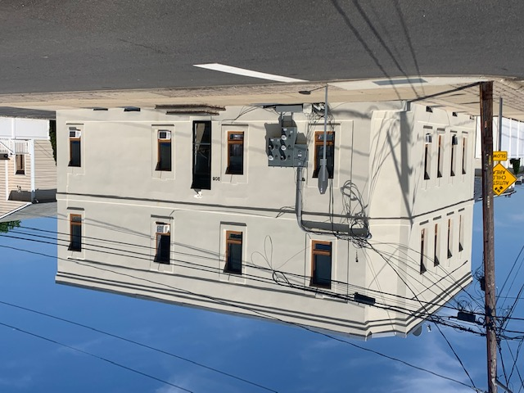
Location: 205 Vespucci Avenue, Copiague, NY

Description: Legal Four Family Consisting Of 2 Two Bedroom Apartments Rented
@ $2,300 & $2,300, And 2 Three Bedroom Apartments Rented @
$2,500 & $2,600. Tenants Pay For Both Heat And Electricity. The
Building Has Been Fully Renovated.

Total Annual Income: $116,400

Operating Expenses:
Taxes.................$18,116 Water.................$1,700
Heat............Tenants Pay Maintenance......$2,000
Electricity.........$ 300* Insurance..........$4,000
Miscellaneous...$ 2,000 *Common Area Only

Total Operating Expenses: $ 28,116

Net Income: $ 88,284

Purchase Price: $1,599,000

