MEMO

TO: HOSPITALITY OPERATORS INTERESTED in VENICE BEACH
FROM: MARK WURM
310.895.6275
info@planetvenice.com
DATE: 6-21-24

RE: FOR LEASE VENICE BEACH HOSTEL – HOSPITALITY
In VENICE BEACH CLASSIC ORIGINAL PROPERTY
(N.B. ENTIRE BUILDING: HOSPITALITY + STORES / OFFICE SPACE etc.)
CENTER OF VENICE BEACH

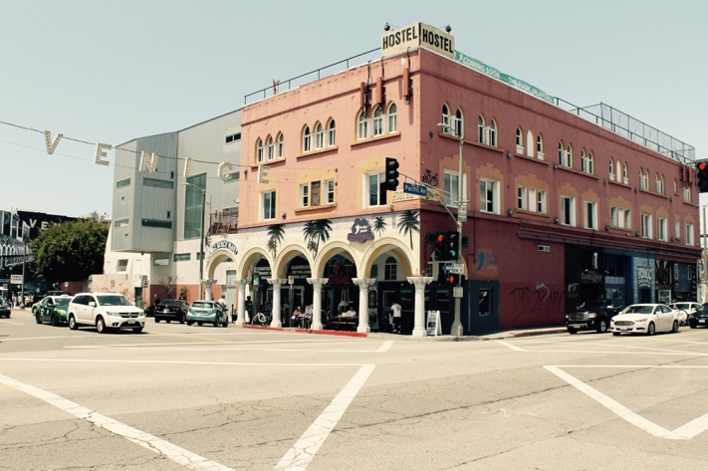

- 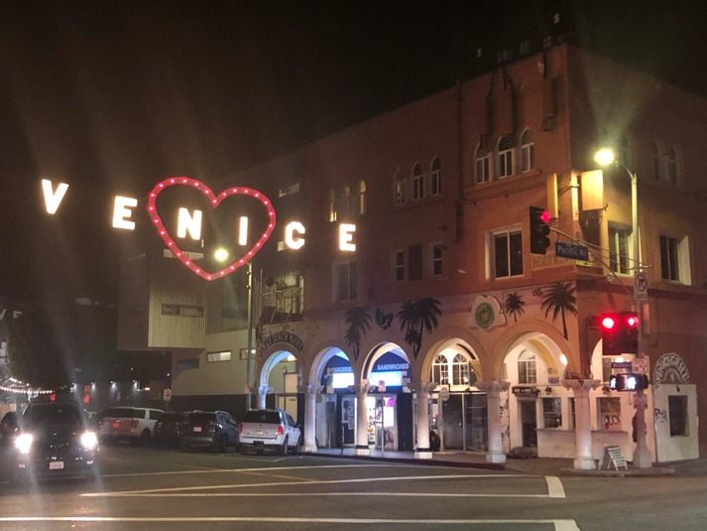

DEAR INTERESTED --

I AM OWNER OF THE VENICE BEACH HOSTEL.
I AM ALSO THE OWNER OF THE ORIGINAL VENICE OF AMERICA COLONNADED PROPERTY –
HOUSING VENICE BEACH HOSTEL & GROUND FLOOR STORES.

WINDWARD – PACIFIC BUILDING
1515 PACIFIC AVE.
(aka 75 – 83 WINDWARD AVE.; 1513 – 1527 PACIFIC AVE.)
VENICE, CA 90291

LEASE OF HOSPITALITY:

I AM PLACING THE HOSTEL PORTION OF THE PROPERTY UP FOR RENT. ONLY AVAILABLE HOSPITALITY PROPERTY IN VENICE.
PRICE: OFFERS INVITED.

PLEASE CONTACT IF INTERESTED.
DITTO IF AGENT - WITH AN INTERESTED CLIENT IF THAT’S WHO YOU ARE.
THERE IS NO LISTING / NO COMMISSION.

THERE IS ATTACHED AN INFO SHEET FOR THE PHYSICAL SET-UP OF THE ENTIRE PROPERTY.
FOR RENTAL OF HOSPITALITY: PLEASE DISREGARD THE INFO FOR THE NON-HOSTEL PART OF THE PROPERTY
- STORES, OFFICES & CELL TOWERS.

TO: HOSPITALITY OPERATORS

BUSINESS OPPORTUNITY:
VENICE BEACH HOSTEL – HOSPITALITY
RENTAL + KEY MONEY / SALE

IMPROVEMENT

LOCATION:
ENTRANCE TO VENICE BEACH
NORTH-WEST CORNER of WINDWARD AVE. & PACIFIC AVE.
NOTEWORTHY:
VENICE SIGN HANGS FROM BUILDING
ARCHES OVER WINDWARD AVE.

ORIGINAL:
ABBOTT KINNEY VENICE OF AMERICA BUILDING

ADDRESS:
1515 PACIFIC AVE. / 75 WINDWARD AVE.
VENICE, CA 90292
UPDATED:
INFRASTRUCTURE FULLY UPDATED

PROPERTY USE

CURRENT:
UNITS OPERATED AS HOSPITALITY – HOSTEL
DETAIL:
SECOND & THIRD FLOOR: TRANSIENT OCCUPANCY: HOSTEL

28 SINGLE APARTMENTS w/:
BATHROOM
KITCHENETTE
TRUNDLE BED AREA + BREAK-FRONT (BUILT-IN)
CLOSET
10 FT CEILING
VINYL WINDOWS
ETHERNET & CABLE
N.B. 2 UNITS COMBINED AS DORM w/ 2 BATHROOMS ( HAVE PARTITION WALL
BETWEEN THEM REMOVED – WALL REPLACEABLE; BUT DORM w/ 2
BATHROOMS AND 2 KITCHENETTES)

MEZZANINE:
ALSO AVAILABLE FOR ADDITIONAL / RELATED USE

CURRENT USE: COMMON AREA FOR TRANSIENT OCCUPANCY: HOSTEL
KITCHEN
BATHROOM
2 COMMONS: LOUNGE & TV/POOL TABLE ROOMS
STORAGE AREA
LUGGAGE ROOM
LINEN ROOM
RECEPTION

SEPARATE PART (OVER 83 WINDWARD GROUND FLOOR STORE) MAY ALSO BE
RENTED
SEPARATELY; HAS SECONDARY STAIRCASE
SEPARATE PART (OVER 1513 PACIFIC GROUND FLOOR STORE) MAY ALSO BE
RENTED
SEPARATELY; USED AS ADDED OFFICE / MANAGER APT.

PHYSICAL CONDITION: REHAB, etc. WORK

ORIGINAL “VENICE IN AMERICA” BUILDING FROM ORIGINAL DEVELOPMENT OF
VENICE BEACH
ARCHES COVER STREET ON WINDWARD AVE.
VENICE SIGN ATTACHED TO BUILDING

REHABILITATION DONE: MID-1990’s & RECENT
EARTHQUAKE RETROFIT
ALL MECHANICALS REDONE IN BUILDING MID-1990’s:
ALL NEW PLUMBING;
ALL NEW ELECTRICAL WIRING;
ALL NEW GAS LINES, etc.
ALL NEW ELECTRICAL SERVICE: 800 AMP, 3 PHASE SERVICE
ALL NEW ROOF + FENCING

ALL ROOMS: ETHERNET; PRIVATE WITH COMPUTERS
BUILDING: WI-FI
BATHROOM COSMETIC – GRANITE COUNTERS; VESSEL SINKS; PEDESTAL
SUPPORT; WAINSCOT; PLANK WOOD GRAIN RESILIANT FLOORING OR
TILE
ALL NEW VINYL WINDOWS
UNITS - PLANK WOOD GRAIN RESILIANT FLOORING

TENANT IMPROVEMENTS: DESIRABLE (?) AND PROSPECTIVE TENANT MAY DO

HVAC: MULTI-SPLIT HEAT PUMP UNITS (no ducting; pipes only) –
N.B.: CURRENT UNITs - GAS FURNACES (through – wall)

HOTEL LOCK SYSTEM

INTERIOR COSMETIC RE-DO

N.B.: NO ELEVATOR

=======================================================================

FOR INFORMATIONAL CLARITY ONLY:

GROUND FLOOR: 6 STORES
ADDRESS & OCCUPANCIES:
75 WINDWARDS – HOSTEL SAFETY SECONDARY STAIRS
77 WINDWARD – MINIMART
79 WINDWARD – FOOD
83 WINDWARD – FOOD
1515 PACIFIC – HOSTEL ENTRANCE
1513 PACIFIC – ART GLASS SHOP -
1525 PACIFIC – STORAGE RENTAL
1527 PACIFIC – BARBERSHOP
CELL SITES:
ATT
T-MOBILE

End/end/end

CONTACT

NAME: MARK WURM

PHONE: 310.895.6275

EMAIL: info@planetvenice.com

BUSINESS OPPORTUNITY:
SALE / KEY MONEY OF HOSPITALITY OPPORTUNITY

RENTAL OF HOSPITALITY:
28 ROOMS
MEZZANINE SPACES ADDITIONALLY AVAILABLE

OFFERS INVITED
ONLY AVAILABLE HOSPITALITY PROPERTY IN VENICE.

PLEASE CONTACT IF INTERESTED.
AGENTS - WITH AN INTERESTED CLIENT.
(NAMED CLIENT PROTECTION; NO EXCLUSIVE LISTING.)

