FOR LEASE
THE DEPOT RESTAURANT
AND
BANQUET FACILITY (Optional)
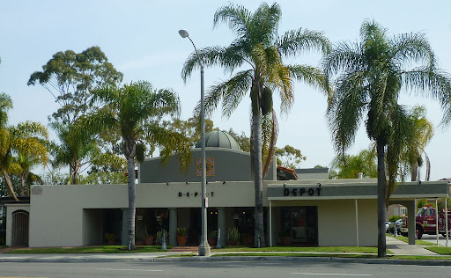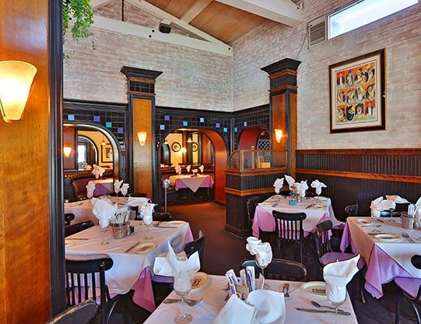
1250 CABRILLO AVE.
TORRANCE, CA 90501
.
35 Years of Continuous Full Service Restaurant, Bar and Banquet Facility
Owner/Operator is Retiring Leaving a High Quality Historic 5,446 Sq. Ft.
Restaurant with 32 Parking Stalls and Overflow Parking for 5+ Vehicles On Site

• Exclusive Banquet Space is an Additional 2,000 Sq. Ft. and adds 39 Parking Spaces
• Additional On Site Parking is Also Available After Work Day
• Floor Plans Available
• Open Most Every Work Day for Inspection (CALL FOR SHOWING / DO NOT
DISTURB TENANT)
• Asking $2.50 Gross Modified Gross Per Square Foot or $13,615.00 Per Month

Business & Equipment Plus Furniture/Memorabilia is Included.
Full Liquor License is Available.


Sojka-Nikkel Commercial Realty Group, Inc. Joseph J. Sojka, Broker
Jessica J. Sojka, Broker c (310) 344-5207
(310) 534-8000
(310) 534-8000

