94 8th Avenue, New York NY 10011 – FOR SALE BY OWNER
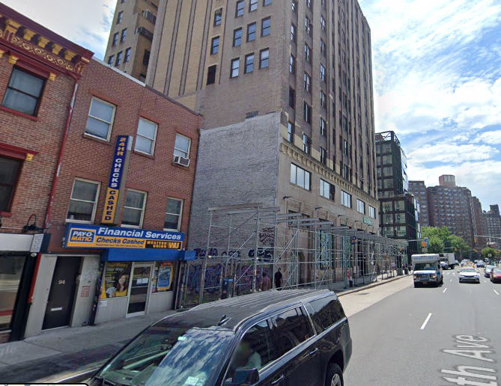
Asking Price: $5,250,000
Block & Lot: 0764-0074
Zoning: C1-6A (Resi Eqiv. R7A)
Lot Dimensions: 19.37 x 73.5 Ft.
Lot Size: 1,424 Sq. Ft.
Building Dimensions: 19.37 x 73.5 Ft.
First Floor Built Full
Existing Footage: 2,850
Stories: 3 (Walk-Up)
Units: 2 (1 Residential & 1 Comm)
FAR: 5.00
Buildable Sq Ft. – 7,120
Air Rights – 4,270
Taxes (23/24) - $29,987
For more information please call owner at:
212-682-2048

Located in Chelsea near the meatpacking district on the east side of 8th Avenue between West 15th Street and West 14th Street, one block from Google headquarters. Property is primarily a 2-Family with One Store on the Ground Floor and a Residential duplex above. Built in 1901. Perfect for user investor. Currently 2 tenants, 1 Commercial and 1 Residential. Fully Occupied.
Commercial Unit – Pay-O-Matic Store – Monthly Rent $15,457 / Annual $185,490.40 – Lease Expiration 11/13/2029 plus 5-year option renewal
Residential Unit – Monthly Rent $5,200 / Annual $62,400 – Lease Expiration 06/30/2025
Total monthly income $20,657 / Total annual income $247,890. Total Annual Operating Expenses – ($36,662)
NOI: $211,228 Annually

