

1510 E. Colonial Dr. Suite 307
Orlando, FL 32803
Phone: (407) 677-1700

C. Brenner, Inc.

Commercial Real Estate

½ Acre Development Opportunity
602 S Park Ave, Apopka, FL 32703

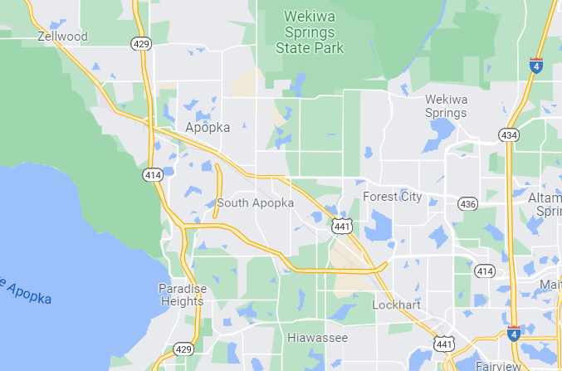
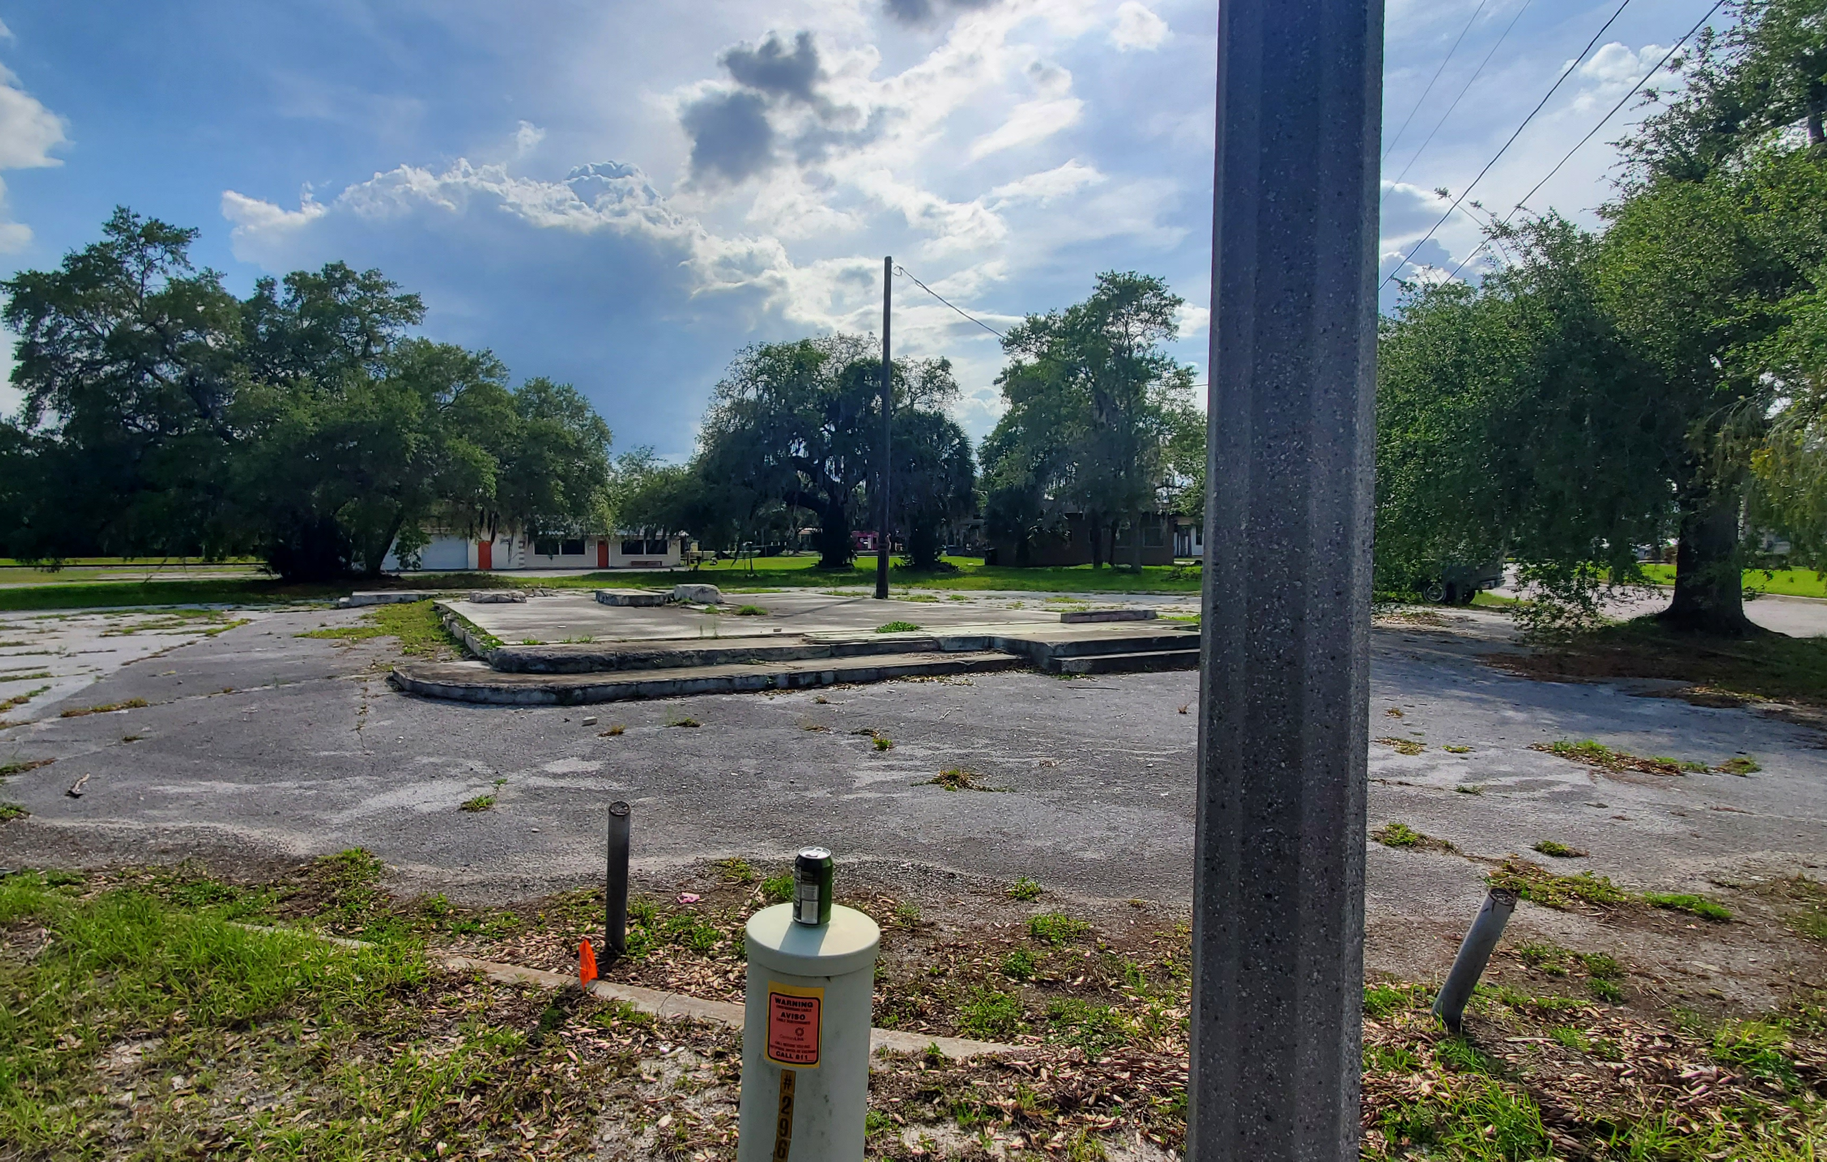

$325,000

- ½-acre development opportunity in Downtown Apopka
- Located on main traffic corner, a block from City Hall and community services
- MU-D (mixed use downtown) commercial zoning

- Ideal for professional, commercial, or city-related business
- Just off HWY 441, convenient highway access, and close to public transportation

Dela Armstrong Cell: 407-733-8881
Lic. Commercial/Residential Broker Office: 407-677-1700
C. Brenner Inc. Email: realtordela@gmail.com

