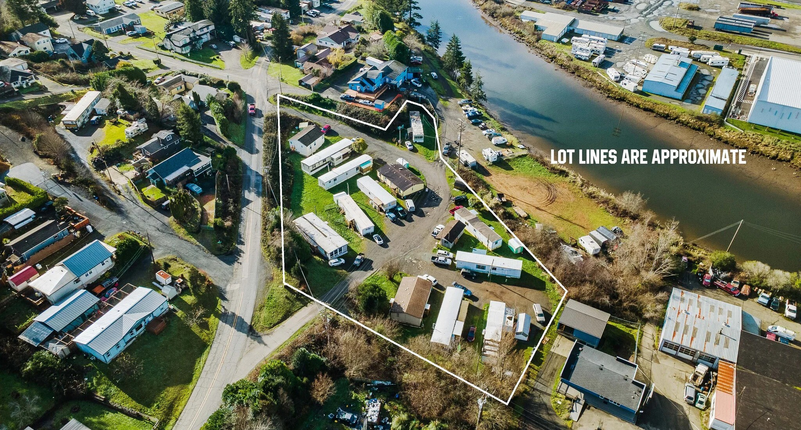
OFFERING MEMORANDUM
93531 COAL BANK LANE
COOS BAY, OREGON 97420
ASKING PRICE | $1,100,000
12  MOBILE HOME SPACES | 10  PARK-OWNED HOMES | 2  TENANT-OWNED SPACES | 1  2-BEDROOM HOME
Established manufactured-housing investment with multiple income streams, separate electrical metering, an on-site laundry facility, and a two-bedroom stick-built residence.
LYLE STRATTON | JEFF CRUMBAKER | 360.718.8787


INVESTMENT OVERVIEW
93531 Coal Bank Lane presents an opportunity to acquire an established 12-space mobile home park in Coos Bay, Oregon. The offering includes 10 manufactured homes owned by the park, two spaces leased to residents who own their manufactured homes, a separate two-bedroom stick-built residence, and an on-site laundry facility.
The property offers a diversified rental structure: the majority of income is generated from park-owned homes, while two spaces produce recurring pad-rent income without ownership of the homes. Electrical service is separately metered, supporting clearer utility allocation and operating control.
Property Highlights
• 12 total mobile home spaces | • 10 park-owned manufactured homes
• 2 tenant-owned home spaces | • Separate 2-bedroom stick-built home
• On-site laundry facility | • Electrical separately metered
• Established income-producing use | • Multiple rental-income streams
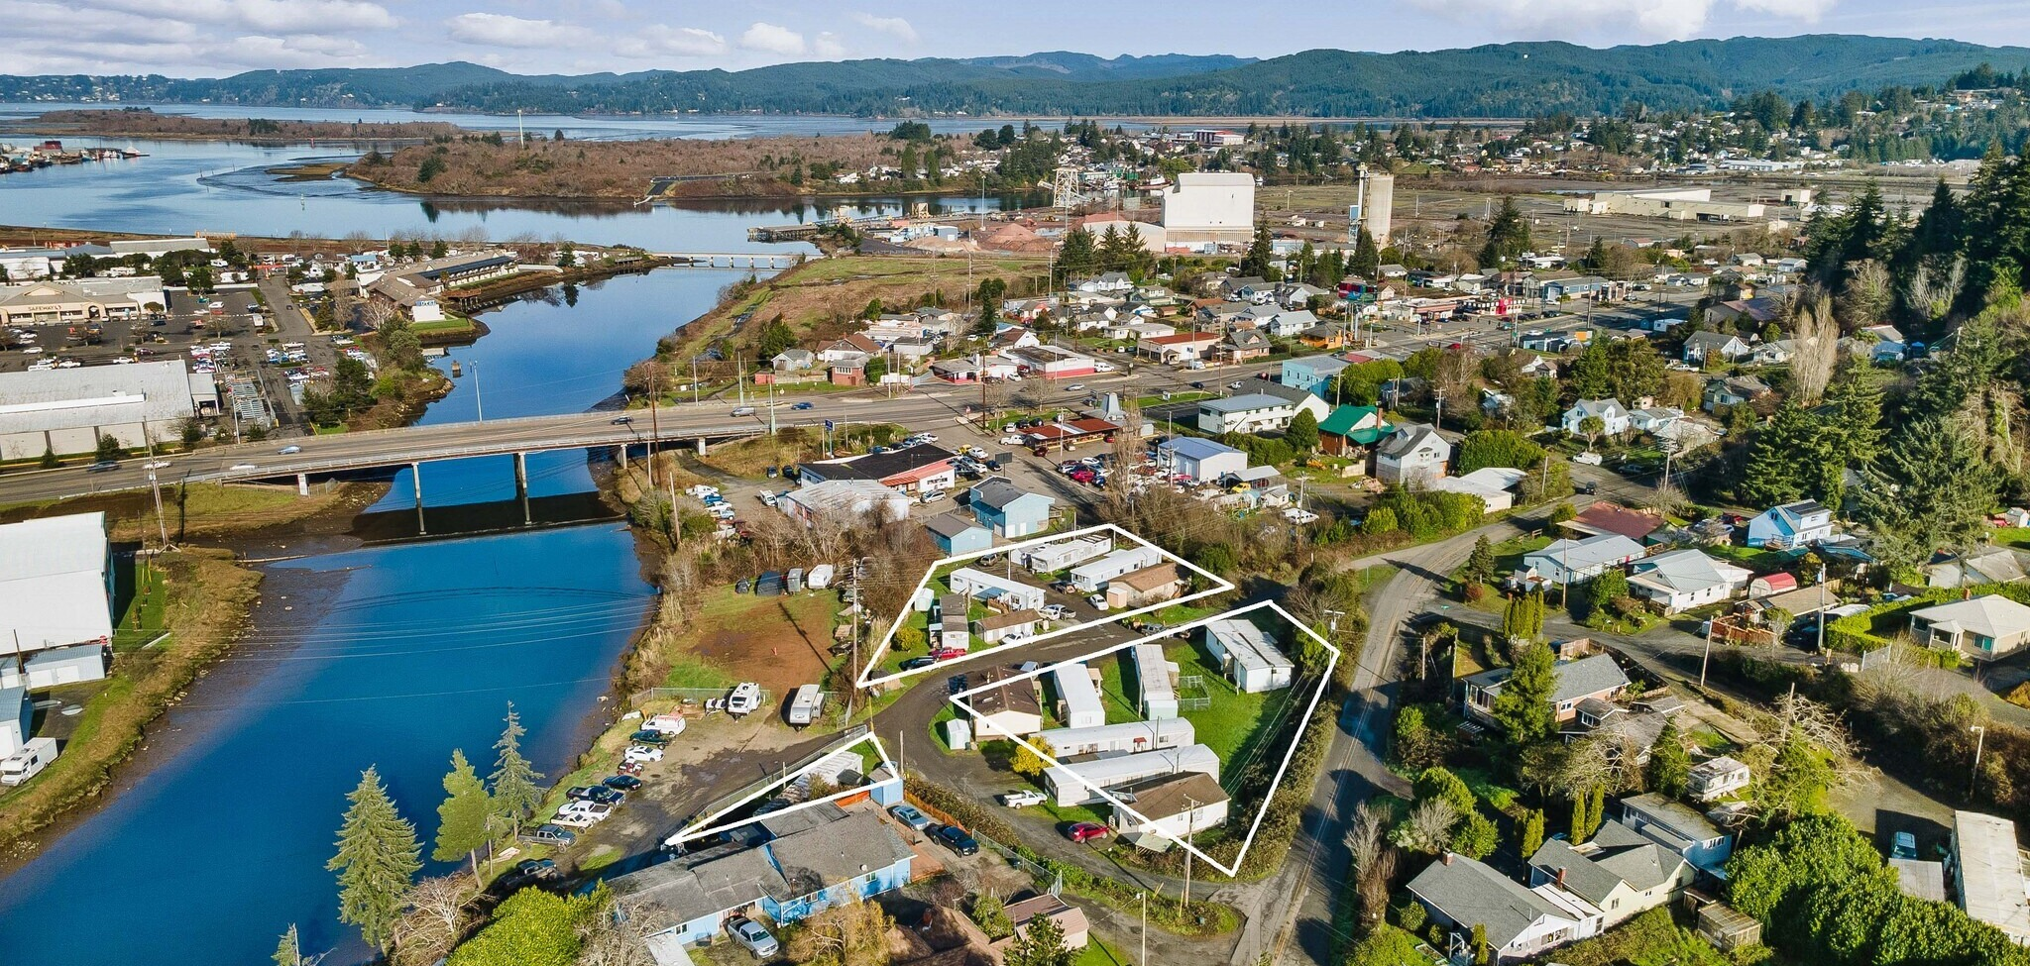

PROPERTY CONFIGURATION
The community combines four distinct operating components, giving a purchaser a mix of full-home rental income, space-rent income, conventional residential rent, and an on-site resident amenity.
Park-Owned Manufactured Homes | 10 homes - ownership controls both the homes and the underlying spaces.
Tenant-Owned Manufactured Homes | 2 spaces - residents own their homes and lease the spaces from the park.
Stick-Built Residence | 1 separate two-bedroom home providing an additional conventional rental component.
Laundry Facility | On-site laundry facility serving the community.
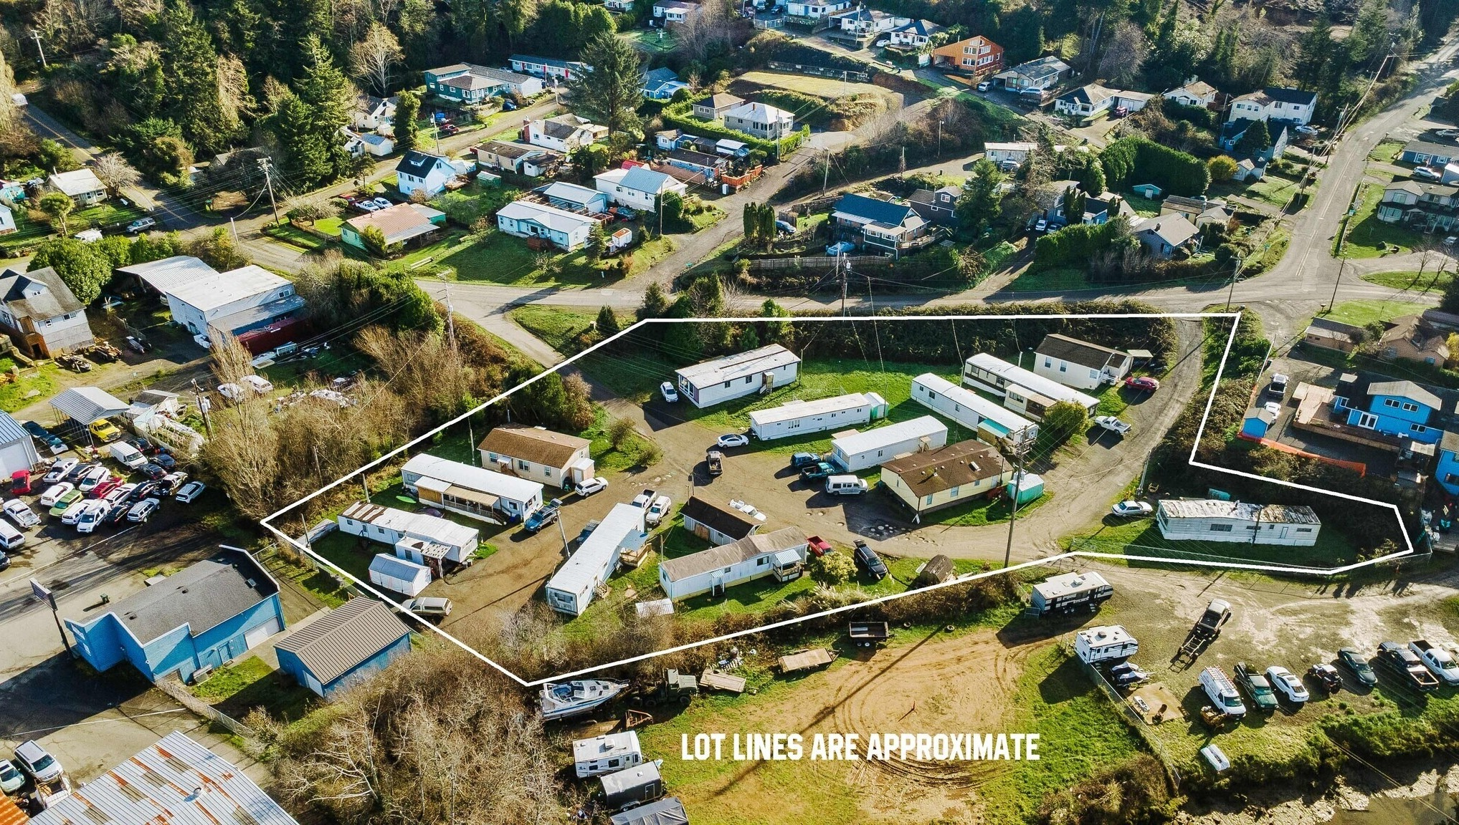

UTILITY & OPERATING FEATURES
SEPARATE  ELECTRICAL METERING | 12  MOBILE HOME SPACES | 10  PARK-OWNED HOMES | 1  ON-SITE LAUNDRY
All electrical service is separately metered. Individual metering is an important operating feature because it allows electrical usage to be measured by residence rather than blended into a single common-area service.
The park-owned-home structure also provides direct control over the majority of the housing stock, while the two tenant-owned homes provide a lower-maintenance space-rent component.
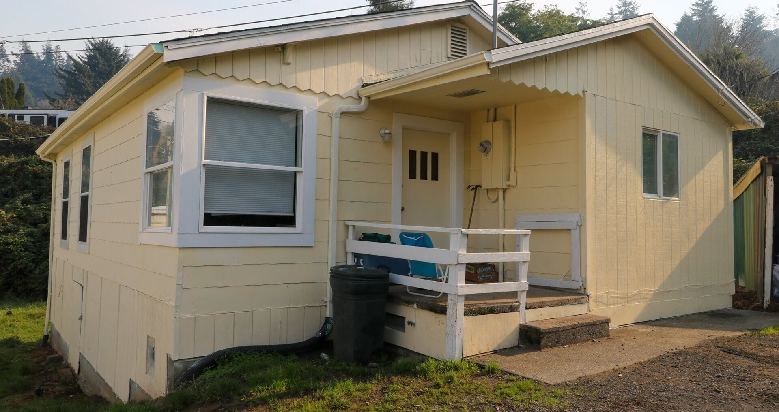

SITE & LOCATION
The property is located at 93531 Coal Bank Lane in Coos Bay, with access from the surrounding neighborhood street network. The aerial photography below illustrates the park setting and its relationship to the surrounding Coos Bay area. Lot-line depictions shown in photography are approximate and should be independently verified.
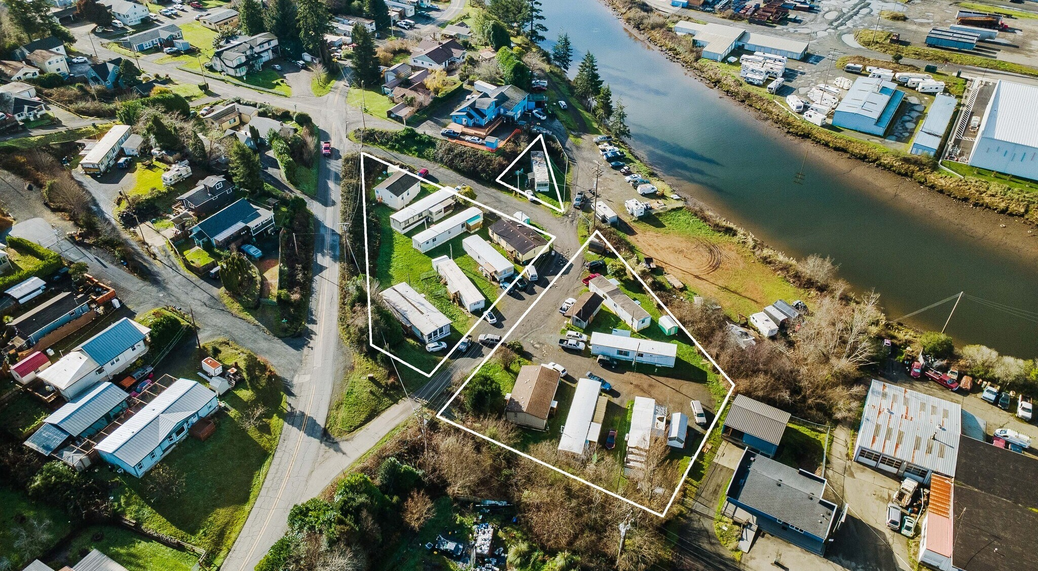
Aerial view - lot lines shown are approximate.

OFFERING FACTS
Property | 93531 Coal Bank Lane, Coos Bay, Oregon 97420
Property Type | Manufactured Housing / Mobile Home Park
Mobile Home Spaces | 12 total
Park-Owned Homes | 10
Tenant-Owned Home Spaces | 2
Additional Residence | Two-bedroom stick-built home
Laundry | On-site facility
Electrical | Separately metered
Asking Price | $1,100,000
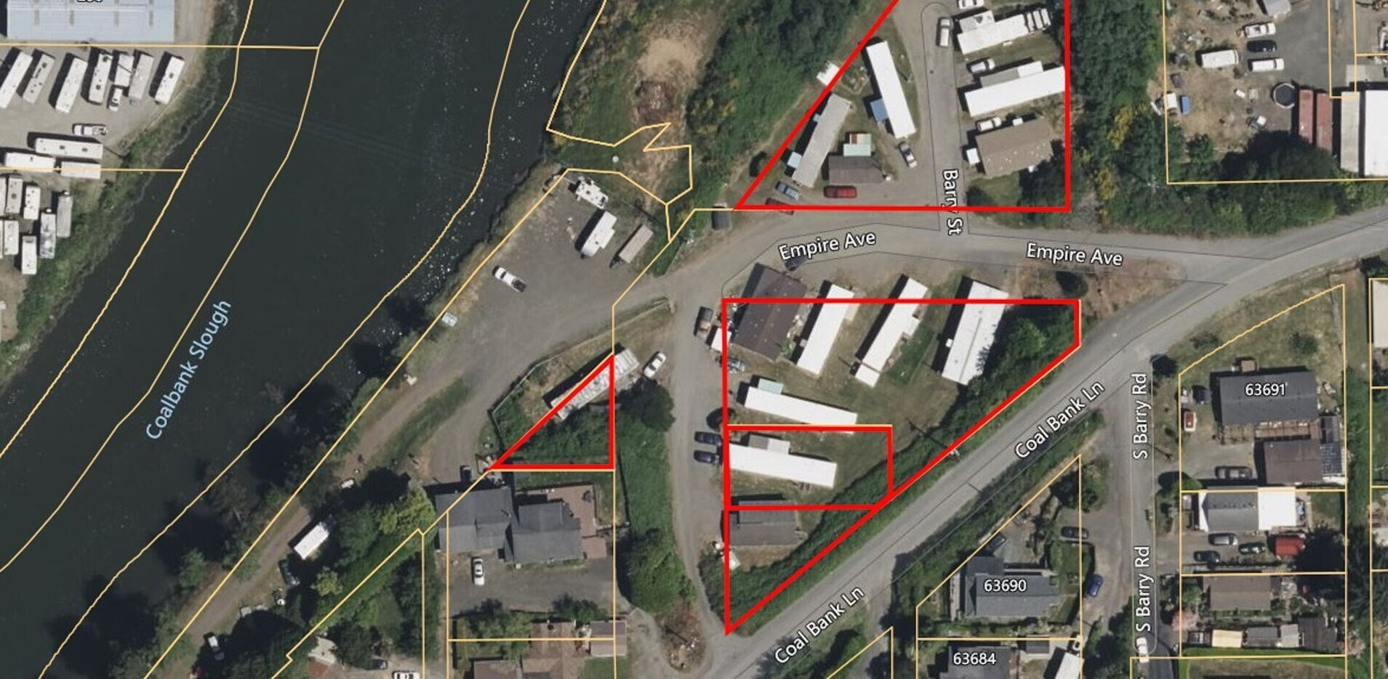

FINANCIAL SNAPSHOT
$147,000  Base Annual Rental Income | $142,531  Effective Gross Income | $108,792  Net Operating Income
9.5%  Selected Capitalization Rate | $1,145,179  Income Approach Value | 9.9%  Cap Rate at $1.10M Ask
INCOME APPROACH TO VALUE
INCOME
10 Park-Owned Mobile Homes + 1 Stick-Built Home + 2 Leased Mobile Home Spaces | $147,000
Other Income - 1% (late fees, laundry, etc.) | $1,470
Adjusted Gross Income | $148,470
Monthly Adjusted Gross Income | $12,373
Less: Vacancy Factor - 4% | ($5,939)
EFFECTIVE GROSS INCOME | $142,531
OPERATING EXPENSES
Real Estate Taxes | $3,162
Insurance - Estimated 2026 | $4,100
Repairs / Maintenance - 2% | $2,851
Water / Sewer - Estimated 2026 | $12,100
Landscaping / Snow Removal - Estimated 2026 | $4,400
Management / Administration - 4% | $5,701
Reserves - 1% | $1,425
TOTAL OPERATING EXPENSES - 23.7% OF EGI | $33,739
NET OPERATING INCOME | $108,792
Selected Capitalization Rate | 9.5%
INDICATED MARKET VALUE | $1,145,179
Rent & Operating Notes
• The two tenant-owned mobile home spaces are scheduled to increase to $500 per month in January 2027.
• The remaining 11 rental homes average approximately $1,001.50 per month, with rents ranging from $660 to $1,650.
• Estimated market space rent for an older park of this type is approximately $625-$675 per month.
• Income approach value is calculated as $108,792 NOI divided by a 9.5% capitalization rate.
Valuation commentary reflects the income and expense assumptions supplied by ownership/broker. Prospective purchasers should independently verify all rents, expenses, market-rent assumptions, capitalization rates, and future rent increases.

PROPERTY PHOTOGRAPHY

Property photographs are provided for general reference. Prospective purchasers should independently verify the condition of all manufactured homes, the stick-built residence, laundry facility, utility systems, site improvements, and other physical components of the property.

INVESTMENT RATIONALE
DIVERSIFIED RENTAL INCOME | Income is supported by 10 park-owned homes, two leased spaces, a separate two-bedroom residence, and an on-site laundry component.

CONTROL OF MAJORITY OF HOMES | Ownership of 10 manufactured homes provides direct control over the majority of the community’s residential inventory.

SPACE-RENT COMPONENT | Two tenant-owned homes generate recurring space-rent income without ownership responsibility for those manufactured homes.

SEPARATE ELECTRICAL METERING | Individual metering can improve operating clarity and reduce exposure to common electrical usage being embedded in master utility billing.

ESTABLISHED MANUFACTURED-HOUSING USE | The property is operated as an existing manufactured-housing investment rather than a ground-up development opportunity.

ADDITIONAL CONVENTIONAL RESIDENCE | The two-bedroom stick-built home provides a rental component distinct from the manufactured-home spaces.

Confidentiality & Disclaimer
This Offering Memorandum has been prepared for informational purposes to assist prospective purchasers in evaluating the property at 93531 Coal Bank Lane, Coos Bay, Oregon. No representation or warranty, express or implied, is made as to the accuracy or completeness of the information. Prospective purchasers should independently verify all rents, leases, expenses, utility arrangements, title, zoning, permits, physical condition, property boundaries, and other matters material to an acquisition.
EXCLUSIVELY OFFERED BY
LYLE STRATTON | JEFF CRUMBAKER
360.718.8787
OPPORTUNITIES VENTURE COMMERCIAL REAL ESTATE
93531 COAL BANK LANE | COOS BAY, OREGON 97420

