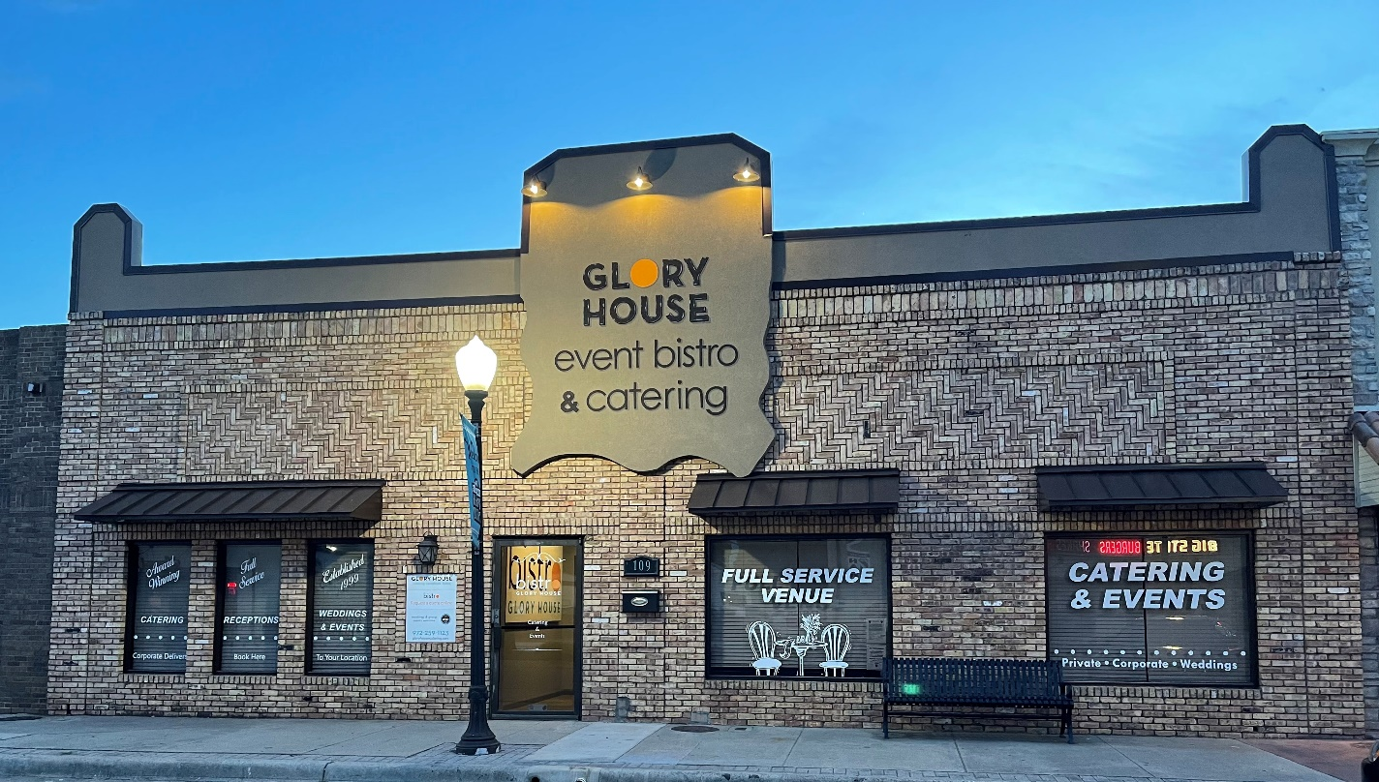

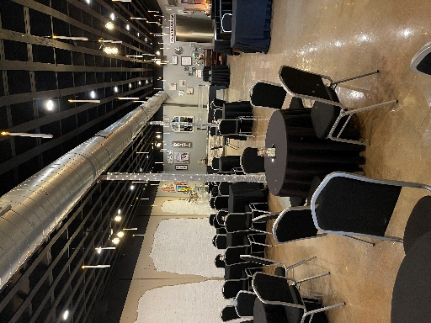
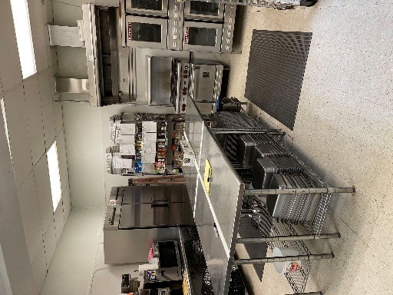
For
Sale
Commercial Kitchen, Dining, Office
972-978-3387
jo@gloryhousecatering.com
109/111 S. Main St. Irving 75060
Commercial property 109/n
$1.8 Mil
Jo Ann Goin
BJK Holdings

