590 Jacks Canyon Road
Sedona, AZ
$377,000
(All reasonable offers entertained)
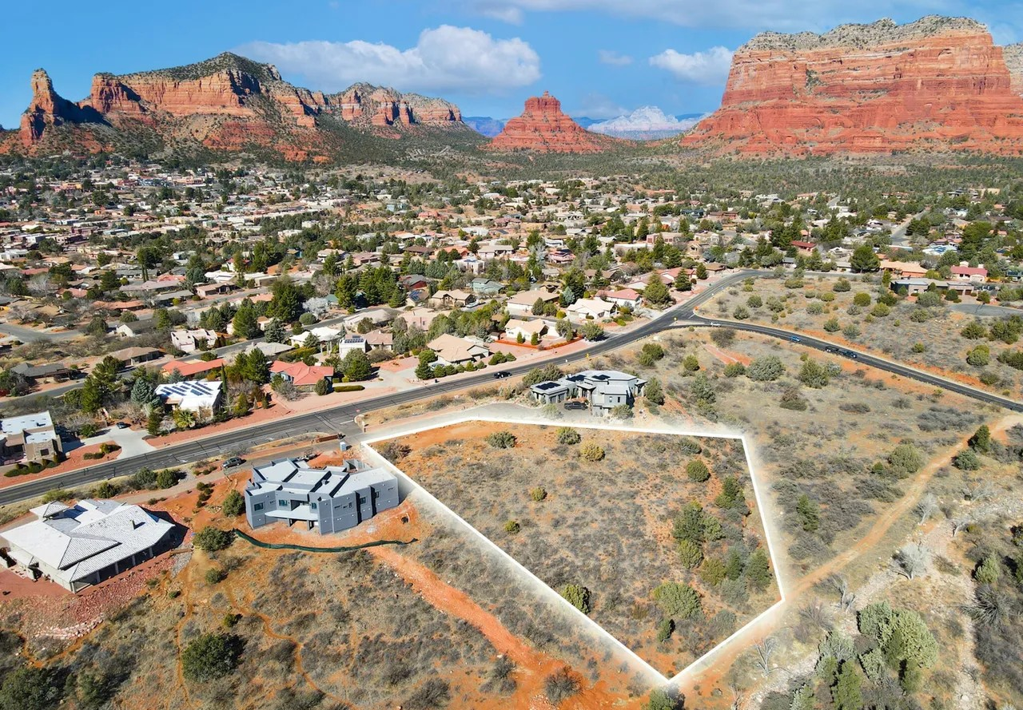
Interested?

Call: 602-902-9000
For more info:
www.Arizona-propertyFORsale.com

- 1.22 acres
- All utilities available on site
- Beautiful Red Rock Mountain views
- Gated Community
- Seller financing available (with 50% down)
- Property Taxes $1646.20 (annually)
- HOA - $53 p/mo.
- Sedona is a world-renowned luxury destination that attracts high-net-worth buyers and celebrities seeking beauty, privacy, and prestige.

- Its iconic red rock views, booming tourism, and extremely limited land supply make Sedona one of the most desirable and resilient real estate markets in the world!

Rare combination of easy access + 1.22-acre lot + 360-degree views + gated community + all utilities = Prime Location.

