FEATURES
14619 Merrill Avenue Fontana CA 92335

INDUSTRIAL FOR SALE!
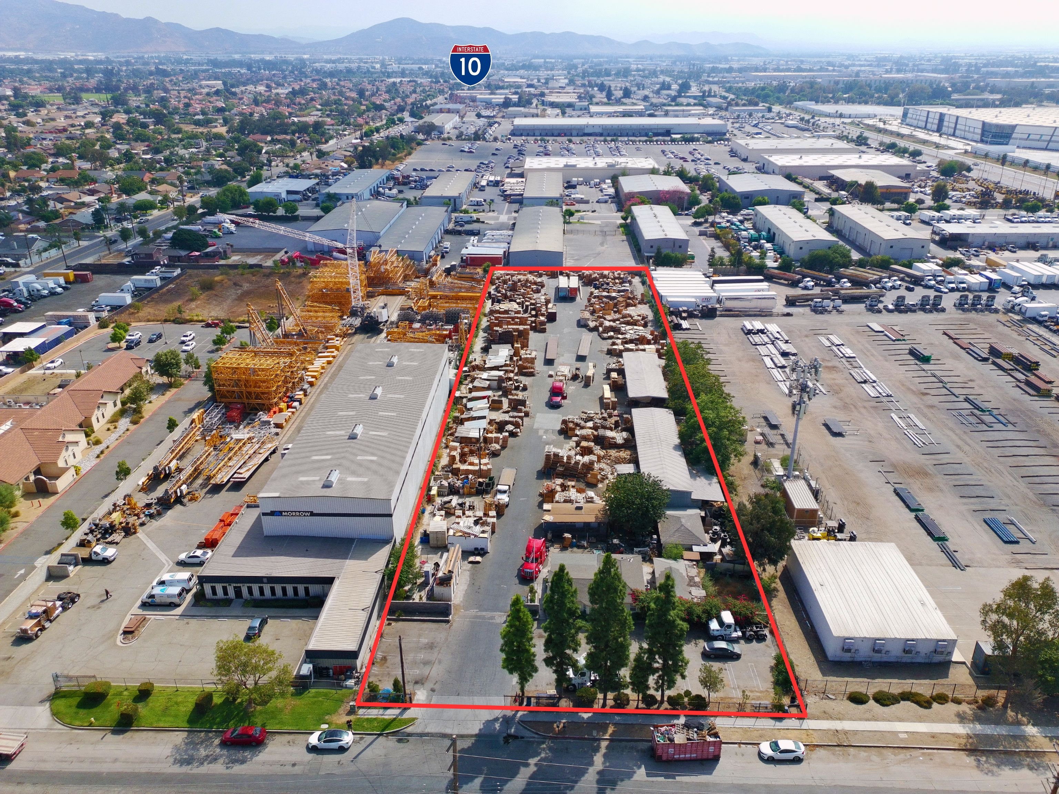

This Grand-Father Property is ideal for Pallet Business as the CUP is in the site. The office is +/-988 Sq Ft with a kitchen and a private office. Fully equipped with Security Cameras, 2 Docks, 2 Large Awnings, conference room, lunch room for employees.
Fire Hydrant inside the yard. Permitted security quarters, 100% paved, Property is located within The County Geographics.
Other businesses allowed: Logistics, Trucking, Warehouse, Manufacturing, Storage, etc..

- +/-104,108 SF
- 2 ½ Acres
- CUP in the site
- Fully Permitted
- Industrial Zone

Asking Price
$6,000,000

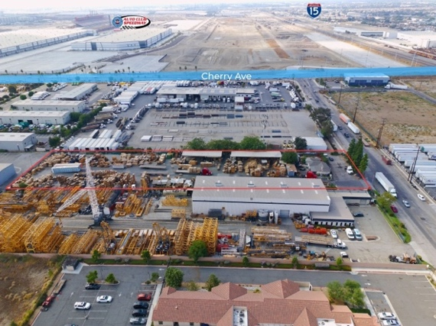
PRESENTED BY
CONNIE VELAZQUEZ
Commercial Associate
(310) 651-4069
DRE Lic #02060631
cvelazquez@mgrrealestate.com
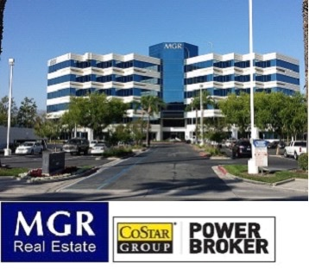
DANIEL VALENZUELA
Senior Commercial Associate
CELL: (951)224-1024
DRE Lic #01871441
dvcommercial@gmail.com

COMMERCIAL | RESIDENTIAL | PROPERTY MANAGEMENT
ONTARIO COSTA MESA VICTORVILLE RANCHO MIRAGE CARLSBAD IRVINE
(800) 777-7647 mgrrealestate.com DRE #01841921
All items on this page are deemed to be accurate, but should be viewed as reference only. MGR Real Estate, Inc. does not warranty/guaranty the validity of any information on this page.

