
EXCLUSIVE: 1,100 SF RETAIL SPACE AVAILABLE
187 Atlantic Ave., Freeport NY 11520

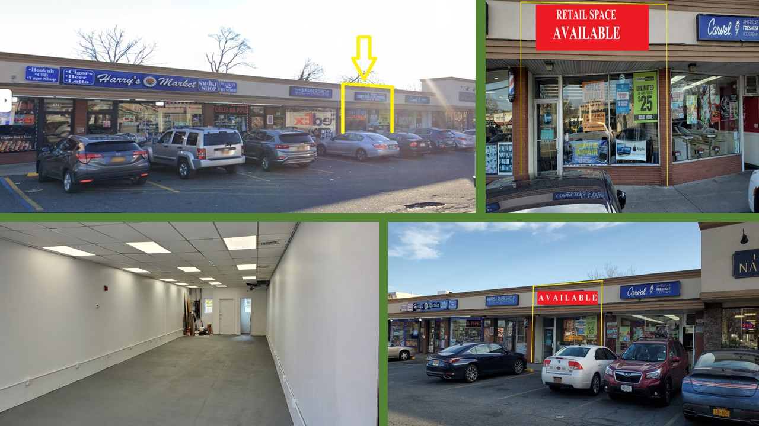
Type: | RETAIL SPACE with ON-SITE PARKING
Unit Size: | + 1,100 SF (NEWLY REMODELED) | For More Information Contact:
Rent: | Call for details | Marvin Hartman  Associate Real Estate Broker
Occupancy | Immediate | (516) 997-0100 ext. 0309 – Office
Neighboring and Co -Tenants: | Boston Market, Carvel, Harry’s Market, Dave’s Barbershop, Mannino’s Catering and Bagels, Atlantic Hardware, Guac Shop, The Bridal World, Pizzeria, Freeport Wine and Liquors, Nail Salon | (516) 659-8131 - cell
Neighboring and Co -Tenants: |  | mhartman@pliskinrealty.com
Neighboring and Co -Tenants: |  | 1 mile 2 mile 3 mile
Brief Description: **NEWLY REMODELED** Outstanding retail location. +1,100 SF Retail Space with great visibility, on-site parking, and street parking.  Act Fast, won’t last! |  | 2022 Population 26,065 156,344 395,715
 |  | Avg. HH Inc. $130,435 $155,234 $152,312
 |  | ADT: 29,067
591 Stewart Avenue • Suite 100 • Garden City, NY 11530
516-997-0100 • web: www.PliskinRealty.com • E-Mail: jpliskin@pliskinrealty.com
All information furnished is from sources deemed reliable, but no warranty or representation is made as to the accuracy thereof and same is submitted subject to errors, omissions, change of price, rental or other conditions, prior sale, lease or financing or withdrawal without notice.

