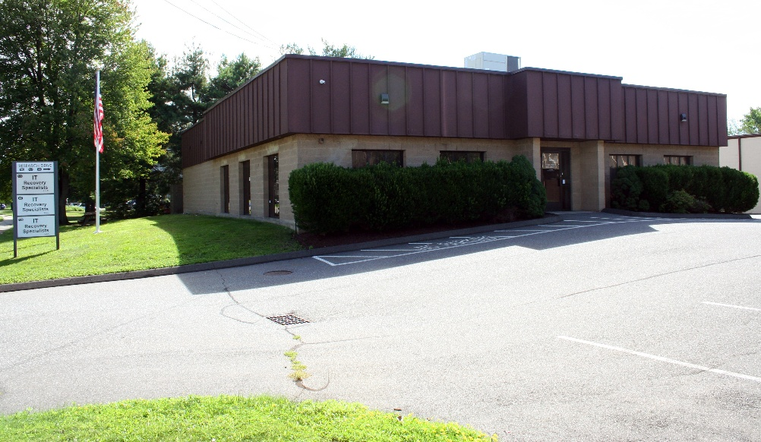
- Office Condo -Milford, CT |  | 2 bathrooms  5,414 sq. ft.  Central Air Conditioning & Heat  2026 Taxes $8,602

*** Triple Net Lease ***
 | Overhead loading dock door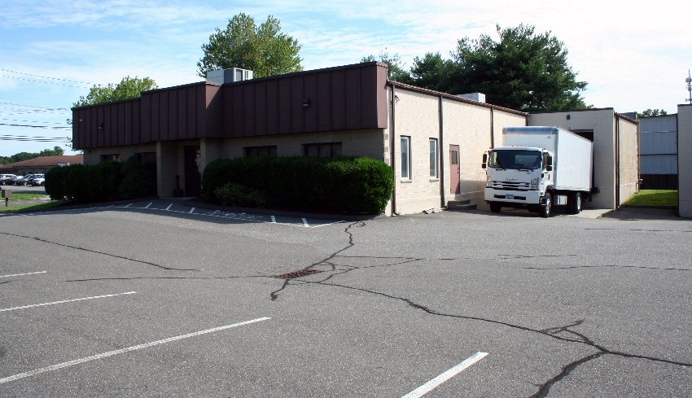 Plenty of parking
 | - DAY ONE  Color Exploration |  | - DAY TWO  Texture & Materials
 | - DAY THREE  Lighting Aesthetics |  | - DAY FOUR  Furniture & Space
 | (901) 555-0189 |  | tandb@example.com

