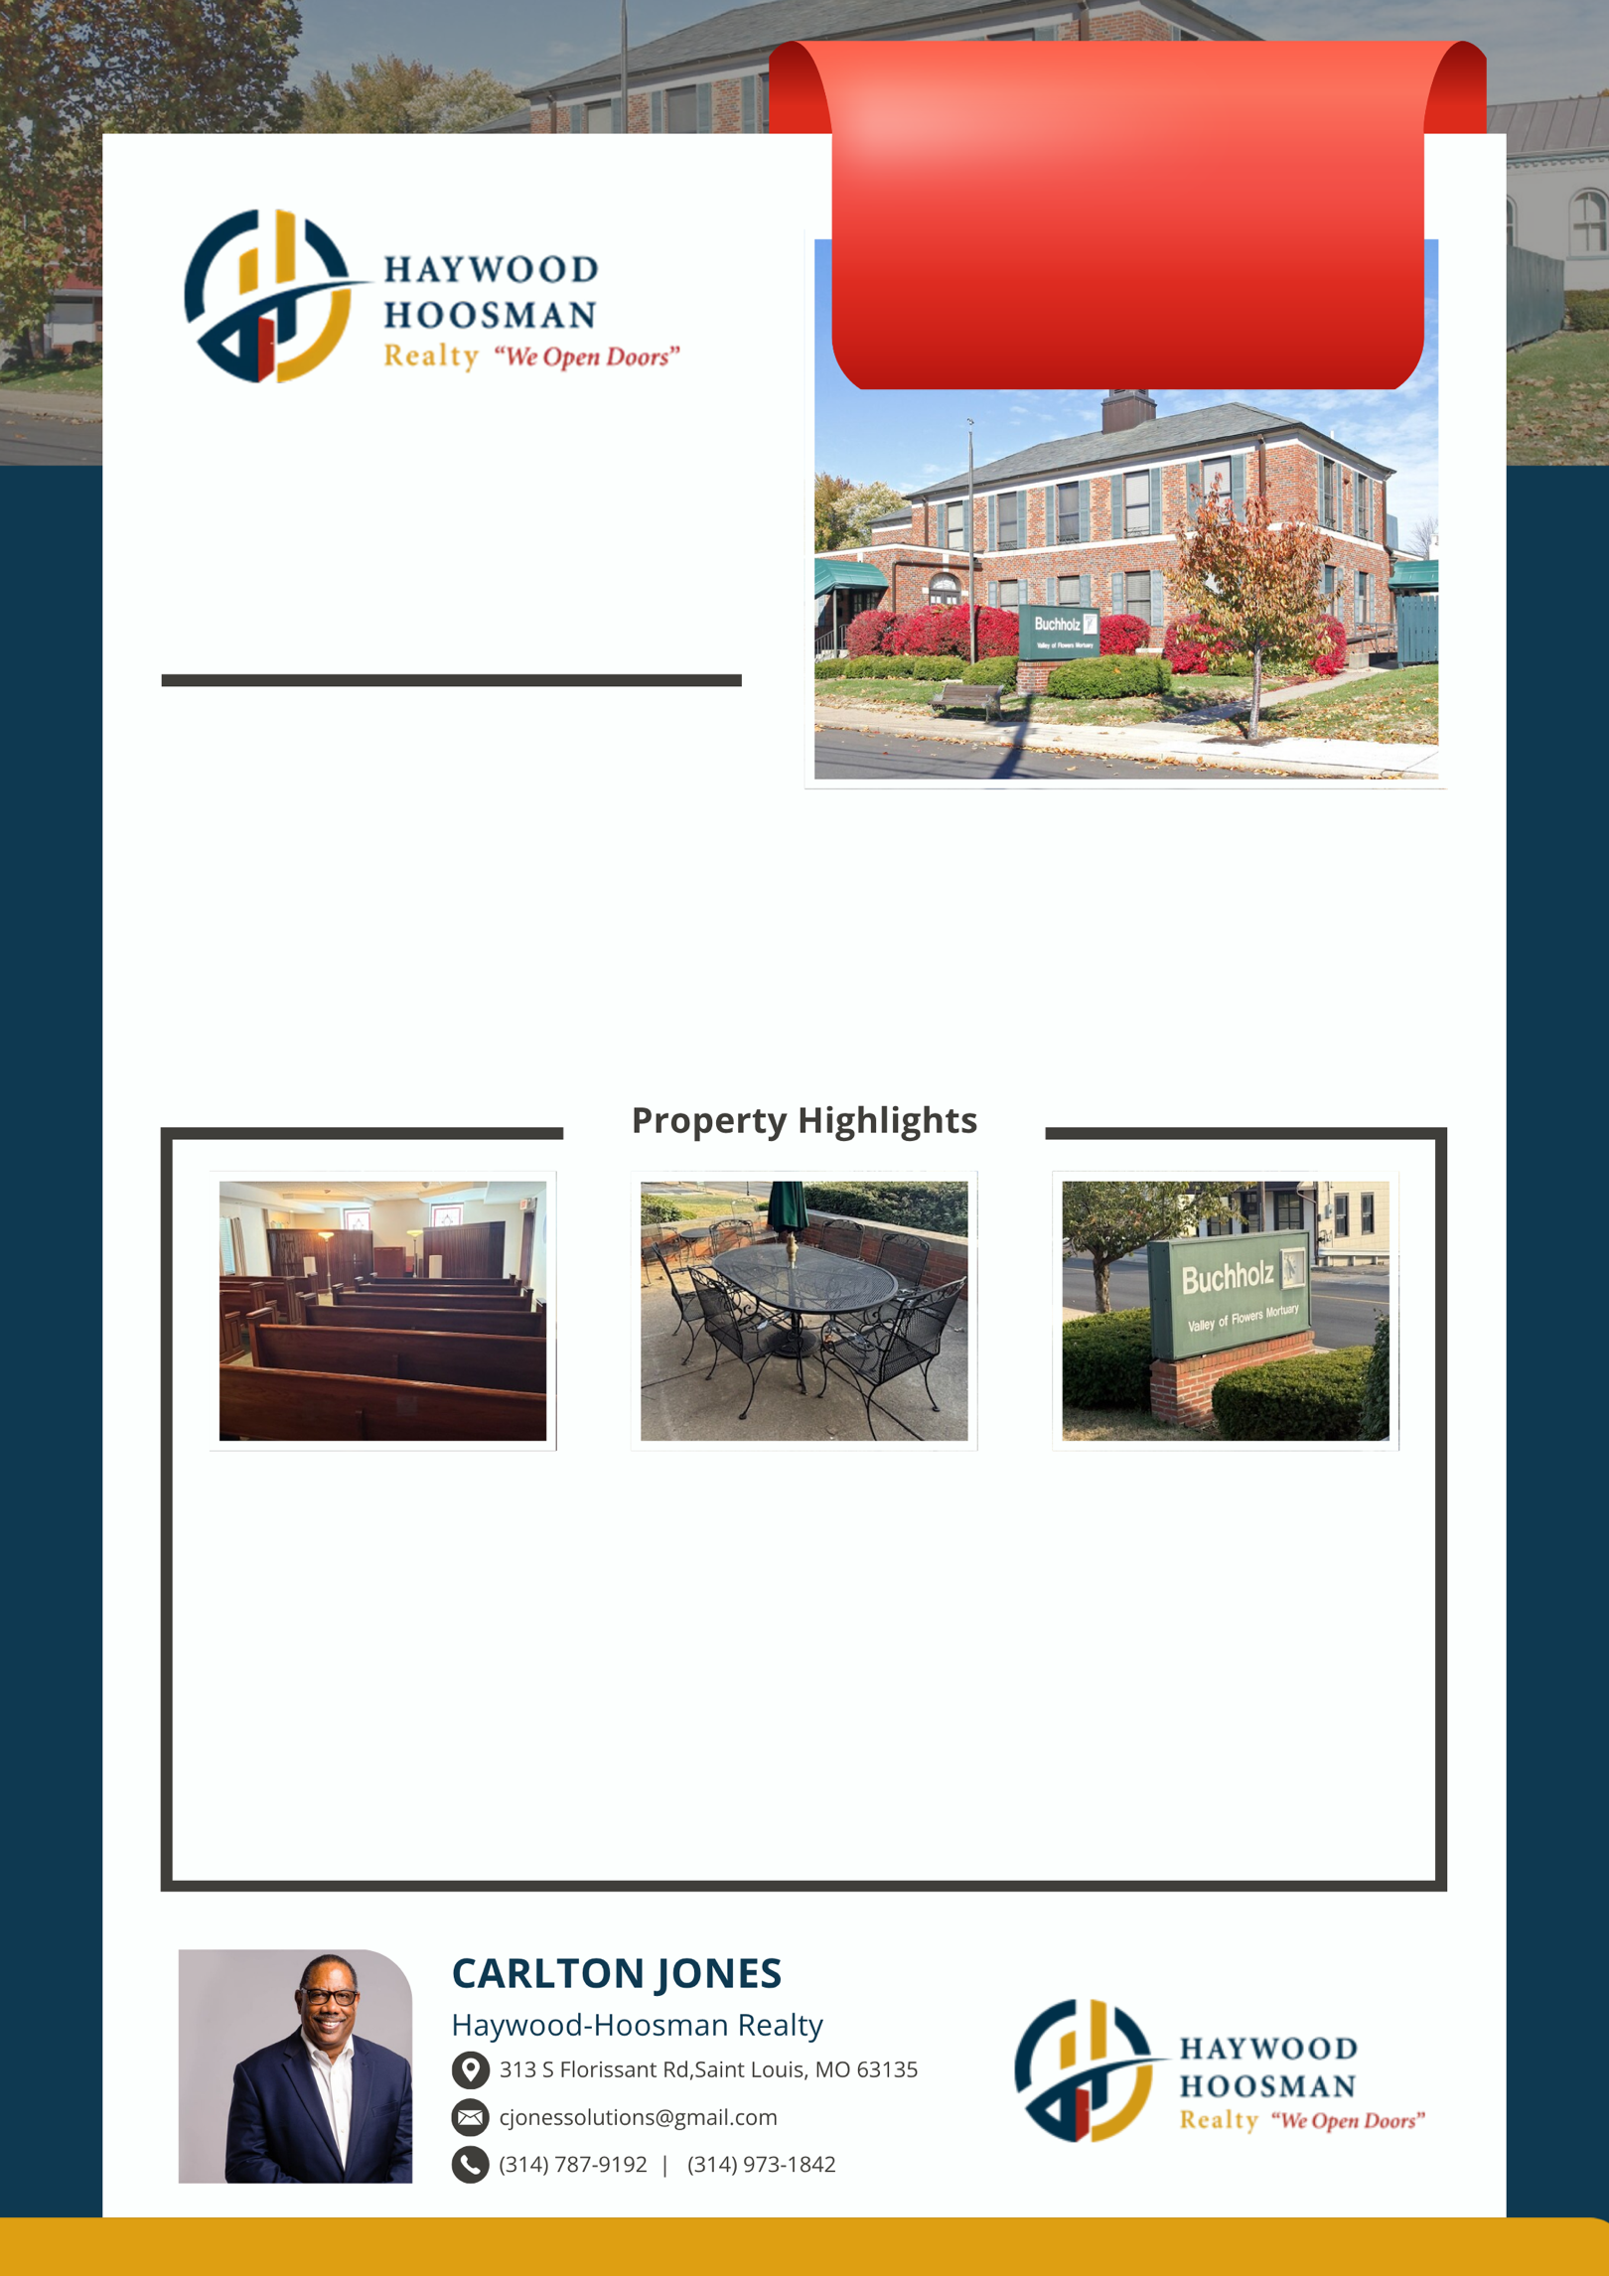
LANDMARK BUILDING IN OLD TOWN FLORISSANT
A rare opportunity to own a piece of history. This elegant 11,236 SF property, once City Hall and Police Station, is ideal for retail, headquarters, or fine dining. Strong maintenance history and plenty of parking make it a smart investment with timeless charm.
HISTORIC CHARM, MODERN POTENTIAL
Built in 1956 and impeccably maintained, this stately property blends history with opportunity. Perfect for investors or owner-users seeking a corporate hub, conference center, or upscale dining venue—with public amenities and strong infrastructure already in place.
PRIME RETAIL & OFFICE OPPORTUNITY
Centrally located in Old Town Florissant, this versatile three-story building offers 24-hour access, elevator service, and 45 parking spaces. Whether for retail, corporate use, or a high-end restaurant, it’s a flexible property with long-term value.

MOTIVATED SELLERS. OWNER MAY FINANCE WITH STRONG DOWN PAYMENT. Take another look at this classical, elegant premium construction 11,000 plus sq. foot building in Old Town Florissant, Missouri, formerly the City of Florissant City Hall and Police Department. Perfect for offices, corporate headquarters, conference center, or a fine-dining restaurant with patio. The property offers an elevator with 4,000 lb capacity, public restrooms on each floor, excellent maintenance records, and shared adjacent parking at 619–625 Rue St. Francois. 625 is stand-alone parking that goes with the property. Shown by appointment after 5pm on weekdays and until 1pm on Saturdays. Call or email to schedule a tour ASAP.
HISTORIC ELEGANCE MEETS MODERN POTENTIAL
▼ PRICE REDUCTION
SALES PRICE
$1,199,500
619-625 Rue
St Francois St
FLORISSANT, MO 63031

