Contractor sites for rent in the Bowie-Upper Marlboro Area.
600 Crain Hwy, Upper Marlboro, Maryland.

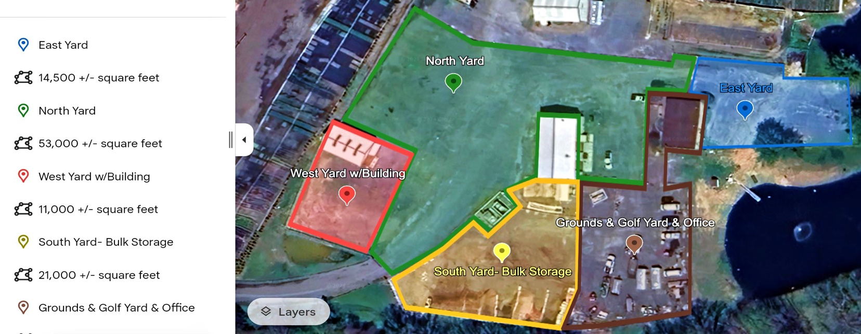
Description of Sites

**EAST YARD** Equipment and Truck parking, along with Employee parking, with the potential for One (1) or Two (2) Office spaces, a shared Conference Room with Wi-Fi internet access, a Restroom, and a Separate Fenced-in Yard and entrance. This Rents for $1,900 to $3,400 per month.

**NORTH YARD** Site-Equipment and Truck Contractor yard that Parks up to 40 Trucks or Trailers with an optional Three Bay Equipment Repair Shop that is heated with a commercial waste-oil heater, also One (1) office, Two (2) storage rooms, One (1) commercial equipment lift, and Four (4) 16'-foot-high drive-through doors. 2 Fuel Tanks with 2,000 gallons capacity each for Diesel and Gasoline re-fueling. Complete wash bay with hot waterpower washing of equipment. Parking for employees during work times. One (1) employee restroom and separate Wi-Fi internet connection. Fenced-in Yard with the potential of separate offices on site with 288 sq feet space meeting room. This area rents for $5,500 - $9,500 per month based on the use of the shop building with the contractor's yard.

**WEST YARD** Equipment and Truck parking space of 9,500 sq. feet for indoor and outdoor storage space. A one-bay shop with 16' high ceilings and 16' doors that has propane central heating in the shop. Separate equipment and supply areas are indoors with an air compressor for use in the repair shop along with a parts washer. This building is 1,440 square feet of locked and covered space.
The yard can also be locked and fenced separately to fit your needs. This area rents for $1,900- 3,340 per month, based on the use of the Yard and Shop/ Storage building being included.

**SOUTH YARD**- The storage yard is large enough to park 4-5 commercial vehicles and store bulk soil, gravel, mulch, and other bulk on a Macaden block top base with 5 large concrete block stackable bins. This has a separate office/meeting room with WIFI internet access. The yard can be seen at all times with its own glass see-through roll-up door and 2nd entry with separate access. The yard is fenced in and is locked with an internet security camera. This Rents for $2,200 - $2,900 per month.

**GROUND & GOLF YARD** This Contractor yard area has its own Equipment and Truck parking for 14 commercial trucks, with separate 500-gallon fuel tanks for fueling equipment. The area has room for storing 1/4 of an acre of plant material that can be watered on-site as needed.
This contractor yard also has an option for its own Separate entry to the potential of One (1), Two (2), or Three (3) offices with a shared 9-person conference room for management meetings and a stand-alone 30-file combo cabinet-locked corporate filing system. The office space is HVAC zoned with an employee restroom and fully separate Wi-Fi Internet and Video Conferencing including a separate security system. This area rents from $2,300 to $4,100 based on the added yard and office space.

