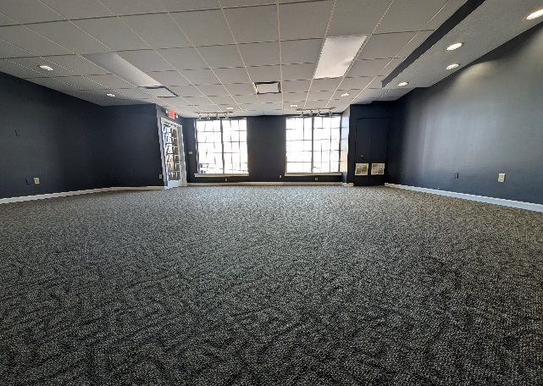
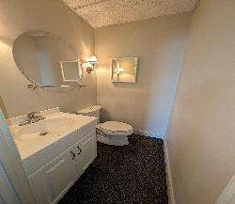
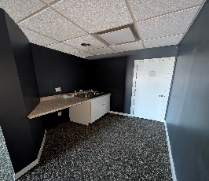
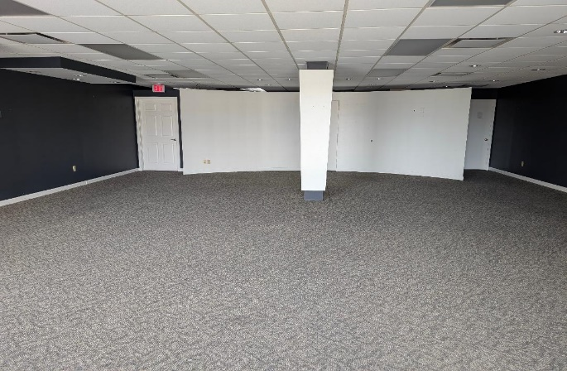
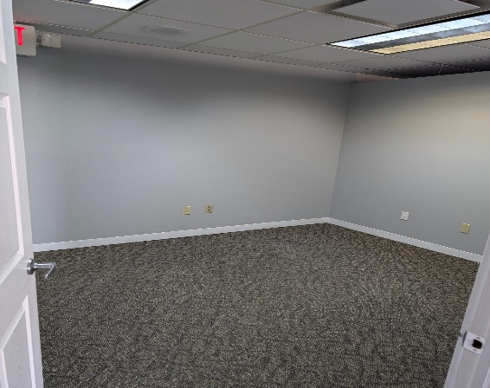
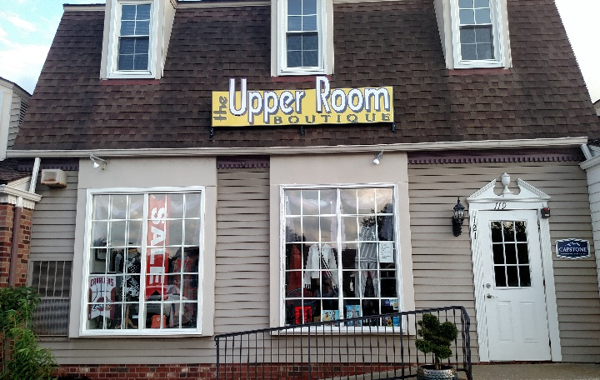
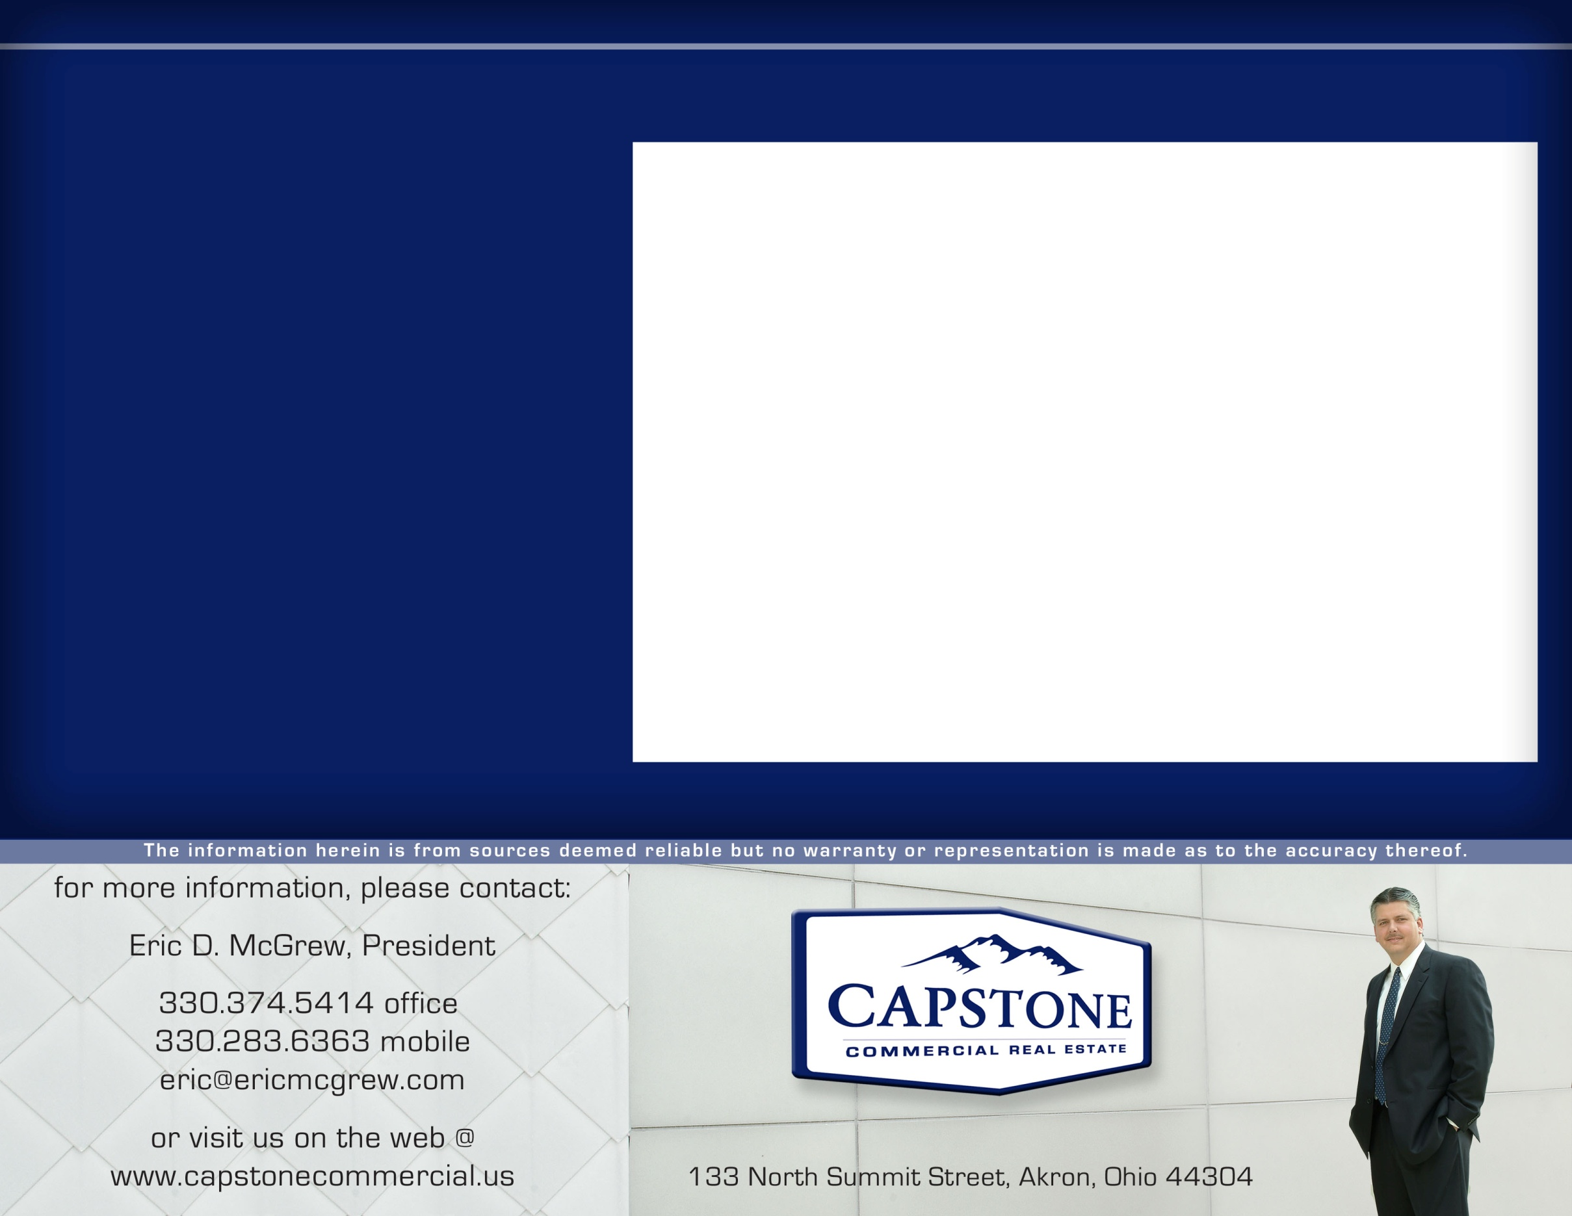
PRIME FAIRLAWN AREA RETAIL SPACE!

1,275 Square Feet available on the 1st floor in this upscale neighborhood retail shopping center

In addition to the open retail space, this suite contains1 private office, storage room or break room with sink, a wet bar area, and restroom.

Available for lease 3/1/26.

Shared parking for 121 cars.

Other businesses in the plaza are a wine bar, upscale men’s clothing store, dry cleaners, framing store, olive oil store, nail salon, chiropractor, massage therapist, health insurance office, fitness center, card and gaming store and several office tenants.

Conveniently located across from Dillards at Summit Mall and at the intersection of Ghent Road and Sand Run Parkway, near two I-77 highway interchanges within 1 mile, two airports (CLE & AKC) within 30 minutes and an educated workforce population nearby.

All of these amenities make the Fairlawn area of West Akron one of the region’s most desirable places to shop and work.
1,275 Square Feet - Call for leasing rate
10 x 12 private office
Your name here

119 Ghent Road, Fairlawn, OH 44333
Upscale Boutique Retail - FOR LEASE
121 Ghent Road, Fairlawn, OH 44333

