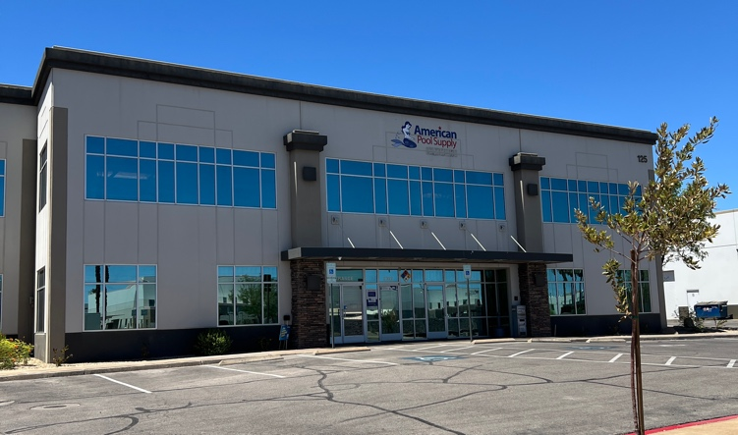
High Image 12,320 SF Freestanding Building

HENDERSON CORPORATE PARK
125 CORPORATE PARK DRIVE
HENDERSON, NV 89074

Henderson Corporate Park is located at Corporate Park Drive and Mary Crest Road. Prime Henderson Location with immediate access to I-215 & I-515 Freeways, along with close proximity to Harry Reid International Airport, the Las Vegas “Strip”, Convention Centers and Nearby Retail and Restaurant Amenities.

FOR SALE:
3,700,000
($300.32SF)

Property Details

- +/- 12,320 SF Freestanding Building

1000 SF HVAC Office
11,320 SF Evaporative Cooled Warehouse

- Situated on a 0.82 Acre Parcel

- Large CMU Wall Fenced Rear Yard Area

- 800A, 120/208V, 3-PH Main Power Panel

- 2 – 12’ x 14’ Grad Level Loading Doors

- 22’ Average Clear height

- Fire Sprinklers

- Warehouse Skylights

- Parking Ratio: 1.64 : 1,000SF

- I-G Zoning (Industrial-General - City of Henderson)

- High Image Concrete Tilt Construction

- Business Park Environment

- Immediate Access to I-215 and I-515 Freeways

- APN: 178-15-611-045

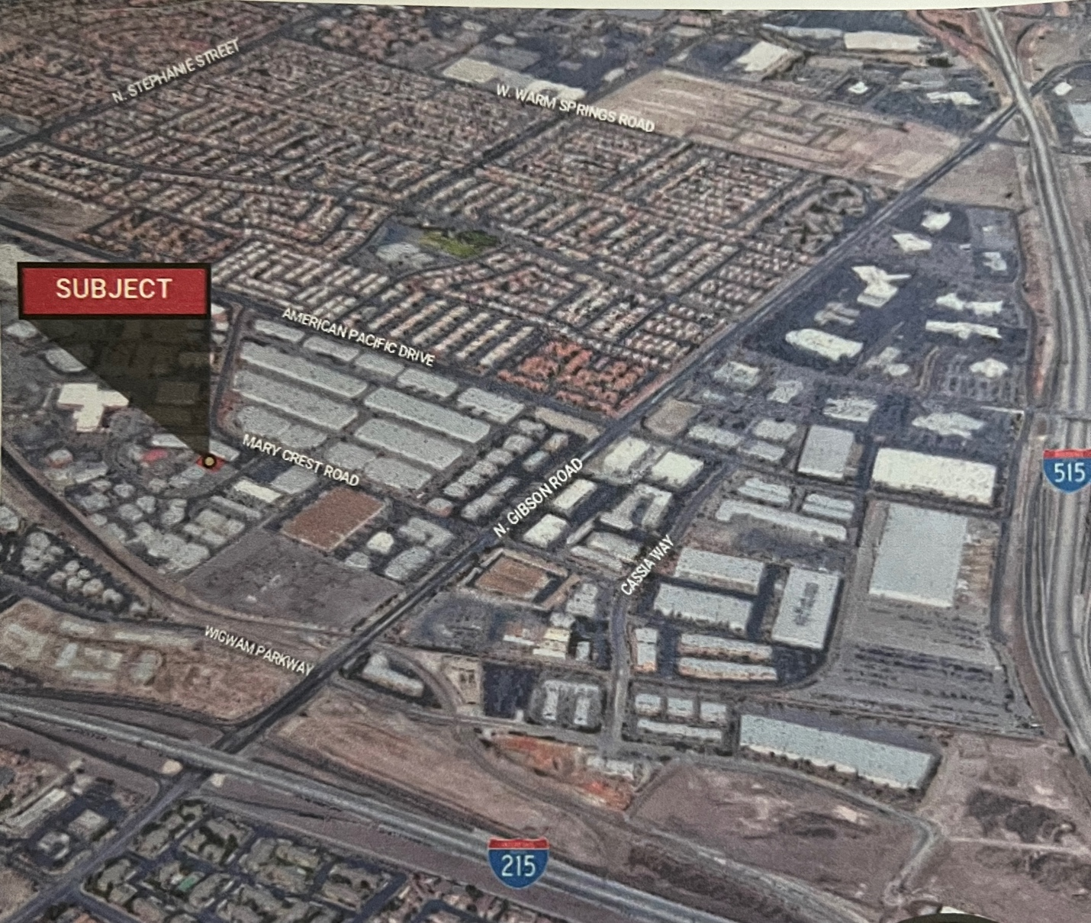
Jan Craddock
702-768-9621
Jancraddockre@gmail.com

GENERAL REALTY GROUP
6330 South Eastern Avenue
Las Vegas, NV. 89119

