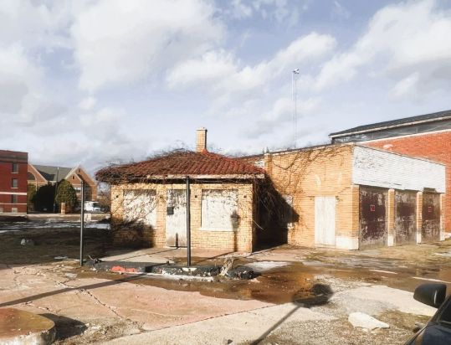

Parcel # 01-003825.
Lot Size 4,051 Sq. Ft.
Property Type Service station (full service)
County WAYNE
Living Area Sq. Ft. 1,181 Sq. Ft.
Year Built 1934

**For Sale: Historic 3-Bay Gas Station in Brush Park, Detroit, MI 48201**
**Maximum Asking Price: ** $10,000,000.00 **Minium Asking Price: ** $5,000,000.00
Discover a unique investment opportunity in the heart of Brush Park, one of Downtown Detroit's premier neighborhoods. This historic 3-bay gas station features:
- **Prime Location:** Situated on a corner lot, offering high visibility and accessibility.
- **Spacious Interior:** 1,181 square feet of versatile space, ready for your creative vision.
- **Newer Roof:** Ensured durability and reduced maintenance for years to come.
- **Endless Possibilities:** Ideal for converting into condos, a bar and grill, office space, or your own imaginative project.
The building has been completely cleaned out, providing a blank canvas for your ideas. Opportunities like this don’t last long in such a desirable area, so don’t miss your chance to make your mark in Brush Park!
**Contact us today to purchase this prime real estate @ (248)-510-1743, commercialrealestate4sale25@gmail.com**

